Research and Enterprise, November 2016

A Guide to ORCID and linking to Scopus
ORCID - Open Researcher and Contributor ID

Research funders, publishers and government returns are starting to request that Universities and academics include ORCID identifiers in bids, outputs and REF and HESA returns. It has there been agreed that all academic staff should create an ORCID.

The Research and Enterprise Directorate on behalf of the University will manage and provide guidance and training on setting up and linking ORCID's. One of the key ways in which ORCID will be used is in the active linking of SCOPUS and CROSS REF to the ORCID ID.

It has also been announced that it will be mandatory for all individuals submitted to the next Research Excellence Framework to have an ORCID iD.

What is ORCID?
ORCID is an open, non-profit, community-based effort to provide a registry of unique researcher identifiers and a transparent method of linking research activities and outputs to these identifiers. ORCID is unique in its ability to reach across disciplines, research sectors, and national boundaries and its cooperation with other identifier systems.

The ORCID Community

The ORCID community includes individual researchers, universities, national laboratories, commercial research organizations, research funders, publishers, national science agencies, data repositories, and international professional societies, all of whom have been critically affected by the lack of a central registry for researchers. ORCID coordinates with the community through Working Groups and bi-annual Outreach meetings.

Documentation

ORCID works with the research community to identify opportunities for integrating ORCID identifiers in key workflows, such as manuscript submissions and grant applications. ORCID encourages third parties to develop applications that interact with and enhance the utility of the ORCID Registry.

The Next Steps
ORCID’s have to be managed by the individual and cannot be managed by the university on their behalf. They must also link to relevant external profiles and the following pages outline how this can be done.

- REGISTER

If you haven’t already registered for an ID this is your first step. You can get your unique ORCID identifier from here : Register now! (https://orcid.org/register)

It states that registration takes 30 seconds but Please note that although it only takes 30 seconds to register there are a number of additional steps you need to take in order for you to be fully searchable and have all the relevant information about your profile.

- ADD YOUR INFO

The most important thing you must do once you have your unique ID is to add your affiliation to the University of Huddersfield. Please note that ORCID is linked to RINGOLD which is a database that has unique codes for all business and Universities. In order that we can pull out data of University of Huddersfield associations we need you to choose the ‘University of Huddersfield’ option without the School or department option. You can add in your department in a separate field.

Next, you should add all the variations of your name in your record. This could include any abbreviations you use professionally (initials and/or a nickname, for example) as well as other names you are or have been known by. ORCID is set up to allow as many different names, variations, and combinations of names as you need! Without this extra data, anyone searching for you by name alone will still be unable to distinguish you from someone else with the same name as you.

Enhance your ORCID record with your professional information and link to Scopus.

The single most important thing to do is to to use your ORCID iD and make it work for you, for example, to enable auto-updates from other systems such as ResearcherID, SCOPUS (see step 3) and CrossRef which to date has issued over 75 million digital object identifiers (DOIs) for articles, book chapters, images, and more.

So keep your information updated, include your iD when prompted to do so in manuscript submission systems, grant applications, and other research workflows, make sure it’s linked to other identifiers and profiles you use, such as ResearcherID and Scopus, and include it in your CV, your web page, your signature line, and more. This way your ORCID profile can be automatically updated.

It’s also helpful to enhance discoverability of your existing works by using our search and link wizard to connect information about your research outputs to your ORCID record.

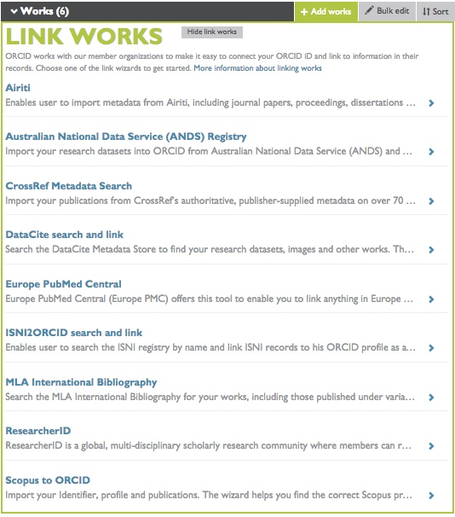

You can also use the Uber wizard to add details of your funding.

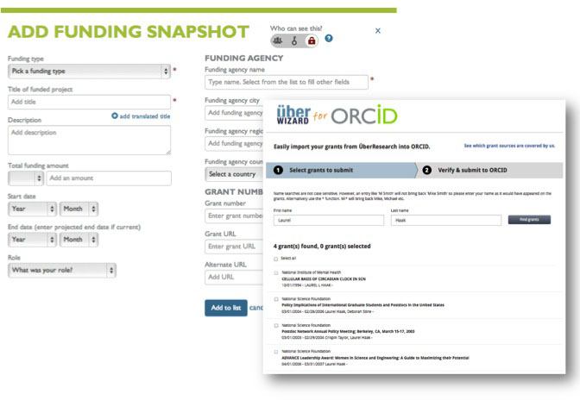

- Linking your ORCID to your Scopus ID

As part of the implementation of the new research information management system PURE it will be necessary for Research and Enterprise to import manually all outputs that are both in Scopus and ePrints (institutional repository) into PURE. In order to carry this out it is extremely important that where ever a member of staff has an ORCID and Scopus ID that these are linked so that the import can be carried out in an effective and timely manner.

- Find your profile

You can find your author page in Scopus by searching through ‘Author Search’
https://www.scopus.com/search/

if you are relatively new to the organisation and have not yet published under the university of Huddersfield it is possible that you will still be listed under your previous organisation

- Check if ORCID has already been linked

If an ORCID is associated to a Scopus author profile, you will see a link to that ORCID on the Author details page.

- Use the Scopus wizard to link the systems together

Below are the steps that need to be taken by an individual in order to link the 2 systems together.
You can use the Scopus Author Feedback wizard (right hand column on your profile page) to import into ORCID your Scopus profile and the list of your publications in Scopus.
The wizard takes you through the steps of finding the correct profile(s) in Scopus and checking the publications it contains.
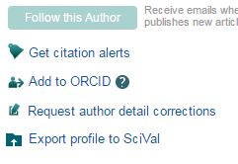

Once you’ve reviewed the profile and identified any corrections

- Your Scopus Author Identifier is sent to ORCID
- Scopus remembers your ORCID ID
- The corrected publication list is sent to ORCID (optional)
- Any corrections you make are submitted to the Scopus Author Feedback team. You will receive an email with a request to confirm them.

- Confirm any emails from Scopus.

Registering in Scopus

Some features in Scopus, such as alerts and saved searches, are available only if you register. Registration is a one-time activity. The information you enter is stored in your Scopus profile.

To register

- Click Register at the top of any Scopus page, or click Not Registered? inside the Login box.
- Complete the Your details and E-mail and password sections.
- If you like, click Show other settings to enter your role, job title, and/or address information.
- Click the check box if you would like to receive emails about future updates, releases, or related products.
- Click the check box for I have read and understood the Registered User Agreement.
- Click Register. You will receive an email confirming your registration.

To send author details to ORCID

Once you have registered with Scopus you will find on the Author details page an option to ‘Add to ORCID.

Click the Add to ORCID link at the top of the page to open the Author Feedback wizard.

The following screen will appear if you have an ORCID click ‘Sign In’

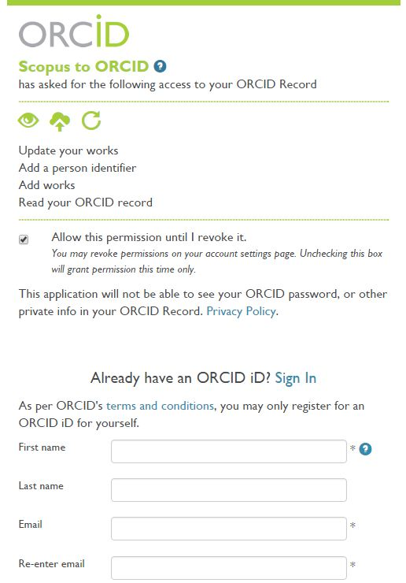
If not you can register for an ORCID on this page.
You will then be asked to Sign into ORCID.
Once you have signed in to ORCID a screen will appear asking you for your email address so that your ScopusID can be sent to ORCID.
After typing in your email select Send Author ID. 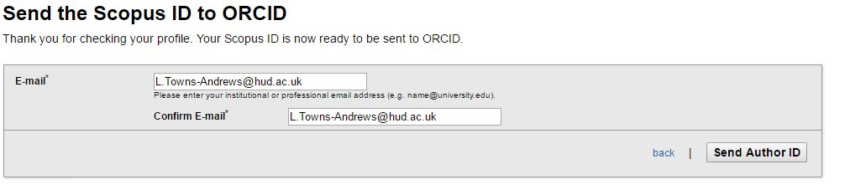
You will then be asked to review all you rpubication that are in Scopus and push them to ORCID.
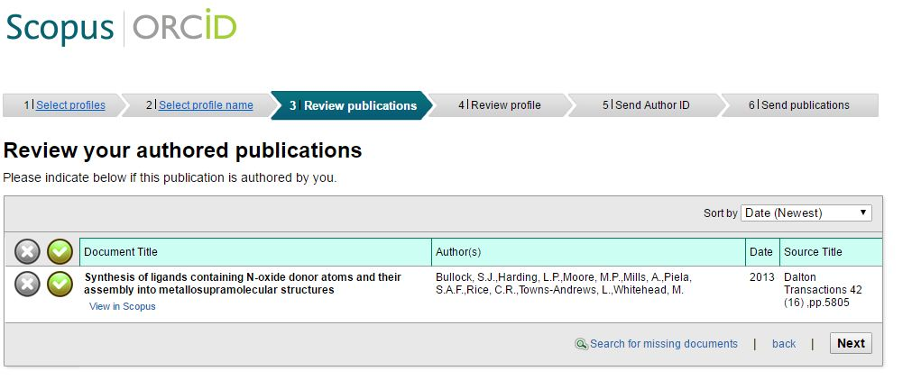
You will then be be asked permission to send the list to your ORCID aceept this and your ORCID ID will be published with any works within Scopus.
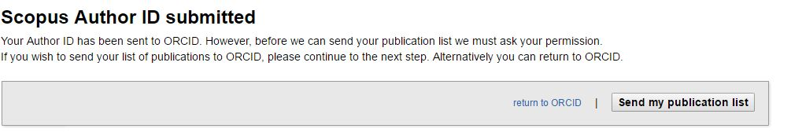

Remember to include your ORCID identifier on your staff profile, when you submit publications, apply for grants, and in any research workflow to ensure you get credit for your work.

- CONTACT US

If you need to chat to a member of our team about your ORCID please get in touch:
Research and Enterprise:
01484 471105

CHECKLIST

Register for ORCID iD
Affiliate yourself to the University of Huddersfield
Add all the variation of your names to your profile
Link your ORCID to Scopus
Link your ORCID to CrossRef
Link your ORCID to ResearcherID
Remember to include your ORCID in publications, grant
submissions, on your social media channels

