Cycle Parking Spaces – updated 25.07.2023

Location | Spaces | Type | Notes
3M Buckley Innovation Centre  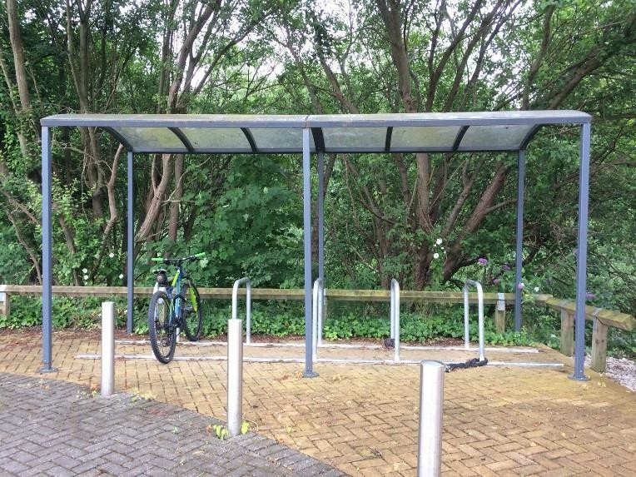  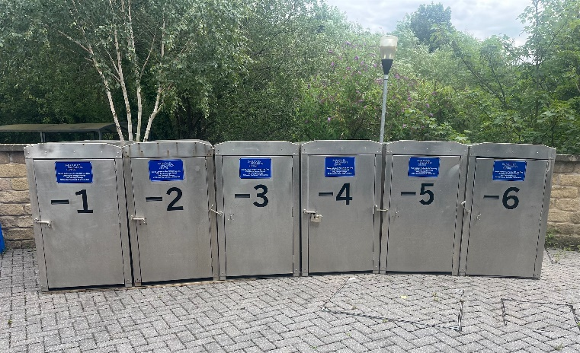 | 10  6 | Sheltered Sheffield stands  Lockable individual silver metal cabins
Charles Sikes Building  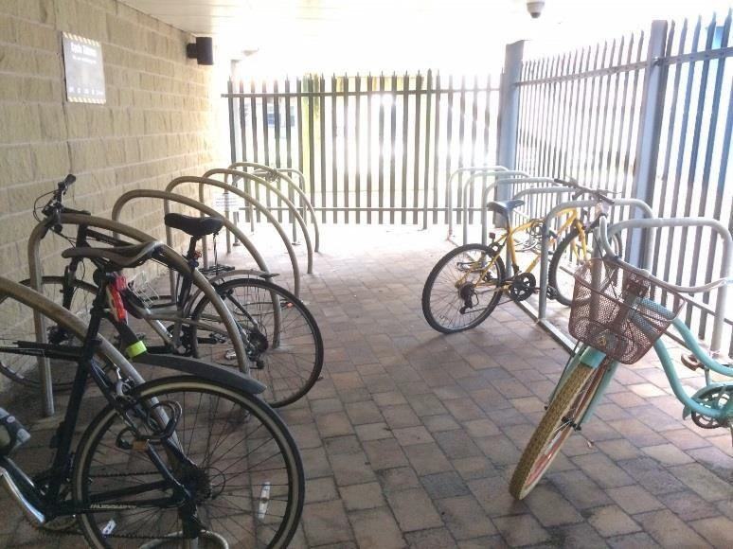 | 26 | Secure sheltered Sheffield stands | ID card access*
Percy Shaw House  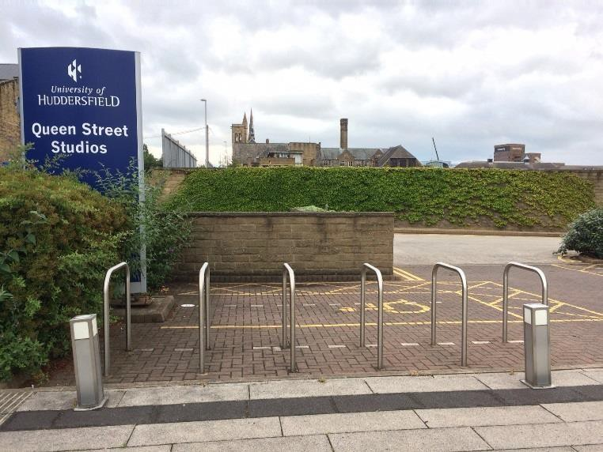 | 12 | Sheffield Stands

Spärck Jones Building  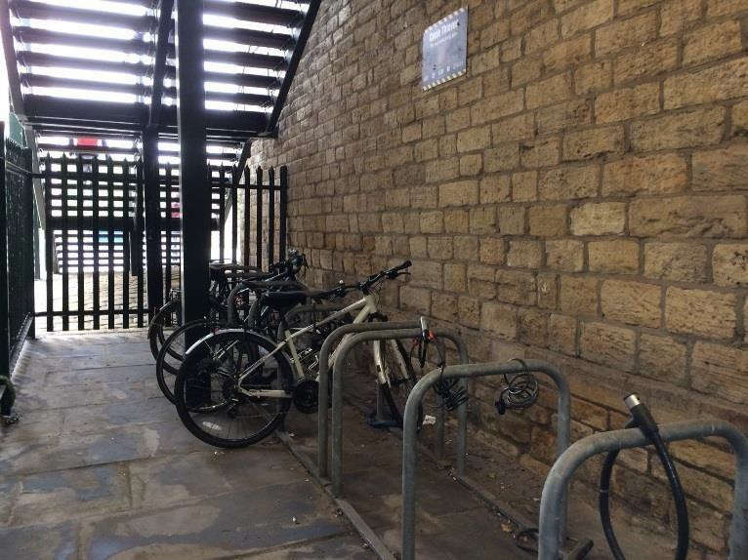 | 18 | Secure sheltered Sheffield stands | ID card access*
Harold Wilson  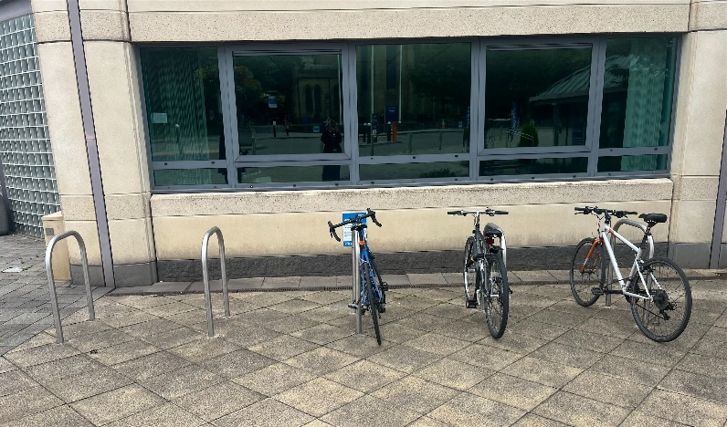 | 10 | Sheffield stands
Bronte Lecture Theatre  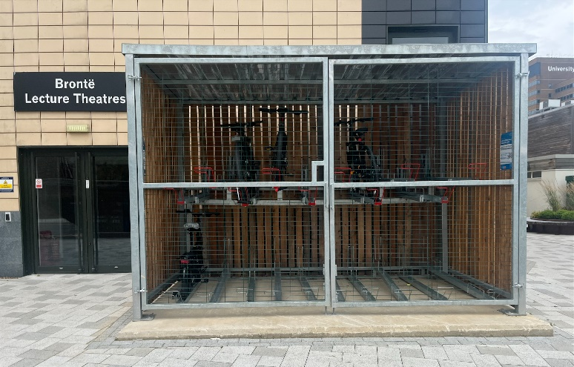 | 20 | Sheltered pull out, double story, slide out stand
Total spaces | 102

*Contact Estates to enable card

