**Activating, setting up your Substitute**

**Step 1**: Login to Unit4 via the web: [Login - Finance Systems Support team. (hud.ac.uk)](https://agressoweb.hud.ac.uk/MS7_Live_Web/Login/Login.aspx)

Username: Your AD login (e.g. fina,sbus,cmsx, shum)

Client: Enter the company e.g. H1, H3, EI

Password: Unit4 password (reset using the ‘forgotten your password?’ option)

Please note: if you are a user *of multiple companies*, you will need to login to each company and follow the below guidance as substitutes are set within each company.

You can view which company you are setting your substitute up on the tab, for example:

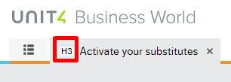

**Step 2**: Once signed into Unit4, every users homepage and menu can look different depending on your access, but you will be able to locate the *‘Activate your substitutes’* function with the *‘Your employment’* option:

**Step 3**: There are 3 possible scenarios:

**3i)** you are editing/adding substitutes that already exist on the system.

**3ii)** you are setting up multiple substitutes for your absence period.

**3iii)** you require a new substitute adding or a substitute for specific Unit4 elements.  
  
**3i)** **Editing/Amending existing substitutes**  
You will need to amend the *‘Absence status’* to *‘I am currently out of the office’* and next select your *‘Absence date from’* by selecting the calendar icon:

In the *Substitutes box*, current listings shown can be edited to be re-used. To do this click anywhere into that line.  
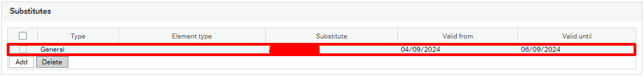

Then amend the *‘valid from’* and *‘valid until’* dates using the calendar icons.

Once set up complete, select the blue **save** button at the bottom of the screen.

If your substitutes are *blank* as shown, you can select *‘Add’*.

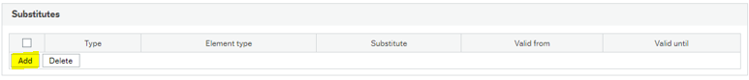

Click on the *‘Substitute’* dropdown to reveal substitutes you have setup in the system: 

You may then select a *‘Valid from’* and *‘Valid until’* date and then press **Save** at the bottom of the screen.

If you select the *‘Substitute’* dropdown and the substitute you require is not listed, please contact [FinanceSystemsSupport@hud.ac.uk](mailto:FinanceSystemsSupport@hud.ac.uk) to requeest set up.

**3ii)** **Setting up multiple substitutes for your absence**  
You will need to amend *the ‘Absence status’* to *‘I am currently out of the office’* and then select your *‘Absence date from’* by selecting the calendar icon.

You can either amend a previously used substitutes or add a new ones as shown in step *3i*.

For example, user is out of office for 2 weeks and wishes to set up substitute 1 for week 1 of absence period and substitute 2 for week 2 of absense period: 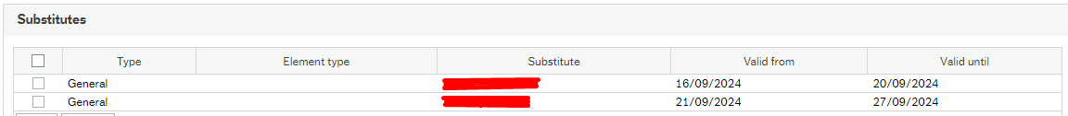

Once set up complete, press the **blue Save** button at the bottom of the screen.

**3iii)** **New substitutes setting up on the system or substitutes for specific elements**  
For a ‘new substitute’availability please contact [FinanceSystemsSupport@hud.ac.uk](mailto:FinanceSystemsSupport@hud.ac.uk), with details of the individual you require adding. Once the new substitute is available for use, you will be able to follow step 3i or 3ii.

For a substitute setup for ‘specific Unit 4 elements’, please email your request to [FinanceSystemsSupport@hud.ac.uk](mailto:FinanceSystemsSupport@hud.ac.uk). Provide details of the *name* of the substitute, the range of substitution *date from/date* *to* and the *specific element/s* they are to be your substitute for.

NB: an element could be a request to substitute only for purchase card tasks, or to action MGRN task, or approve employee expense only as examples. Please query with Support options available to you if required.

**Step 4:** Return to work procedure.

It is *good practice* that on your return to work to update the *‘Absence status’* to *‘I am currently in the office’* to ensure your substitution setups are turned off. This is particularly important for closing substitute setups that had ‘*no end date’* added.

If you have added an end date to the substitute set up, when this date passes your substitute will stop receiving your Unit4 tasks.

To update the ‘*Absence status’*, repeat *Step 1* and *Step 2* to login and navigate to the ‘Activate your substitutes’ function. Next select the dropdown and ensure you select your *‘Absence status’* to *‘I am currently in the office’*.

Then press the **blue Save** button at the bottom of the screen.

You have now *turned off* the substitute function, terminating any Unit4 workflow task to the substitutes listed. All future tasks will be directed to yourself for action.

Please remember to repeat this for all companies set up for substitution *(H1/H3/EI)* if necessary*.*