Budget Holder Approval

As a budget holder, you are responsible for the income and expenditure in your sub-project (e.g XXX123-01). This means: -

- Approving a requisition

- Approving an invoice where the invoice value is greater than the order by more than £50.00

- Approving an invoice with an extra line that is not on the original purchase order

- Approving a purchase card transaction

- Approving a travel expense

- Approving a sales order

You will receive an email similar to the one below when either one of the above occurs, asking you to log onto Unit4 to action the outstanding tasks.

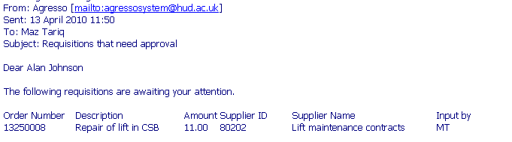

If you follow the link from the email this will open the following log on screen for Unit4. Please note this link will only work while using Uni Desktop when off campus.
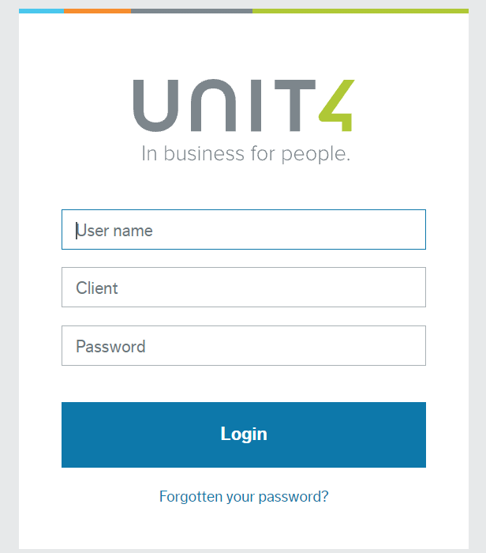
User name- This is your network user name (e.g FINAHB2)

Client- H1 (H3 for Enterprises)

Password- This will be different to your network login. If you have forgotten your password, please use the ‘Forgotten password option’ to reset it.

Note: You will need to be set up as a user on Unit 4 before you can access the system, please contact Finance Systems Support, financesystemssupport@hud.ac.uk to check if you have an account or need setting up.

Once logged onto the Unit 4 system you will see the outstanding tasks by clicking the tick icon in the top right hand side of the screen and selecting the task you want to approve.
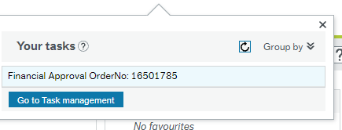

Approving a Requisition

You can then see the requisition details. Check that you are happy with the relevant details and the expenditure should be coming out of your sub-project, e.g. quantity, price, description, nominal, sub-project.
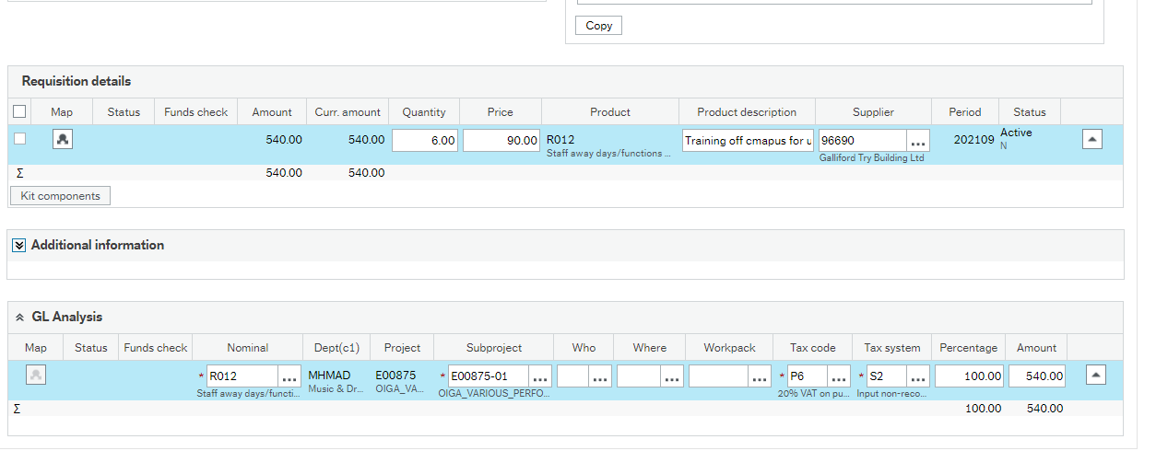

At this point, the items have not been purchased; the requisition has to be approved before the purchase order can be sent to the supplier.

Once you are happy with the requisition details click the Approve icon at the bottom of the screen.

This will then show the item as successfully processed and an automatic email will be sent to the person that input the requisition to notify them of what they need to do next.

The requisition is then fully approved and will be converted into a purchase order ready for the requisitioner to send to the supplier and proceed with the purchase.

Rejecting a Task

If you do not agree with any part of the requisition or would like further details, you can click on the Reject button at the bottom of the screen 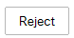
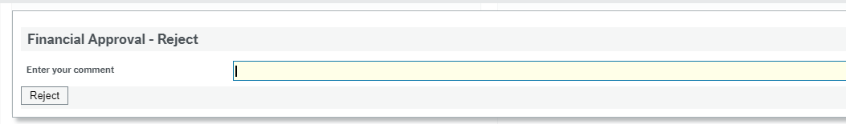
This will bring up a box asking you to enter an explanation for the rejection. This will then send the task details back to the person who input the requisition for them to action what you have requested.

Depending on the action taken, the requisition may or may not come back to you for re-approval.

Invoice approval – where the value of the invoice is greater than the tolerance

When an invoice is received in Finance, where the value is greater than the purchase order by more than £50 or 2.5% of the order value, you will receive a task in Unit 4 similar to the one below.

There will be a short explanation explaining why you have received the task.

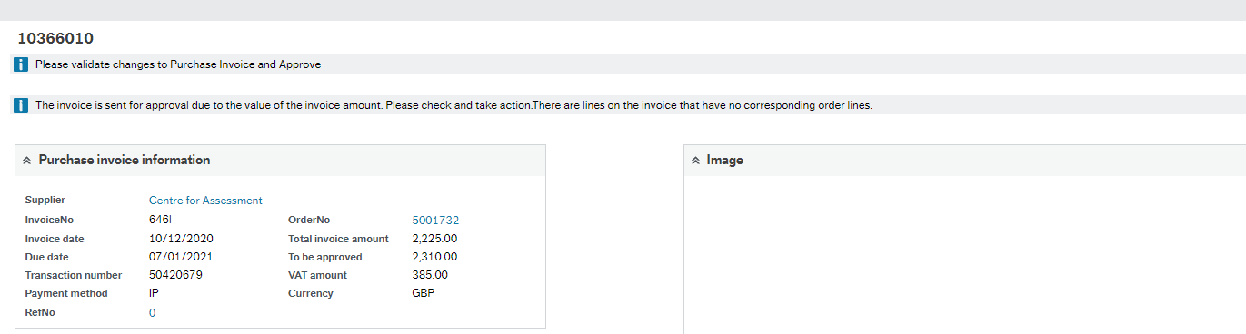

You can see the value of the original order in the Order Lines table under Order Price and how much has been delivered by the requisitioner, and then value of the invoice under Purchase invoice details, which has been sent to Purchase Ledger from the supplier.

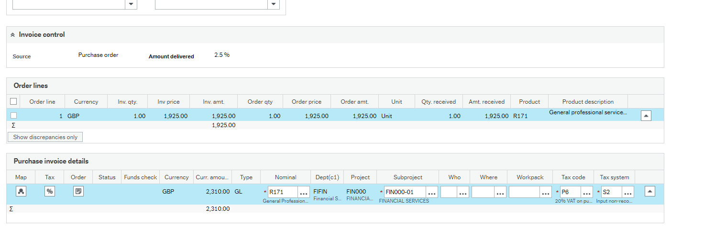
If you are happy with the extra expenditure then click the Approve option at the bottom of the screen 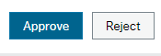.

Rejecting a Task

If you do not agree with the transaction, you can click on the Reject button at the bottom of the screen
This will bring up a screen asking you to enter an explanation for the rejection. It will then send the task details back to the person who input the requisition for them to action upon.

Depending on the action taken, the requisition may or may not come back to you for re-approval.

NEED EXAMPLE

Invoice approval – where there is an extra line on the invoice that was not on the original purchase order

When an invoice is received in Finance, where there is an extra line, this will be routed to you as the budget holder to approve the extra expenditure.
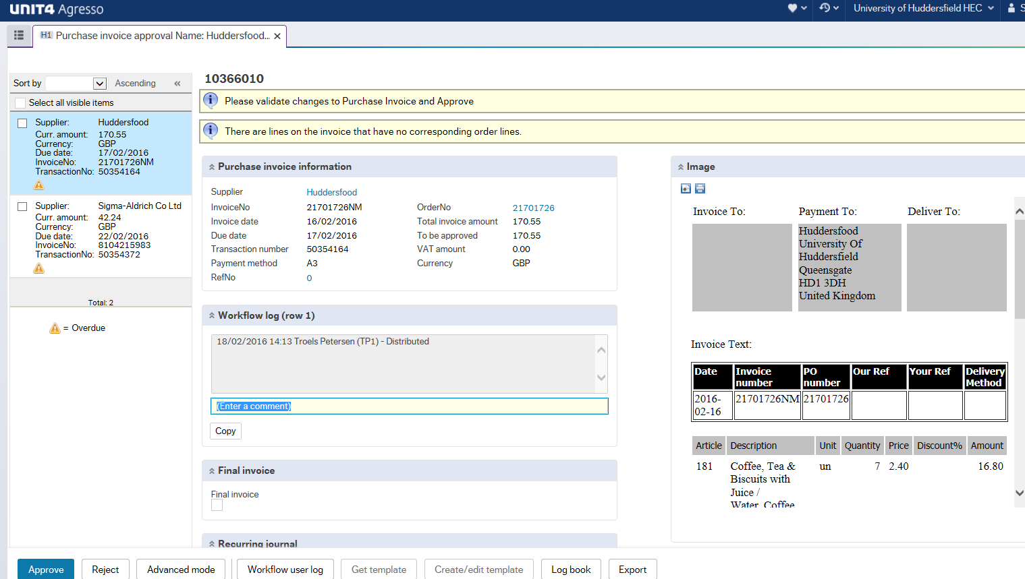

In the Order Lines table you can see what has been ordered. In the Purchase Invoice Details table you can see the value of the extra line. The scanned invoice image will give you the relevant details.

If you are happy with the extra line of expenditure, click the Approve button.

Rejecting a Task

If you do not agree with the transaction, you can click on the Reject button bottom left hand side of the screen 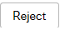
This will bring up a screen asking you to enter an explanation for the rejection. It will then send the task details back to the person who input the requisition for them to action upon.

Depending on the action taken, the requisition may or may not come back to you for re-approval.

Approving a Purchase Card Transaction

You have received this task as something has been purchased using one of the Universities Purchase Cards, this transaction has then been coded to a sub-project that you are budget holder for.

Your task will appear in the top right corner (along with all over tasks)
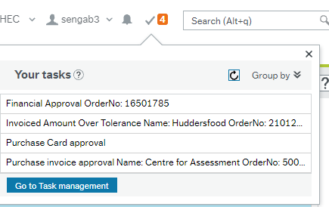

Once you have selected the task, another tab will open up the transaction.

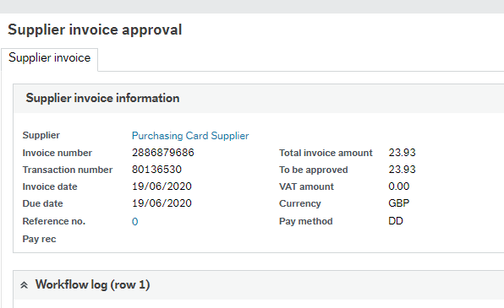

The below details will show how much the transaction is for, the sub-project and what the cost is for;

Note- The costs have already occurred, you are not approving the spend, you are approving where the costs should be coded to.

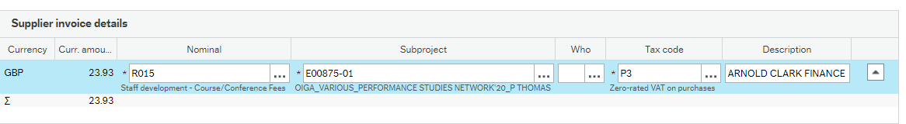

Items to check here are:-

- Nominal- Do you agree with the coding or what the item/product is?
- Sub-project- Is this the correct sub-project to be used?
- VAT - Has the VAT been coded correctly – P8 for 20% VAT, and P3 for no VAT, and
- Description – is this meaningful and relevant?
If you agree with the coding and the text, simply click the button bottom left of the screen. You will then get a message across the screen telling you have successfully approved the transaction.

BUT WHAT IF?

I disagree with the nominal? Simply overtype the nominal to be what you want, and press the Tab key. NOTICE This will also amend the Tax code, so you will need to amend it accordingly.

I disagree with the Sub-project?

If you do not agree with the transaction, you can click on the Reject button bottom left hand side of the screen
This will bring up a screen asking you to enter an explanation for the rejection. It will then send the task details back to the person who coded the transaction for them to action upon.

Depending on the action taken, the purchase card may or may not come back to you for re-approval.

Approving Travel Expense

Expense claims for Schools will go to the School office for approval before it goes to the budget holder. You will receive an email informing you that there is an outstanding task and you can click on the hyperlink (on campus only or using Uni Desktop off campus) to take you straight to the task.

You will need to log into Unit 4 as above (page 2)
You can access your tasks by clicking on the icon.

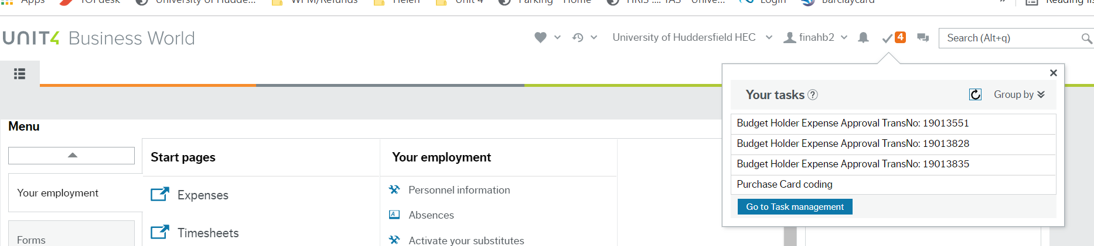

This is an overview of the task
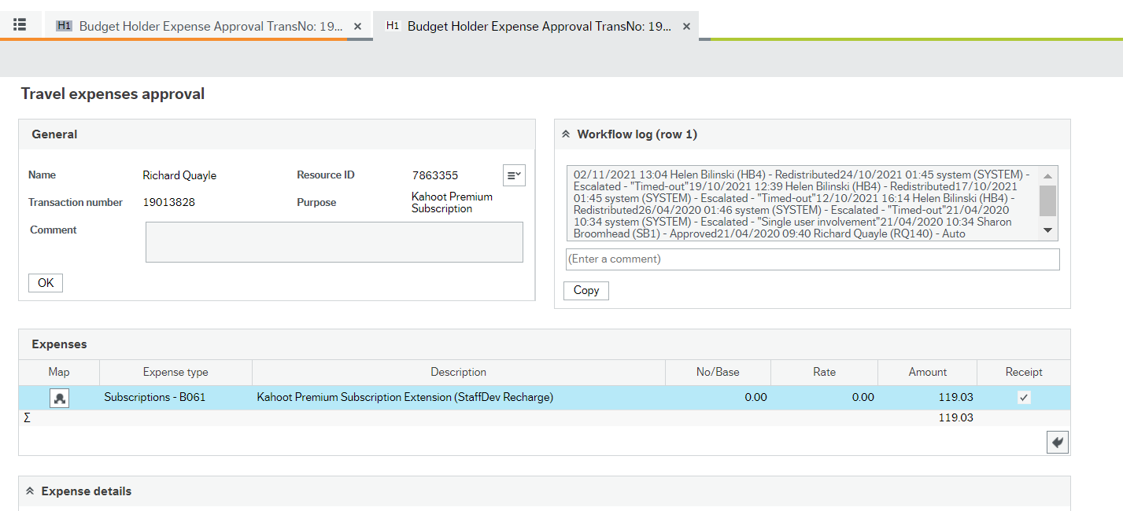

The top section shows the basic details of the claimant and the expense claim

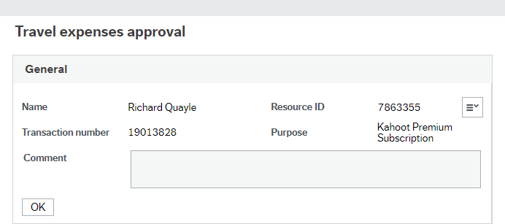

This is the section with the expenses lines to check. Click on a line to highlight it. The expense details for the line will open up below

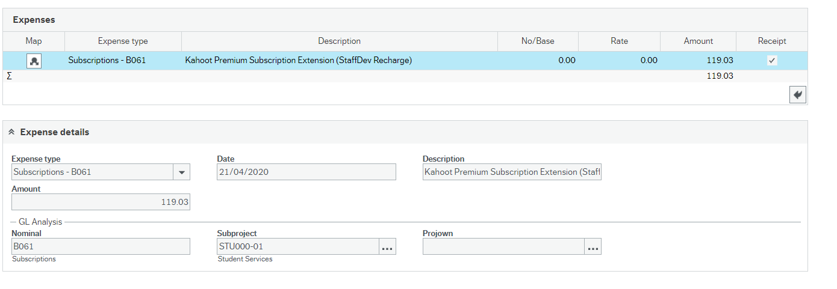
Items to check here are:-

- Expense type/Nominal
  - do you agree with the coding?

- Subproject
- If the dummy subproject is used (example: ADAEXP-01) this must be changed to a valid subproject or else the task will return to school office when approved.

- Description – is this meaningful and relevant?

- Amount – is this the correct amount and is it documented on the receipt? The amount can be amended in the expense details section.

- Receipts – click the icon in the top right corner to see the receipt attached to expense line. Double click on the image to see it in full size.

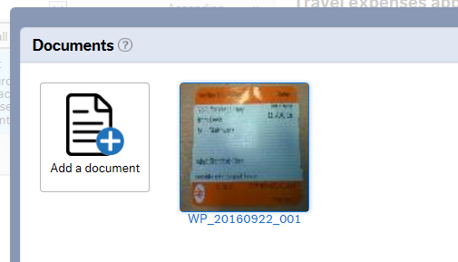

If you agree with the expense claim and the text, simply click the button bottom left of the screen. You will then get a message across the screen telling you have successfully approved the transaction. Now click on the next task in the list.

If you are not happy with the expense details click 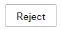
In the text box you need to explain to the claimant why you are not happy with the expense claim and inform them of any changes they need to make for the claim to be approved.

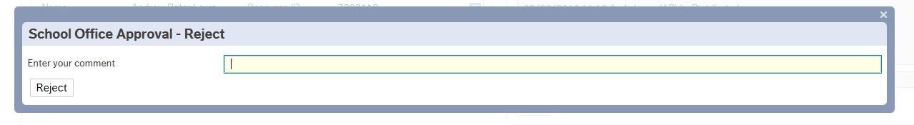

Approving a Sales Order

N.B Not all budget holders will receive Sale Order approval tasks.

A sales order has been raised using the sub-project you are responsible for, you are approving that you agree the income should be going into that sub-project. Once a sales order is approved and invoice will be sent to the customer.

You will receive an email informing you that there is an outstanding task and you can click on the hyperlink (on campus only or using Uni Desktop off campus) to take you straight to the task.

You will need to log into Unit 4 as above (page 2)
You can access your tasks by clicking on the icon.

This is an overview of the task
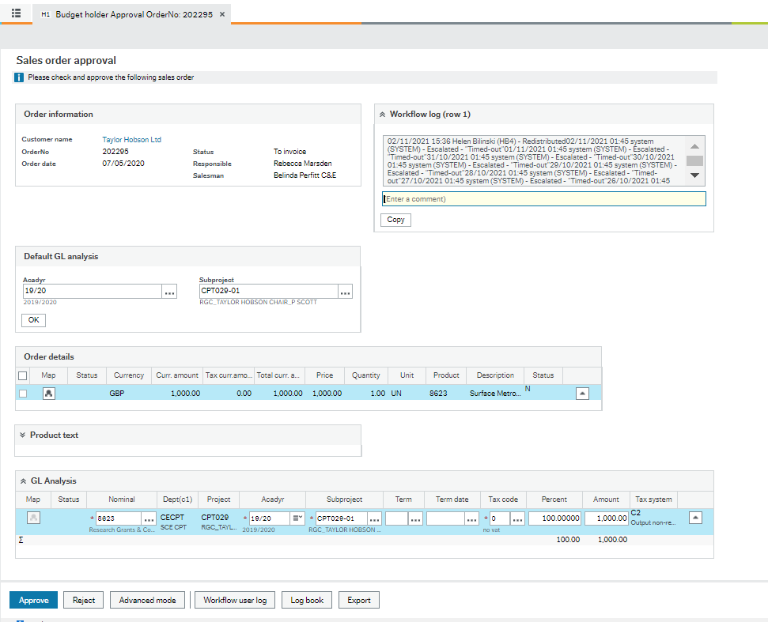

The order details shows what has been raised and the GL analysis shows the nominal and sub-project that has been used.

You have the option to approve or reject the task. If you reject there will be a comment box asking why you have rejected the sales order, this will then go back to the inputter and depending on the request, the sales order may not come back to you for approval.

If you agree with the sales order, click approve in the bottom left hand corner.

