This instruction document describes how to input an expense claim of behalf of another person.

Login to Unit4 to claim your expenses
By following the URL link you can log on to the Live Unit4 system:
https://agressoweb.hud.ac.uk/MS7_Live_Web/Login/Login.aspx

Alternatively, via the Staff Hub internet page login:
From the tab ‘Online Systems’, locate the link for Unit4.

The following Login box should appear.
- Enter the details requested and then click the LOGIN button.
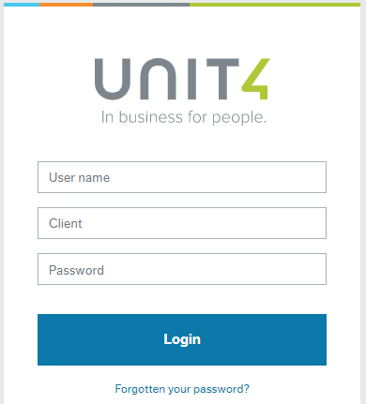
User name: the same as your computer login e.g. FINATP
Client: is the University company to be used
Client = H1 (Main company)

Password: must be at least 6 digits and include a number.
Forgotten your password? -
click on the link to reset

Time and expenses navigation
- From the Menu select Time and expenses and Travel expenses
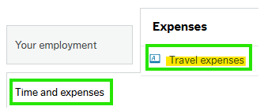

Set up of Travel expense
Tab1 - General:
- Status: either Draft or Ready (for approval), can select either with the results of
  - Draft – this creates a draft for whoever is added to the Resource cell, draft selection allows the claim to be saved and returned to update at a later date.
  - Ready – to submit the claim for whoever is added to the Resource cell, ready to save and send for approval.
- Resource: defaults to your name
Delete the Resource details and press the space bar to reveal a drop-down list of the individuals that you can enter expenses claims for.
Resource - select the individual you wish to enter an expense claim for.
- Travel type: choose either Expense or Advance in the drop-down menu
- Purpose: enter an appropriate and specific purpose of the expenses claim: e.g. Conference ABC – Manchester - date.
NB: “Trip” or “Travel” is not sufficient, as the purpose will become the description for the general ledger posting line.
- Comment: further comments, notes can be entered here for the Budget Holder or School Finance Office.
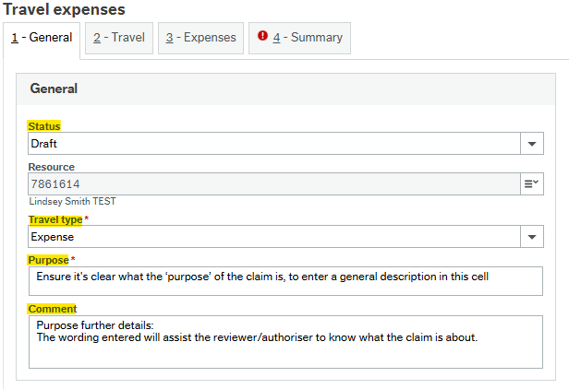

- When all fields have been populated click on Next step icon, moving on to tab 3 – Expenses.

Adding expense lines
Tab 3 - Expenses is the screen where expense lines are input.
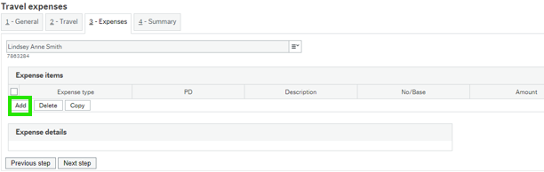
- Click on Add to insert an expense line.

Expense items:
- Expense details: choose the correct Expense type from the drop-down menu and click or tab on to reveal more details in this screen.
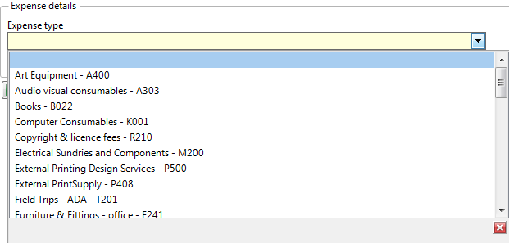
- Description: enter an appropriate and specific description for the expense line.
- Date: enter the date the expense occurred.
- Amount: enter the full cost of the expense item (100% value before split).
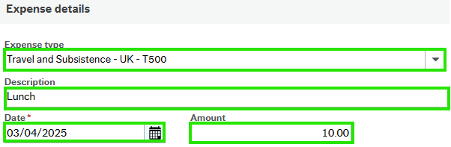
- Tab on to reveal the GL Analysis section.

GL Analysis:
To note, not all GL Analysis boxes will require updating, only those marked as mandatory will prompt for input.
- Nominal: will auto populate from the Expense type selected earlier - no need to update.
- Subproject: is the budget that the claimed is made against. The drop down will reveal which budgets you can claim against. If the budget code is not listed you may use the dummy code of EXP***-01.
NB: if inputting a subproject on behalf of claimant they too will require access or they will not be able to approve the claim.

Attaching a document to the expense claim

- When you have input all details for the expense the line, from this expense line (the whole line will be marked in blue) click on the paper clip icon
in right top corner to add receipt evidence to this line.
- Click on Add a document icon and then select Expense receipt.
- Document type: select from the drop-down Expense receipt.
- File name: Upload.
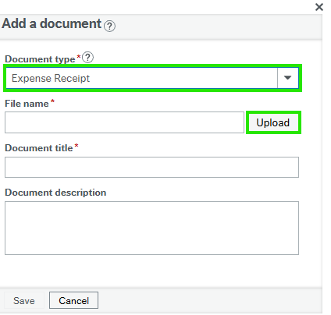

- Click on Upload to select the file/receipt you want to upload and navigate to the receipt to be attached.
- Click on the file and Open to attach.
- Close the window (x) to return to expense claim.

Submitting the expense claim or saving as a ‘Draft’
When you are ready to submit the expense claim for approval:
- tab1-General – return to this tab ensure the Status is set to Ready and click Save in the bottom left corner.
NB: the Resource detail on this screen must be the claimants.
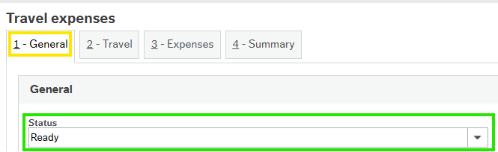
The Success message will advise the claims Transaction number.
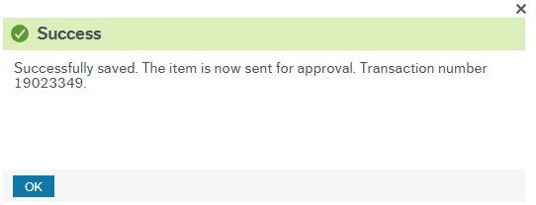
Alternatively - if you are to continue to add to the expense claim later, the Status needs to be Draft and the Resource details need updating to the Proxy inputters details.
NB: saving the claim as a Draft and leaving the Resource details as the claimants means that this Draft is now assigned to them, you as the Proxy can no longer amend the claim and the claim cannot be returned to you, be cautious.
- Save.
The expense claim will now be submitted into work. The claimant will receive an email notifying them that they have an expense claim submitted and need to login to Unit4 to approve the claim. All claims input on behalf of an individual has to be reviewed and approved by them.

Accessing a ‘Draft’ claim
From the Travel expense screen, located at the bottom of this screen is the Open icon.
- click on Open to reveal draft claims.
- click on the line of the draft claim to open.
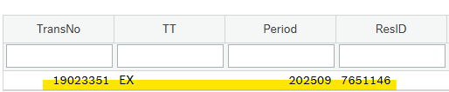

- the draft expense will open and you can continue to update.

Common Issues
NB: a reminder that a saved Draft claim input will be attached to the individual that was added to the Resource field.
NBB: to submit the claim into workflow remember to update the Status to Ready and the Resource field to be the claimants details (not the Proxy inputter).

