Sales Order

Training Documentation

Finance System Support
Call - 01484 47(3833)
Email - FinanceSystemsSupport@hud.ac.uk
URL- https://agressoweb.hud.ac.uk/MS7_Live_Web/Login/Login.aspx
Training- https://staff.hud.ac.uk/finance/financesystems/training/

Sales Order Processing
Web Based
Use this URL to log on to the Agresso on the web:
https://agressoweb.hud.ac.uk/MS7_Live_Web/Login/Login.aspx
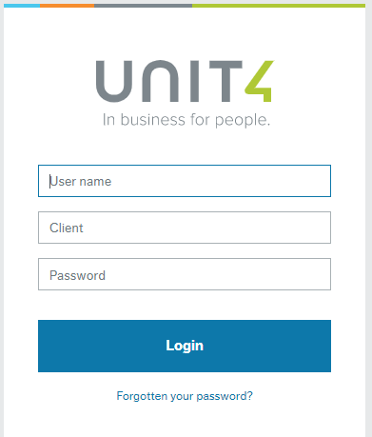
User name: the same as your computer login e.g. FINANN
Client: is the University company to be used select either H1 or H3
H1 - (Main Company)

Password: must be at least 6 digits and include a number. If you have forgotten your password, please use the ‘Forgotten your password?’ option

When sign on is complete, you should be presented with this screen.
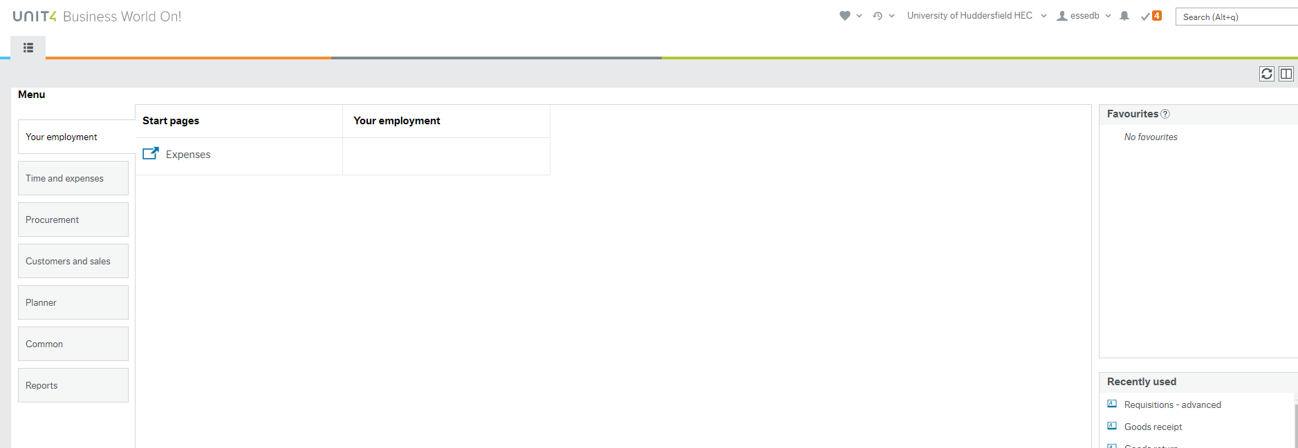

Inputting a Sales Order
From the screen below click
Customers and sales / Sales orders
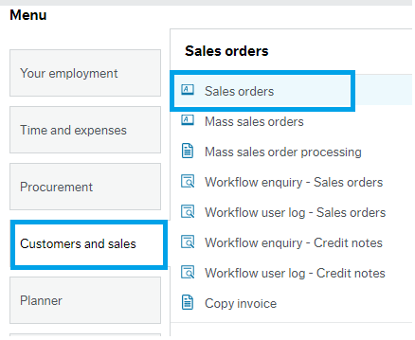

The screen below is the details input screen
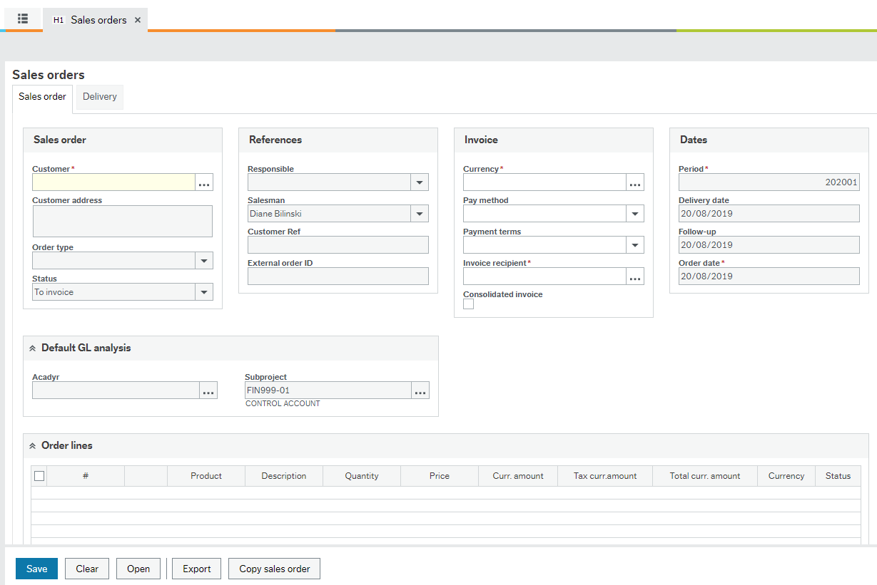
Before inputting any details, it is advisable, that all details required should be provided by the person who requested the order.

Inputting the invoice details
Enter the Customer number, it can be found in three different ways.
Manually typed in if already obtained
Type in the name of the company/Student

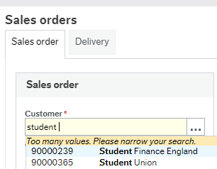

Or Click on the filter box and use the value look up box to search for the name of the company

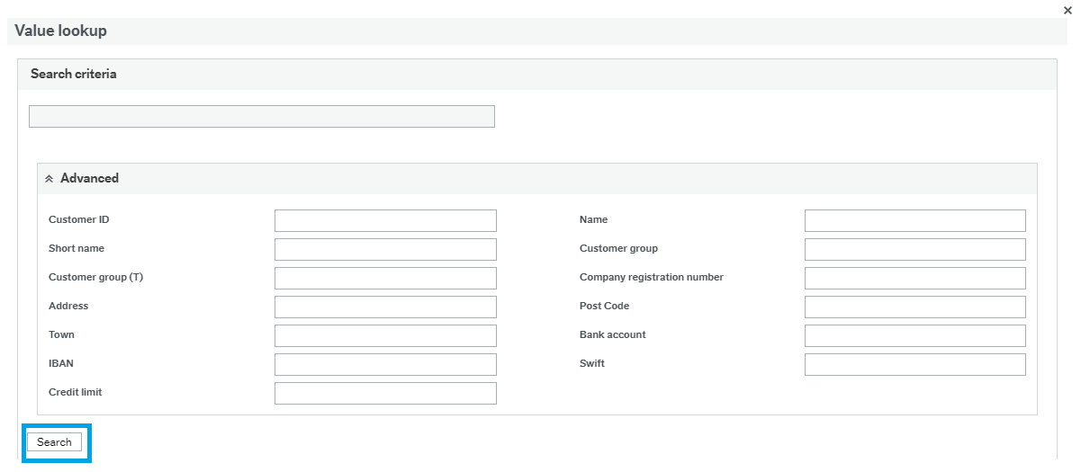

Input the customer ID number or name, once returned name appears use arrow keys or click on it. Highlight customer required and press tab. The Order Type is always invoiceable Sales order and Status is always To invoice.
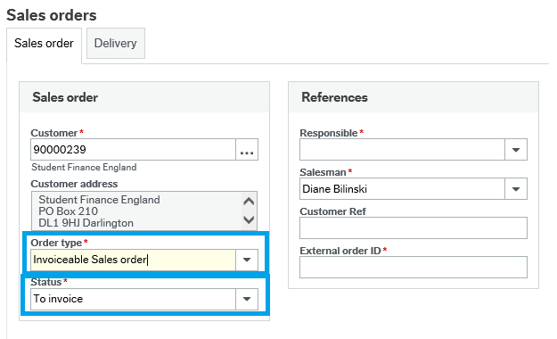
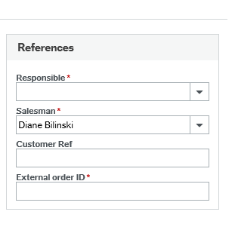
Inputting Responsible (budget holder) and salesman (this should have already defaulted to the inputters name). To enter the budget holder, click the arrow and the drop down box should display a list of names, select the name you require. NB This does not control who the orders goes to in workflow. The budget holder in workflow is determined from the subproject on each line.
This function has predictive text, so start to type in the first letters of the person you wish to input and tab.

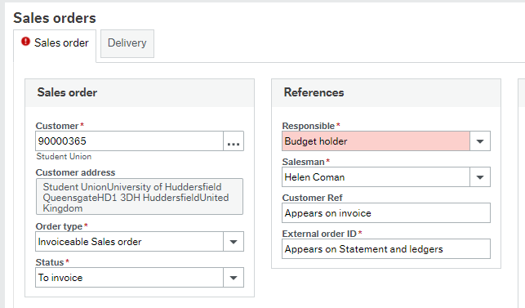
Customer reference box – This will appear on the invoice as “Your Ref:” So enter the customer’s PO number and/or contact name

External Order ID – This will appear in the sales and general ledger and on Statements sent to customer

Default GL Analysis
Academic year – relevant year (current academic year) and should already default in
Sub-project- change this to be the sub-project that it should be raised on.

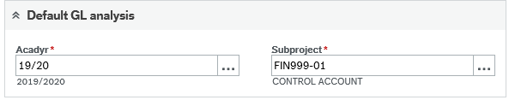

Order lines
Click add button below and product 1 on line one will appear
Each sales order Product Code is in fact the nominal code. Every code has a default VAT treatment. However, it is possible to change the VAT treatment at this stage if it is wrong in your particular circumstances. This will be checked during the approval process.

Select the Product Code and tab. All sale nominal will begin with an 8. A general description appears in the Description field relating to the code selected. This is the description that will appear on the invoice, so simply type over it to enter your appropriate information.

The Description details that are typed here will appear on the invoice that goes out to the customer, so it is important that the description is relevant.
Quantity depends on how many units sold and Price (2 units charged at £50.00, the system automatically calculates total)
NB For a Credit enter the Quantity as a negative number and the Price as a positive number.

More products can be added either click into the next line or click on add option below.
Lines can also be deleted, tick the box and click on delete.

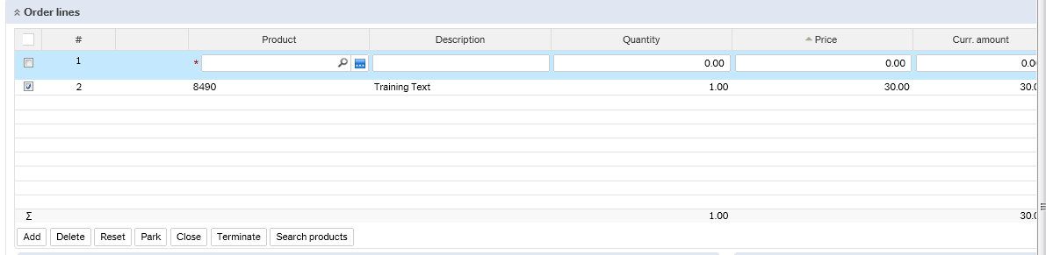

GL Analysis
Over type the subproject to the correct one, press tab.
Term and term date are left blank.
Tax code and Tax system can be manually changed if needed.

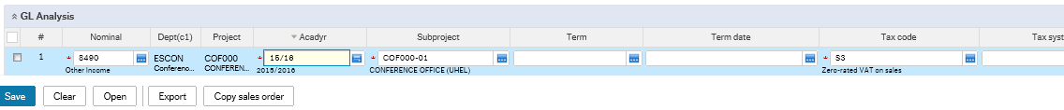

Open the Additional product information/ Workflow log clicking on the arrows.
This is where additional infromation can be added, or further deatil for the budget holder to see in the workflow log (this will not appear on the sales invoice)

Fill in any addtional product information which is relevant or you want to add.

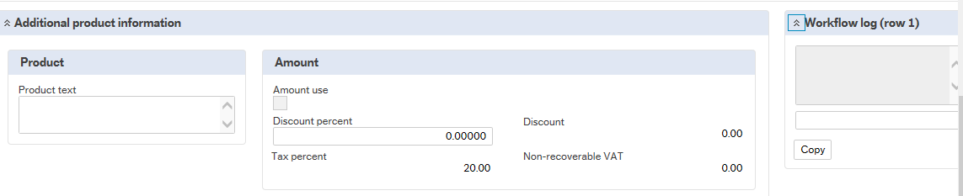

Click save and the posting cycles box apears

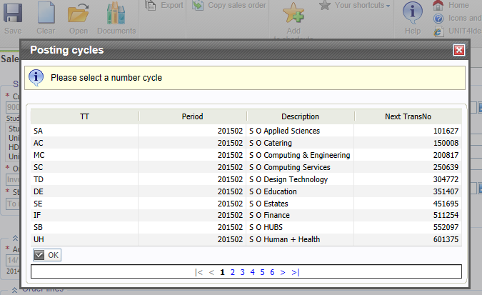

All services and departments have a unique set of numbers, for example select SO HUBS if you are raising a sales orders for the business school and click ok.
Note: Different sequence number for credits CN HUBS for credit notes.

Click OK

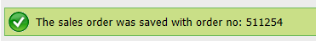

A message will appear quoting an order number. The order number is the reference used before order converts to an invoice. This number should be noted.

Journey of a sales order

Sales orders enter a workflow and can be tracked via an enquiry, at each stage the workflow map will illustrate at what stage the sales order is at.

Three stages are
- Budget Holder Approval
- Finance Check
- VAT check

When all checks are complete, the salesperson will be notified by email to print the order and this will convert the transaction to an invoice.
At this point the invoice will be printed and posted to Accounts Receivable and show on the customer’s account and the income will appear in the subproject.

At each stage the task owner receives an email notification that alerts them there is a task that needs to be actioned.

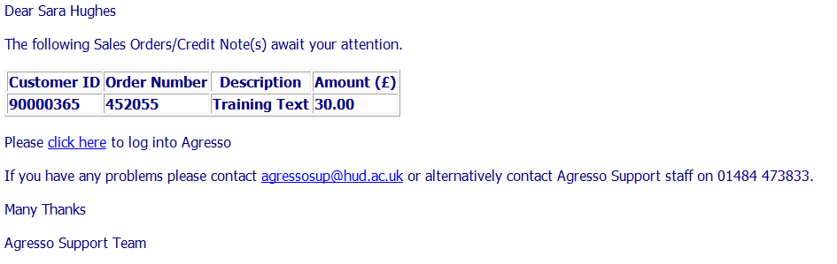
The sales order can be tracked using a Workflow Enquiry

To enquire about the order created

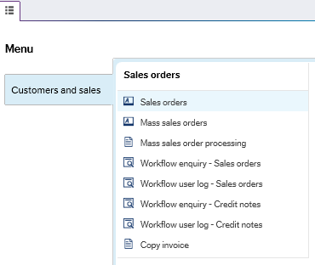

Click on Workflow enquire- Sales Orders

Complete the enquiry box below
Tick active as the sales order has not been approved in workflow. (Then the status would be historical) Enter order number in as below

Click search

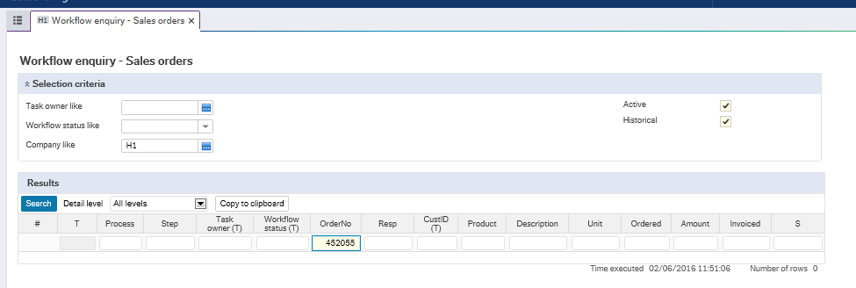

This will show a log and who the order is with (Task owner), click on the workflow status to bring up a workflow map.

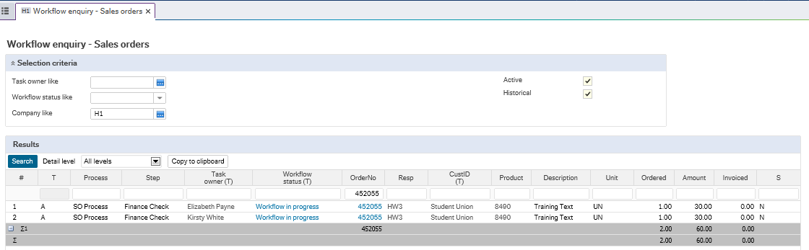

The chart below will appear and highlighted in yellow the current stage of the sales order and who it is with, green is completed stages.

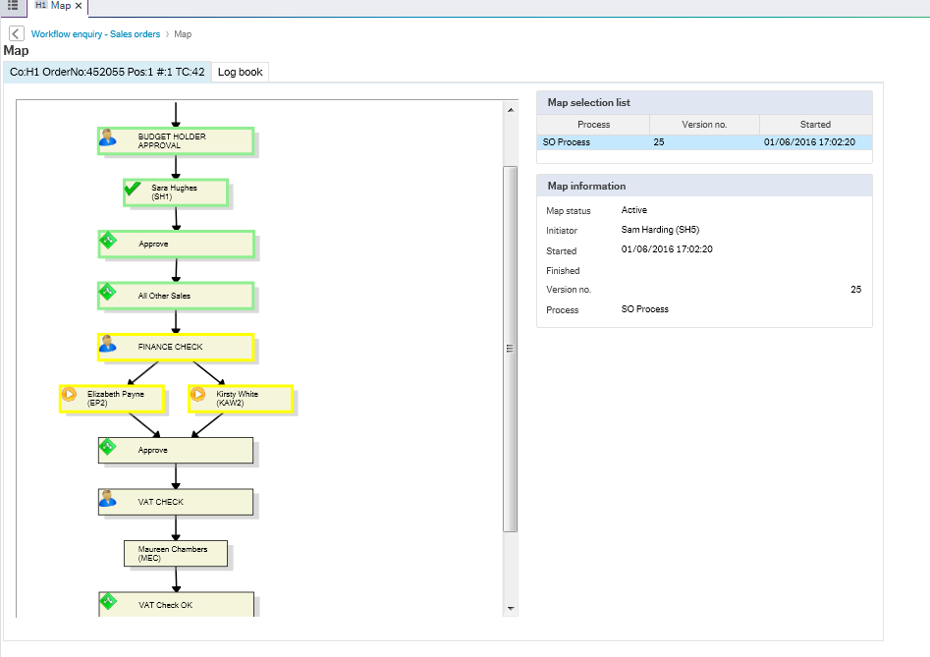

Printing Sales Orders.

Once the sales order has been approved at all 3 stages the inputter will receive an email alert advising sales order is ready to print.

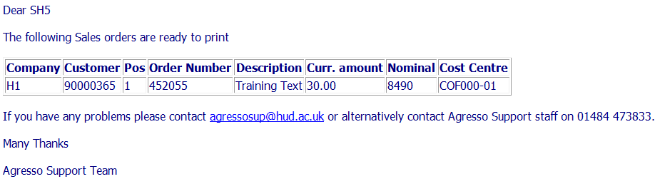

To print a sales order, you will need to log onto Unit 4 and select the following from the menu.

Common/ Ordered Reports/ report Ordering/ double click invoicing sales

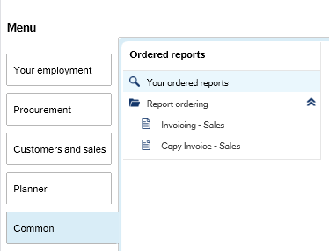

The below screen will appear, click on the variant and select Miscellaneous Invoice Print for H1.

If doing in H3 select Miscellaneous Invoice print for H3 ONLY variant and Miscellaneous Credit Note Print when generating credit notes.

You then need to enter the sales order number in the Order number from and Order number to. Then click save.

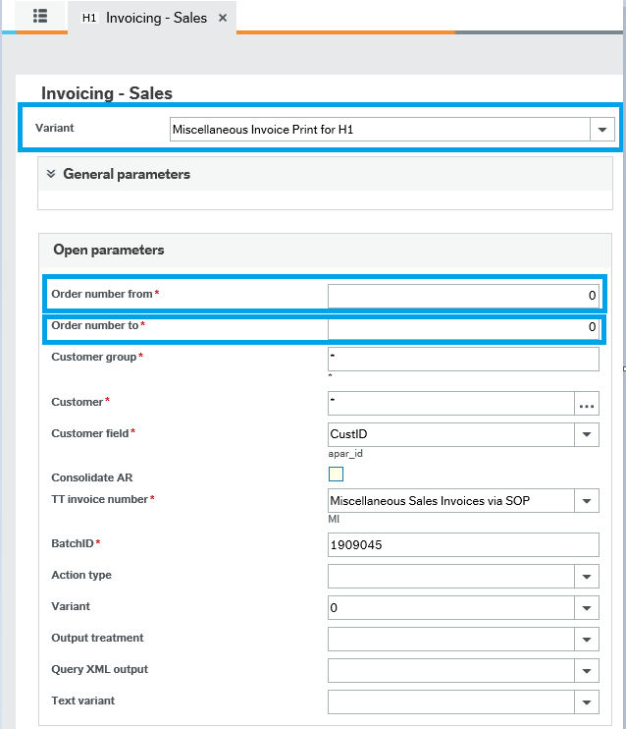

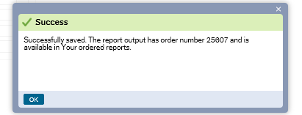

When saved successfully. You then need to go to Your Ordered Reports at the bottom of the page.

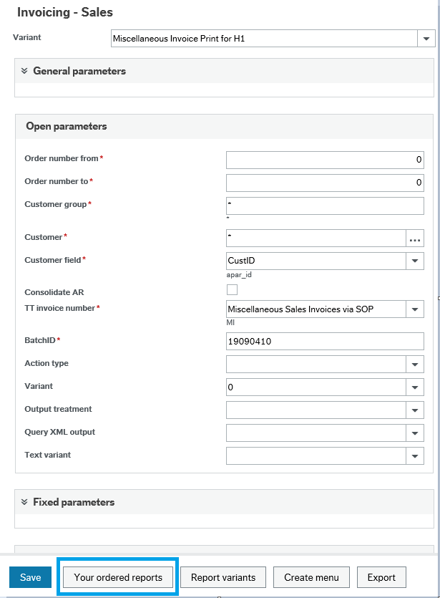

Click on the Show Report., if the file name column doesn’t have a ODF and the status isn’t finished, click refresh until the status is finished.
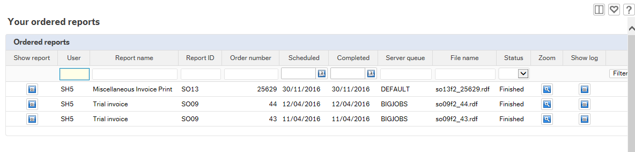
Click open

Printed invoice

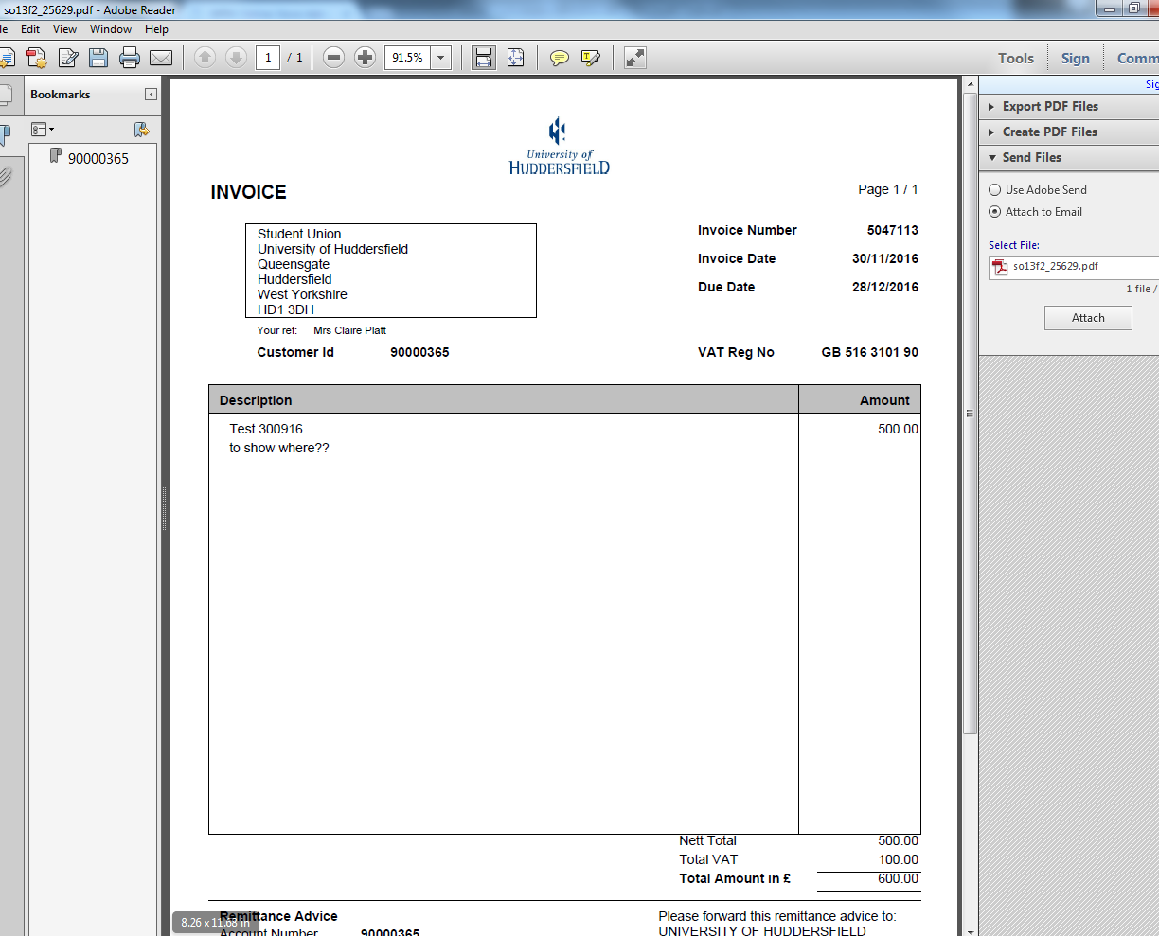

You can now send your invoice to the customer.

Approving of a Sales Order

There are 3 stages of approval for a sales order. Each task owner will receive an email notifying they have something to approve. At any stage the task owner can either accept or reject and return back to the sales person to amend.

Reject A Sales Orders

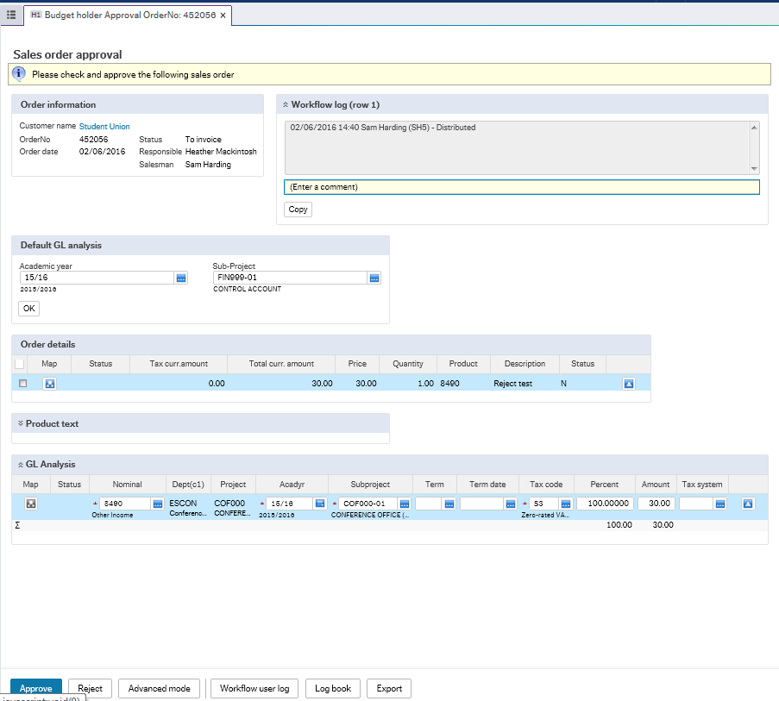

The person who rejects the order has to enter the reason and click reject

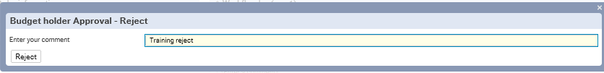

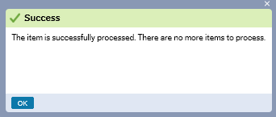

The sales order will re-enter the workflow and go back to the person who originally entered the sales order.

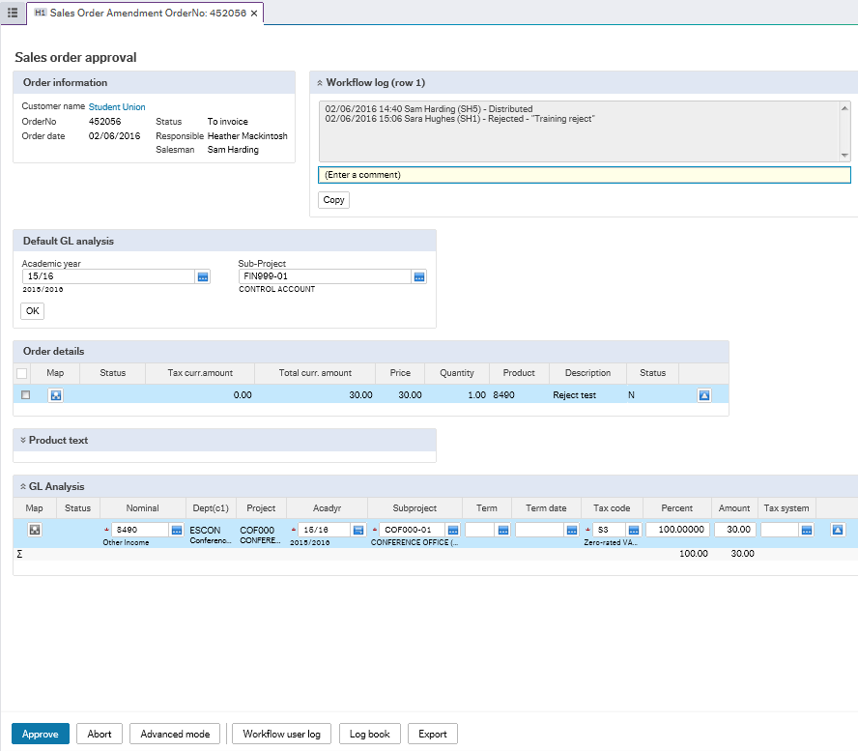
The sales person will receive an email and this will enable them to correct the errors and re submit back into workflow.

