Enquiries- Web

Training Documentation

Finance System Support
Email - FinanceSystemsSupport@hud.ac.uk

Enquiries – Web Based
Funds check by sub-project
The funds check report allows you to check whether there is enough money in the budget to raise an order. To access this it is located in the Global reports pane, within the Full picture by cost centre folder.
In Unit4 select:
Reports/ Global reports/ Full Picture by Subproject/ Funds Checking/ Funds Check by Sub Project
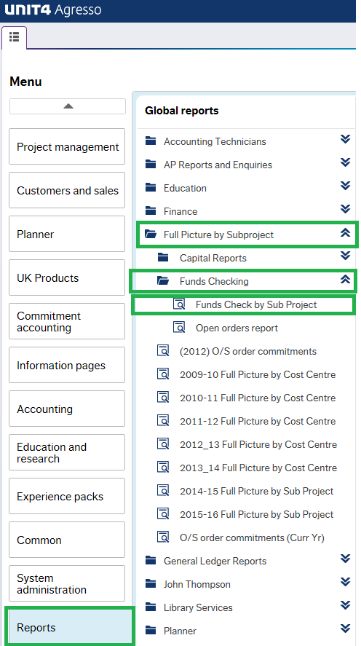

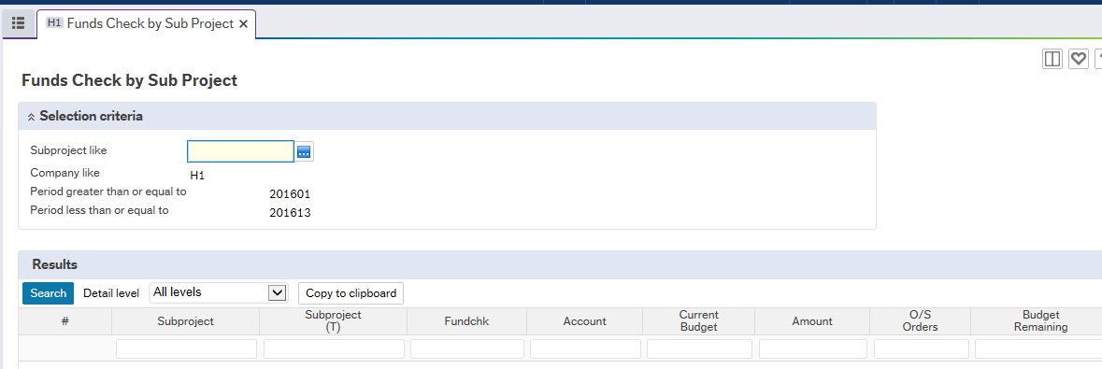Enter in the subproject you want to check and click search

Open orders
In Unit4 select:
Reports/ Global reports/ Full Picture by Subproject/ Funds Checking/ Open orders report
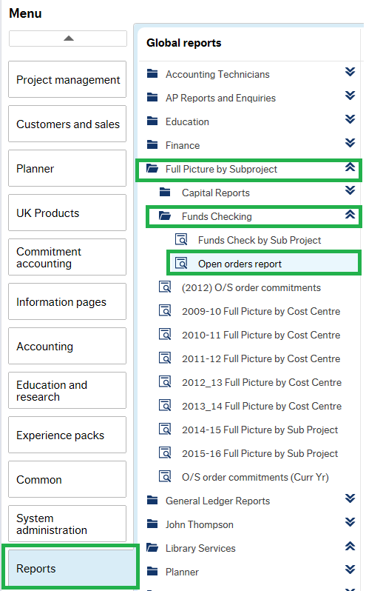

The following screen will appear, just enter the period as appropriate and click the search button.
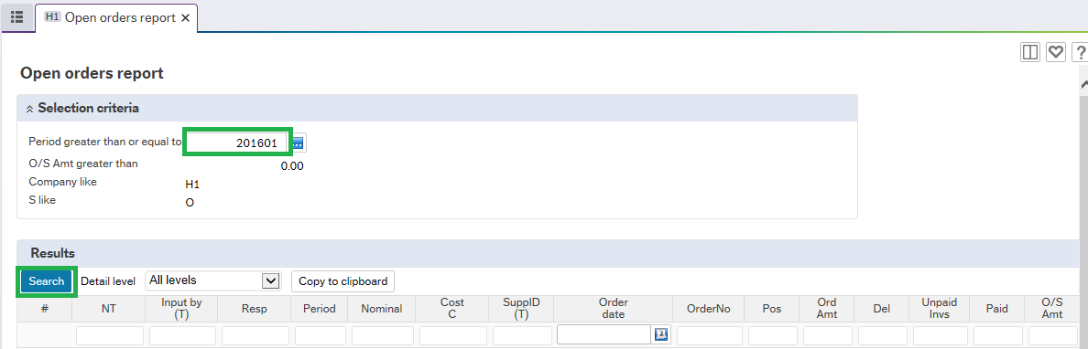

This enquiry looks at all orders with a status of ordered, that relate to this financial year.
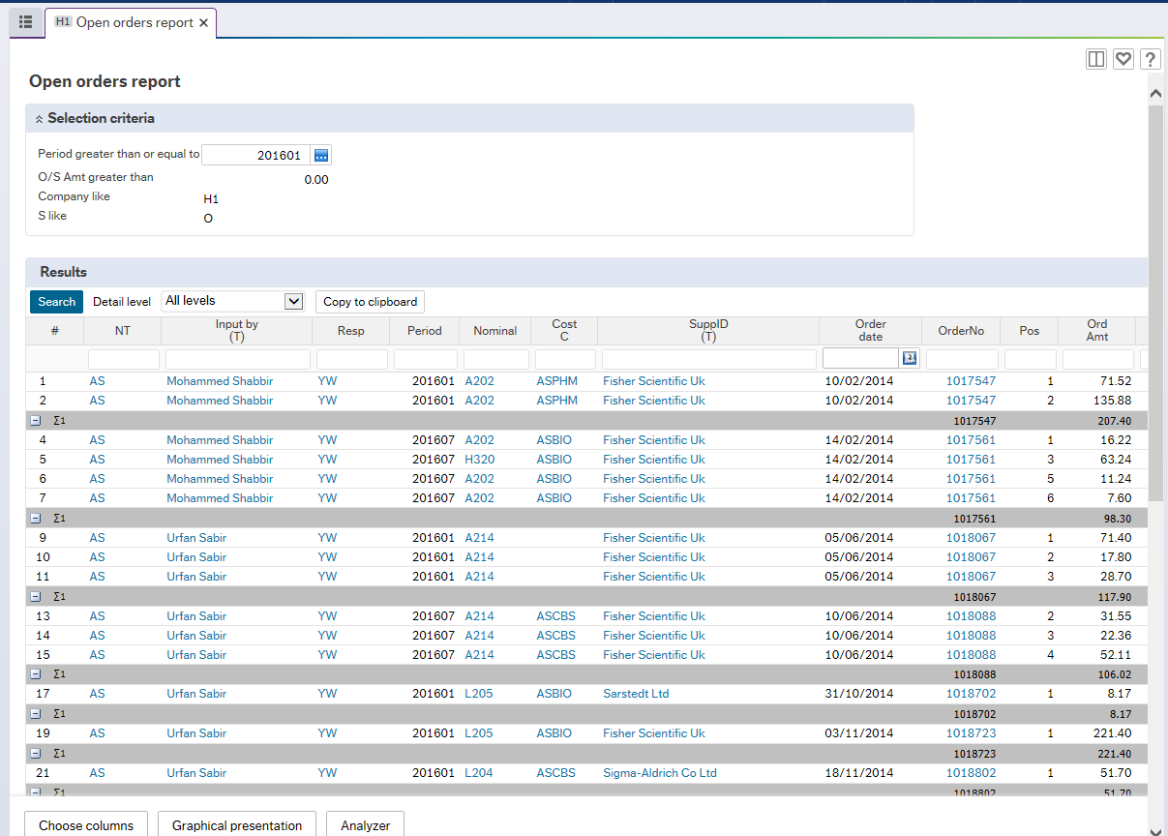

Enquiring on actual expenditure against budget - H1
In Unit4 select:
Reports/ Global reports/ Full Picture by Subproject/ 20xx – xx Full Picture by Subproject
You can access information regarding expenditure against budget via the Full Picture by Sub project enquiry under Global Reports pane. Click on the year that you wish to see the budget in.
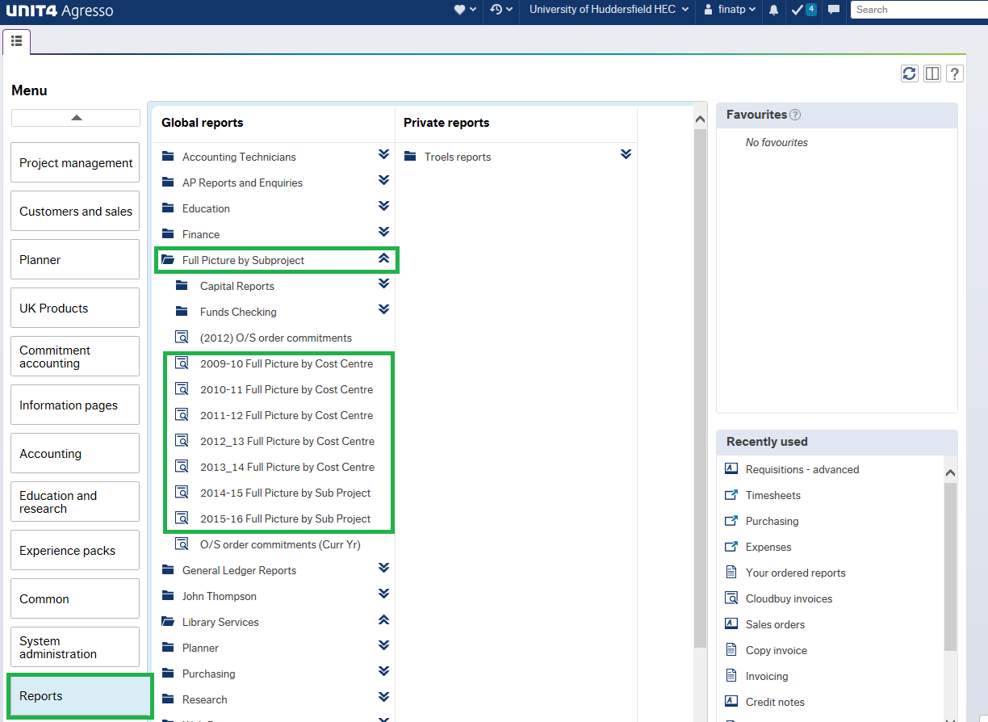
This opens up the following screen where you can enter the sub-project you want to view.
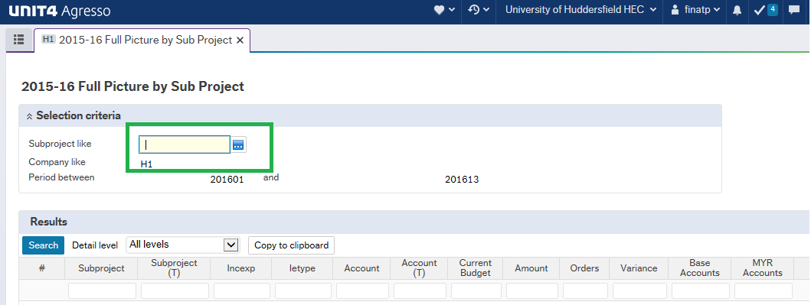
Then press the search button
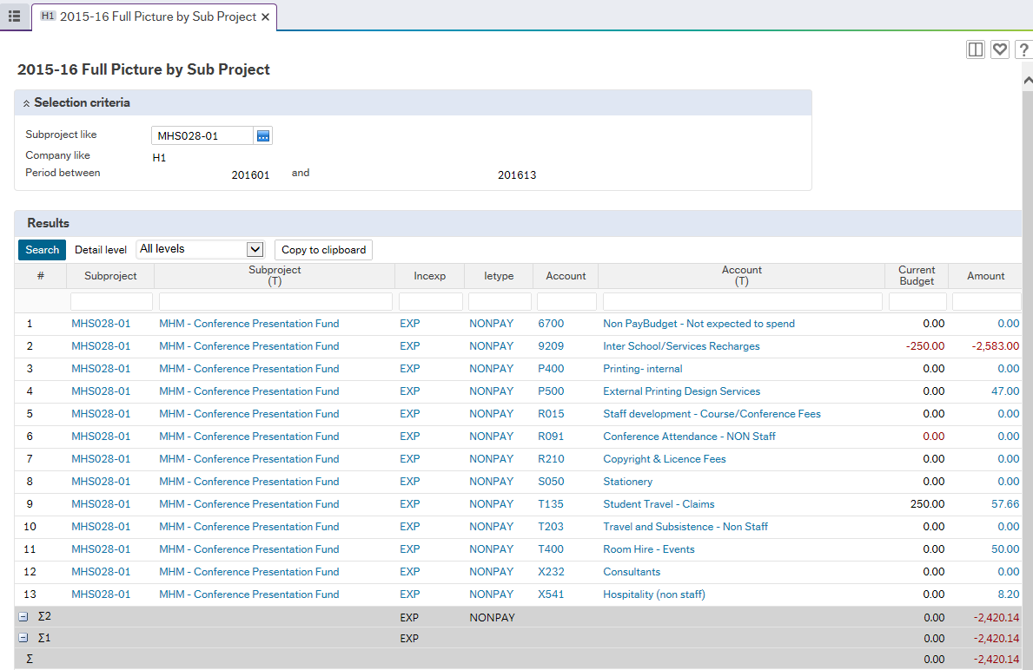

You can drill down to find out further information, by clicking on the hyperlinks.

To View if an order has been paid
In Unit4 select:
Reports/ Global reports/ Finance/ Inv pay enq by Order
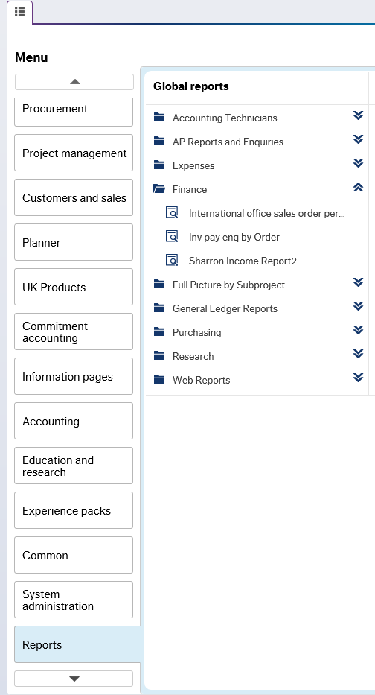

You can the search on the criteria you need to, e.g purchase order number, sub-project and periods.
*note if you require to view a purchase order from the previous financial year then remove the periods*
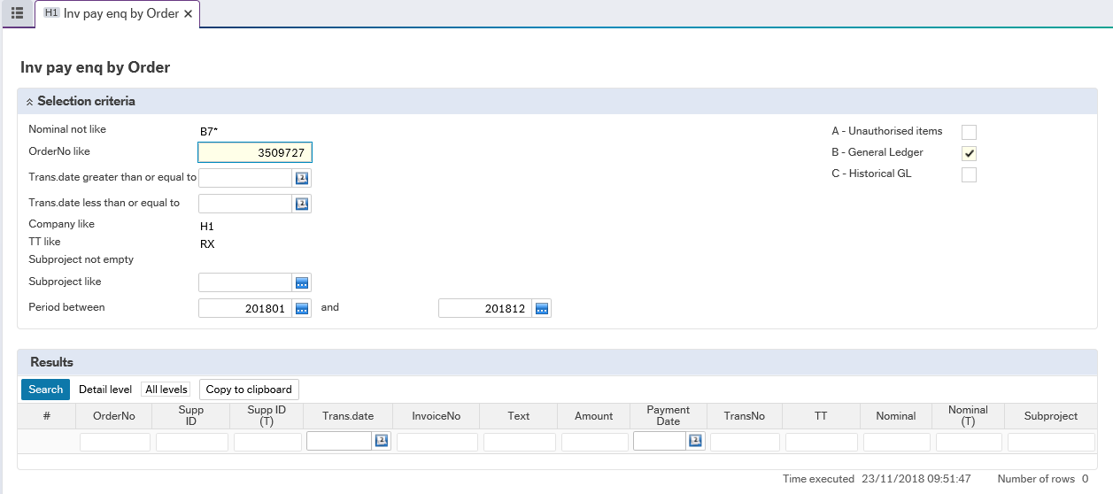
Press search
Your results will then appear
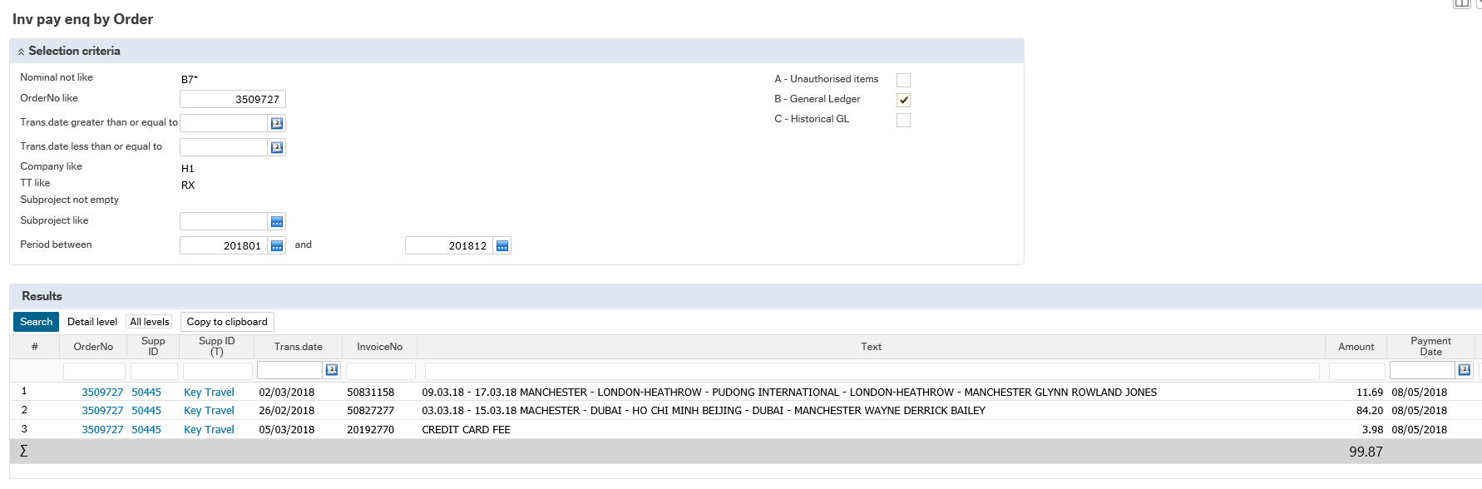
You can then drill down on any of the blue information. The results will show you the order number, supplier, invoice number and invoice text, how much was paid (including VAT) and the pay date.
To view to PO and how much it was raised for drill down via the order number
For example- below is what has been paid and pay date
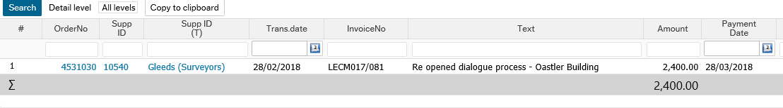
PO shows what it was originally raised for
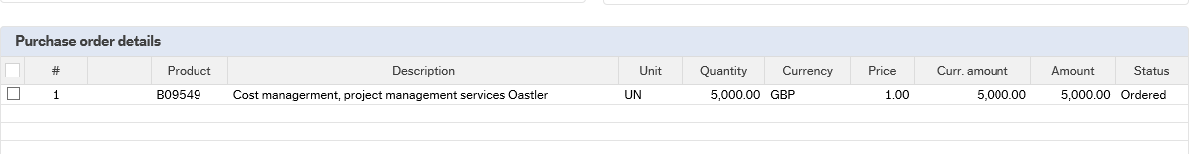

Enquiries – H3
In H3 the same reports can be found in the following location:
Reports/ Global reports/ Full Picture by Cost Centre
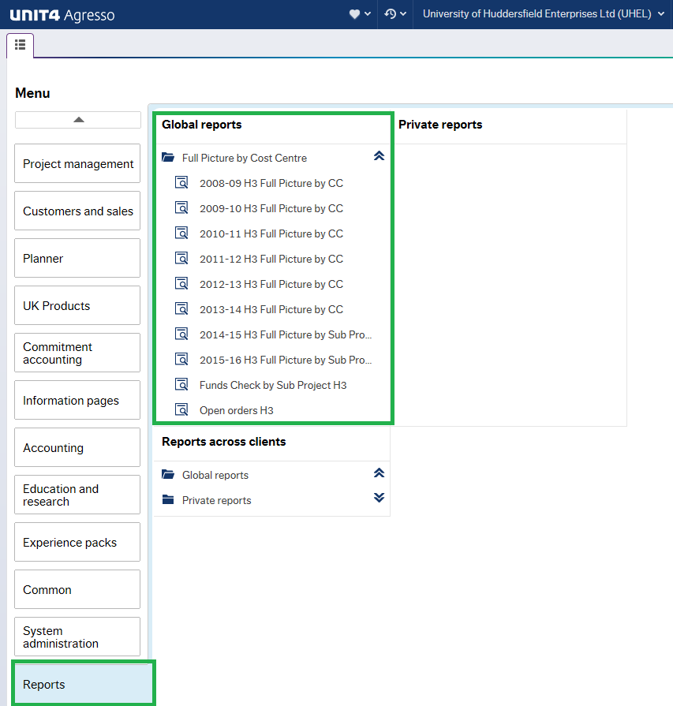

Useful Enquiries
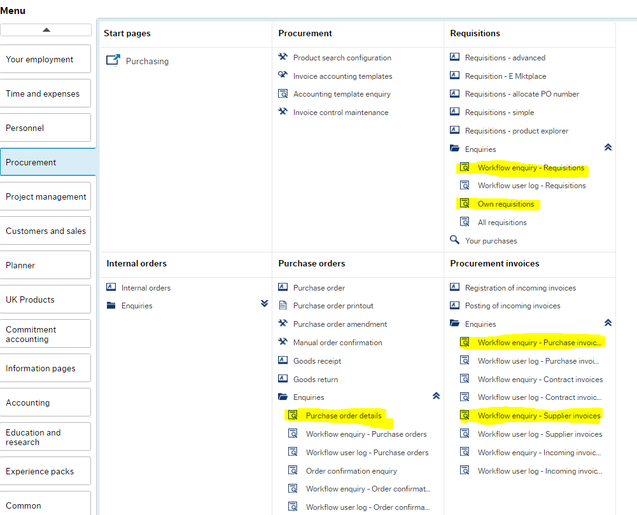
Where’s my requisition
Procurement / Requisitions / Workflow enquiry – Requisitions
What’s my requisitions – and the purchase order number
Procurement / Requisitions / Own requisitions
What is on a Purchase order
Procurement / Purchase Orders / Purchase order details
Where’s the purchase invoice
Procurement / Procurement invoices / Workflow enquiry – Purchase Invoices
Where’s the purchase card transaction
Procurement / Procurement invoices / Workflow enquiry – Supplier Invoices
What’s the purchase card transaction
Procurement / Purchase card / Purchase card transaction

