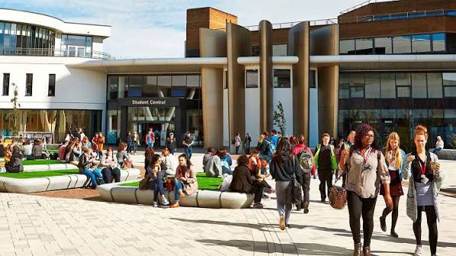
Welcome to our Equality, Diversity and Inclusion (EDI) Events Calendar 2026-2027

Our EDI Events Calendar highlights a wide range of awareness days, cultural celebrations, religious observances, heritage months and inclusion-focused events throughout the year. It has been created to help us recognise, celebrate and learn about the diverse communities, identities, experiences and perspectives that make up our workforce and wider society.
The calendar provides opportunities to increase awareness, foster understanding, and encourage meaningful conversations about equality, diversity and inclusion. By acknowledging these important dates, we can create a more inclusive environment where everyone feels valued, respected and able to be their authentic selves.

While every effort has been made to include a broad range of events and observances, this calendar is not exhaustive. We encourage colleagues to share additional dates and celebrations that are important to them so that we can continue learning from one another and building a culture of belonging for all.
Together, let's use this calendar as a tool to celebrate diversity, promote inclusion, and strengthen our commitment to equity throughout the year.

Events
We will be arranging a number of events across the coming year, working alongside the Staff Networks, our Wellbeing Team, our EDI Champions and Student Union Team bringing everyone together the celebrate our diverse community.
Should you wish to celebrate within your team or department please share with us some details to promote this or some pictures to inspire others. There are a variety of ways that you might want to celebrate, depending on your team/department, these might include:
- Hosting lunch-and-learn sessions or guest speaker events.
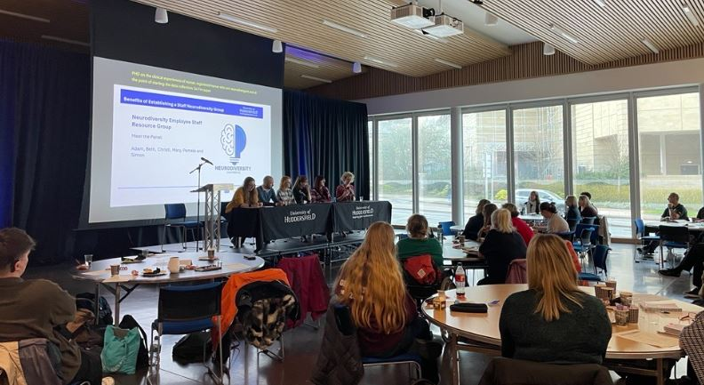
- Sharing educational resources, stories and personal experiences.
- Highlighting key dates through internal communications and social media.
- Organising cultural celebrations and awareness-raising activities.
- Promoting relevant support services, staff networks and employee resource groups.
- Encouraging colleagues to participate in discussions, workshops and training opportunities.
- Showcasing diverse role models, histories and achievements.
- Supporting fundraising or community engagement initiatives linked to awareness campaigns.
For example:
- During Black History Month, colleagues might attend heritage events, share learning resources or celebrate the achievements of Black communities.
- During LGBTQ+ History Month, teams could promote allyship, highlight LGBTQ+ voices and host inclusion-focused discussions.
These activities can help create meaningful opportunities for learning, reflection and celebration, supporting our commitment to equality, diversity, inclusion and belonging throughout the year.
We look forward to sharing more details of the events in the near future. If you have any questions or suggestions we’d love to hear from you at EDI@hud.ac.uk

