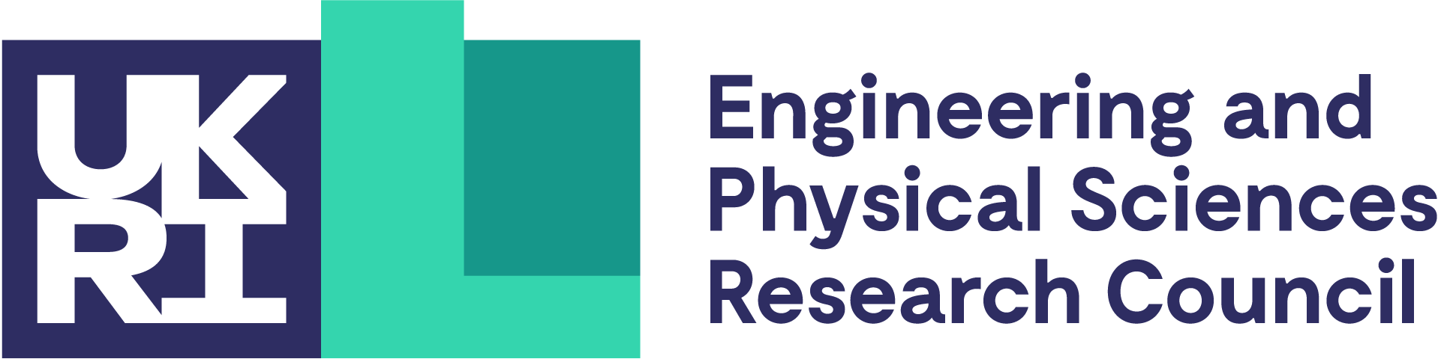

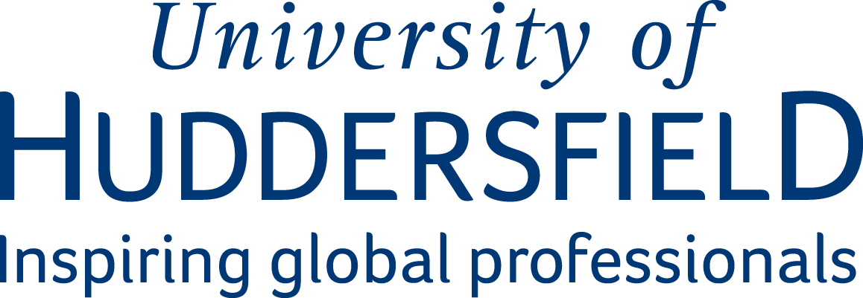

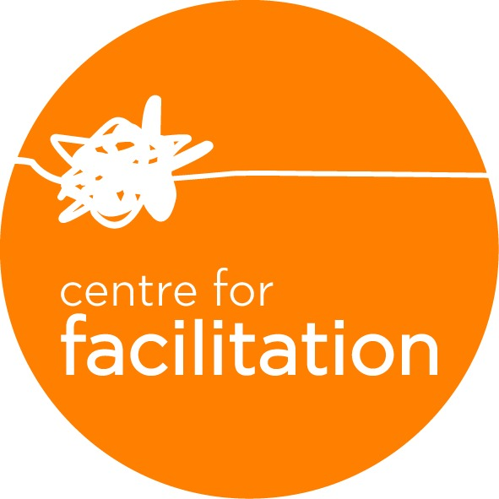
SPARK Sessions
(Supporting Partnerships And Research Knowledge)

These workshops will bring together 20–30 participants from the University of Huddersfield and relevant industry partners. Through structured, interactive sessions, participants will explore shared priorities, develop collaboration ideas, and identify opportunities that could be shaped into future bids for UKRI and other funding sources.
- This is a structured, professionally facilitated workshop.
- During the day you will shape the agenda with your expertise and interests.
- The day is designed to generate potential collaborations aligned to future funding calls.

PROGRAMME
9.30 | Arrival and Registration  There will be refreshments available and you can start connecting with others
10.00 | Session 1 | Workshop Overview and Introductions  Initial connection building and overview of workshop context and process.
 | Session 2 | Exploring UK Industrial Strategy Priorities
 | Each workshop will have 3 priorities to focus on and you will be able to share and connect current and future collaborative potential.
 | Session 3 | Opportunities for Collaboration
 | Generate collaborative opportunities aligned to Industrial Strategy Priorities
12.35 | Lunch and Collaboration Forming  Over lunch you will be able to reflect on and assess the ideas generated in Session 3 to co-design the afternoon sessions.
 | Session 4| Forming and Developing Collaborative Ideas
 | Deep dive the prioritised ideas and map ideas towards potential funding calls
Session 5 | Sharing and Shaping Ideas
A structured peer feedback session to strengthen ideas, test relevancy and identify next steps
15.15 | Workshop Close
Our room is available until 16.00 to allow space for conversations to continue.
Benefits of Expressing Your Interest
- Limited places!
- New connections across research and industry
- Develop early-stage collaboration ideas across disciplines/industries
- Clearer alignment between your ideas and priority funding themes
- Potential partners for future bids

