Employee Guide
Corporate Annual MCard online process

Release: Version 1.2c – customised by the University of Huddersfield
Date: 22/10/2018
Authors: Elida Walton (WYCA), Emily Rye / Sean Morland (UOH)

Contents
How do I order a Corporate Annual MCard on the website? 3
How do I register for an account? 4
Applying for a new Corporate Annual MCard 5
Your organisation & select a card 6
Card start date – example 6
Your details 7
Your photograph 8
Terms and Conditions 8
Review of order 9
Timescales for ordering or renewing your MCard 10

How do I order a Corporate Annual MCard on the website?

- Go to the MCard website  (www.M-Card.co.uk).  - Click on the sign in/ register button at the top of the screen  - Register for a new account, if you don’t already have one. | 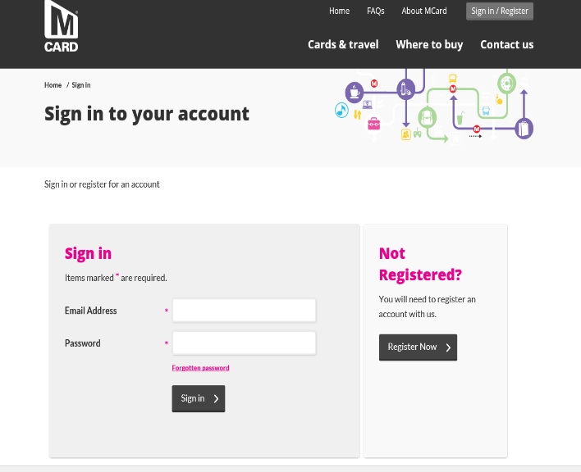  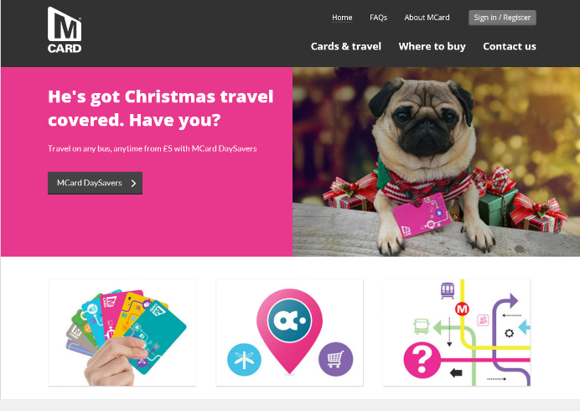

How do I register for an account?

- Complete the registration form

You must input your
- First Name,
- Surname,
- Postcode (use the post code look up to find your address),

- Date of birth,
- Email address and confirm email address
- Password (twice for confirmation).
- Read and accept the Privacy Statement

Then click Register button. –
NOTE –
- The password should be eight characters or more, and should include at least one number and one upper case (capital) letter.
- First Name, Surname and DOB cannot be changed online once entered. If these fields require changing the Employee will need to go to a Travel Centre with proof of the change

Applying for a new Corporate Annual MCard

- Click on Apply for a Travel Card

What the Icons Mean
- Apply for a Travel Card – this will show you what type of cards you are able to apply for (age related) This is where you will apply for your Corporate Card
- Manage Travel Cards – this is what cards you have (live cards) and if you are able to replace or renew
- Update Account Details – you can amend your details here i.e. change of address
- Register a dependant – this is if you have a family member who is eligible for a pass i.e. a parent who is entitled to a senior pass, or a child who requires a school bus pass, you can order one for them on their behalf

- Cards For Me - this shows all the cards you are eligible to apply for

- Click on Apply for Corporate Annual

Your organisation & select a card

- You must input your
- Staff ID/Payroll Number – this is the first seven digits from your staff card, beginning with 7
- Organisation reference number – this is UNI7
- Organisation Name - University of Huddersfield
- Select the right ticket type (use the zone map link to check you have selected the right ticket type)

- Click Next

NOTE
- All fields are mandatory and incorrect information will lead to a delay in approving your application.

- If you get an error message, then check the right Organisational reference number and Name has been entered or speak to your Co-Ordinator.

Card start date – example

- Please ignore any application deadlines given on the MCard website. The University deadlines follow the pattern below.

Apply between  1st – 30th November | Your card will start  1st January
Apply between  1st – 31st December | Your card will start  1st February

Your details

- The application details will be pre-populated with the information already entered at registration

- The address shown is your home address.

- The delivery address should also be your home address – tick Yes if this is not already ticked

Click Next

Your photograph

- Click on Browse to find the photo.(you will need to have a photo stored on your device)

- Ensure that the photo is a full-face passport quality photograph and no more than 12 months old

- Use the edges of the rectangle to zoom in so that the face is clearly visible

- Click next once the photograph is correct.
NOTE - If an unsuitable photo is used it can result in your application being rejected

Terms and Conditions

- Read and accept the terms and conditions  - Then click Next  NOTE – these Terms and Conditions  are in addition to the agreement that  you will sign with the University of  Huddersfield for payment of your MCard  Review of order |  |  | New image needed
- The order review screen will show and confirm the delivery address

- If the details are correct click the next button
- Use the back button if you need to change any details

Confirmation

- .A confirmation web page will then be displayed and the application will be sent to your co-ordinator for approval.

- You will also receive confirmation of the application via email

Timescales for ordering or renewing your MCard

Worked example for a 1st January start

Employee – applies for MCard more than one month before card required or current card expires | Between 1 – 30 November for 1 January start
University coordinators – run validation checks and approve applicant on MCard website | By 11 December
Metro - financial check/approval | 12-18 December
Metro - produces card and posts first class to employee’s home address | By 23 December
Employee - receives card | By 31 December

