Pool Cut-Off Dates
As a general rule, first schedules need to be added to the Pool system by the 7th and accepted by the 14th of the month for payment that month. Please ensure that you check the Pool system (Report 133, which can be accessed by clicking on the pie chart at the top of the page in the Pool system) to confirm these dates:

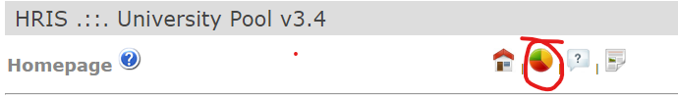

This is especially important where they may fall on a weekend or bank holiday, as cut-off dates will be earlier.

