Confirm Student Progression (CSP)for Research
User Guide
ASIS Support:
ext 2255
asissupport@hud.ac.uk
ASIS Support

Table of Contents

Title Page

Definitions 2
Introduction to the Confirm Student Progression (CSP) process 3
Stages of the CSP process 4
CSP process: Calculate progression - Multi-coloured arrow icon 4
Confirm Progression: Blue Tick 9
Appendix 1: CSP’ing Students enrolled on non-standard year courses 11
Appendix 2: Generating Student Progress Information (SPI) records - reference/context only 12
Appendix 3: Common CSP Problems and Solutions 14
Appendix 4: Progression Information Type (PIT) Code 15
Quick checklist: Calculate progression - Multi-coloured arrow icon 16
Quick checklist: Confirm progression - Blue tick 17

The above titles are hyperlinks – hover over the title you want to select and Ctrl+Click to it.

Definitions
CSP  (Confirm Student Progression) | Set of screens used to progress students to the next / final year of study or to award the student.
SCJ  (Student Course Join) | Screen used to record details of each course attended
SCE  (Student Course Enrolment) | Screen used to record details of each enrolment confirmed.
SPI  (Student Progression Information) | Screen used to record details of progression for each course.
SPR  (Student Programme Route) | Screen used to record details of the particular route and award.
SAW  (Student Award) | Screen used to record details of the award obtained.
PIT Code  (Progression Information Type) | The progression code applied to students as a result of the progression process

Introduction to the Confirm Student Progression (CSP) process

The Confirm Student Progression (CSP) process is used to:

- progress students to the next or final year of their study and
- to award the student.

As the majority of Research courses are non-standard year courses ie courses that span across 2 academic years, the CSP process takes place twice a year:

- once in June/July to progress students to the next academic year eg from occurrence 1A to 1AE, 1J to 1JE, 1U to 1UE.

- once on the anniversary of students’ enrolment eg each September, January, July etc to progress students to the next occurrence eg 1AE to 2A, 1JE to 2J to 1UE to 2U. This allows students to re-register for the next year of study.

NB: The CSP process on the anniversary of enrolment is only used for courses of more than one year in duration. See Appendix 1 for an example of a typical Research non-standard year course plus a table showing non-standard year blocks/occurrences

DATA QUALITY NOTE

The CSP process relies on the data from 4 key screens being linked and matched correctly.

These 4 screens are: Student Course Join (SCJ), Student Course Enrolment (SCE), Student Programme Route (SPR) and Student Progression Information (SPI). Data from these screens used in the CSP process includes Student number, Course code, Academic year, Block and Occurrence codes, Award and Award year and Batch code.

Issues may arise with the CSP process if data in the SCJ, SCE, SPR or SPI screens are mismatched or linked incorrectly.

The CSP process also updates/generates data in other screens. For instance, it will automatically update data within the Student Course Enrolment (SCE) screen and, if it’s the final year of study the Student Award (SAW) screen.

The data contained within some of these screens is used to compile data returns to external agencies such as HESA or generate data for students’ final certificates. It is essential, therefore, when inputting, updating and/or processing data contained within ASIS that it is checked for accuracy to avoid issues with processes/data returns/printed materials at a later stage.

Stages of the CSP process

The 3 stages of the CSP process are shown in the table below:

Icon used to generate the SPI records (see Appendix 2 for more information)
(commonly known as Red jumper man)

Icon used to calculate the progression records
(commonly known as multi-coloured arrow / stripy arrow)

Icon used to confirm the progression of records.
(commonly known as Blue tick)

NB: The award stage is conducted by Registry.

CSP process: Calculate progression - Multi-coloured arrow icon

The following instructions relate to the CSP process for continuing students – students who are progressing from one year of study to another eg 1A to 2A etc. The CSP process for final year students eg students who are to be awarded, will be conducted by Registry.

The CSP process calculates an ‘Actual’ progression (PIT) code and inserts it on the SPI record. The ‘Actual’ progression code is calculated in ASIS as a result of reading students’ data and is used for processing progression.

To progress students (all levels of study):

- Open CSP. The opening menu displays all the relevant process buttons that may be used when progressing students. Click on the Multi-coloured arrow icon to view the processing screen.

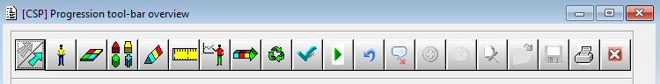

- On the processing screen check the Year is the correct academic year and enter the criteria relevant to the students you are wanting to CSP eg the Route, Batch and/or Course codes, the Block/Occ codes.
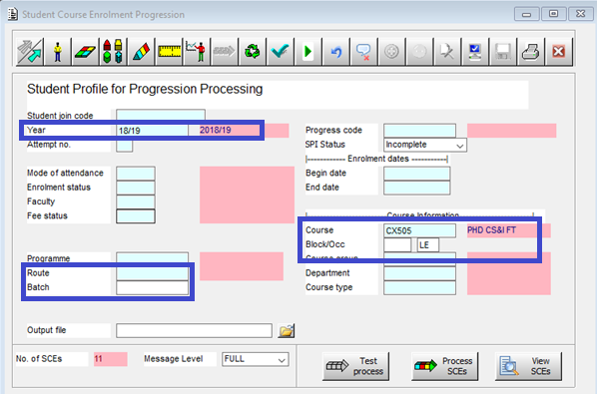

- Check No. of SCEs field at the bottom left of the screen to confirm the number of SCEs that are being processed represent the number you are expecting to process.
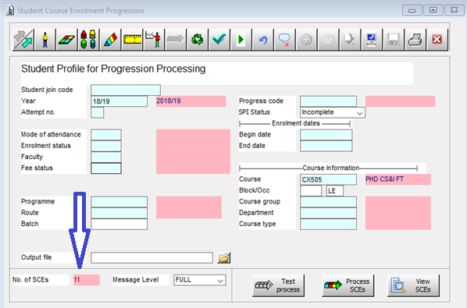

NB: You can process single student using the Student join code (SCJ) and relevant course information.

- Click on the View SCEs button.

- The relevant students will be displayed on the left hand side of the screen in the Available SCEs section.
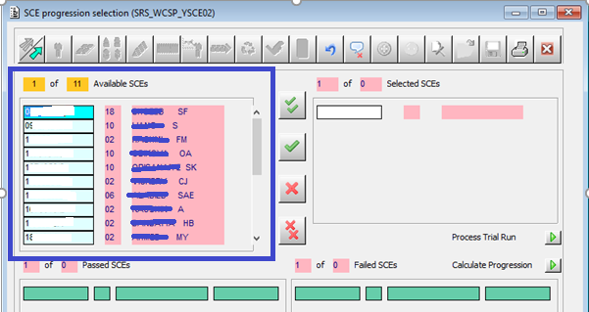

- Select the SCEs to be processed by using the green tick buttons.
The two ticks button will select all the SCEs.

The one tick button will select the highlighted SCE only.

The selection will then move to the right hand side of the screen under Selected SCEs.
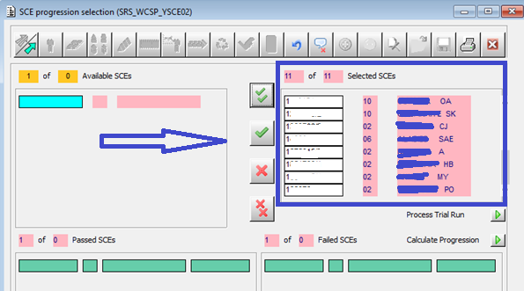

NB: When the records appear they are listed by student ID number. However, they can be sorted by surname which can be useful if you have many students on a particular route/year and need to cross-reference them against any printed lists, etc. Ensure the cursor is on the first surname in the list and from the menu bar, use the Misc dropdown menu and select Sort.

- At this point you can use the Process Trial Run green button to check if the progression rules are working as you expect. SPI records will not be updated by this process and the SAW record will not be created.

- Once you are happy with your data click on the Calculate Progression green run button to run the process.

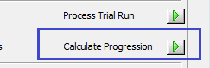

- All SCE records with an ‘active’ status (this will include ‘XC’ ‘Current debtors’) should drop down to the bottom of the screen and show the Actual PIT code eg ‘Progress’. The SCEs that show in the Passed SCEs section have passed the progression process and met the progression rules. The SCEs that show in the Failed SCEs section have failed the progression process because they have not met the progression rules applicable to the course eg inaccurate or incomplete data showing on related records.

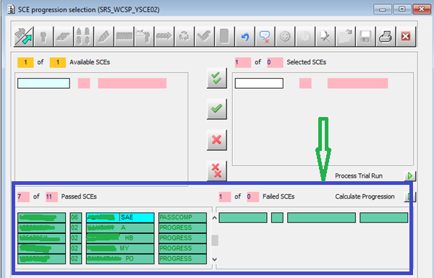

- Close the table using the Red cross on the end of the tool bar

DATA QUALITY NOTE:

Only SCE records with an enrolment status of C or XC will drop down to the bottom of the screen

Records with an enrolment status of W, S or T (Withdrawn, Suspended or Transferred) will not drop to the bottom of the screen.

If a record fails to drop and the enrolment status is C or XC it is probably due to inaccurate or incomplete data showing on other related records. These records will need to be carefully checked when investigating why the progression hasn’t worked.

Form Messaging icon – clicking on the SCE number to highlight the SCE you want to check and then clicking on the Form Messaging icon will give you information as to why that record has not progressed. Common problems for records failing to progress are shown on Appendix 3 of this document together with possible solutions.

Confirm Progression: Blue Tick
=

- Click on the ‘Blue tick’ icon to open the screen. Enter the same route and/or course information block/occurrence for the students as used to calculate progression (multi-coloured arrow icon) and Retrieve using the file icon on the right.

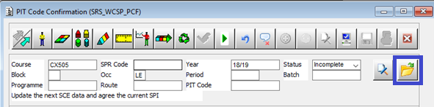

Once the data is retrieved you will be able to overwrite the displayed PIT codes using Agreed PIT codes. To show the list of valid PIT codes, delete the current code showing in the Agreed PIT field and then double click in the field, a pop up window will show the current available codes and their meanings. You can then select the relevant PIT code from this list.

The PIT codes used when processing Research students are mainly (but not exclusively) PROGRESS, NSYPROG, REPEAT See Appendix 4

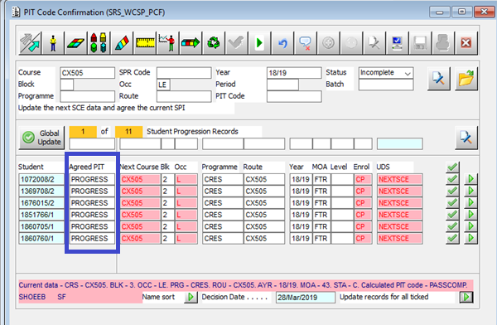

- Click the top Green tick to select all the students to be progressed. Click the Green tick button at the end of each row if you are wanting to progress individual students.

- Enter the date in the Decision Date field.

- Click on the green run button at the bottom right to update all the ticked students’ records

The processed records will disappear.

DATA QUALITY NOTE:

If any records remain it is probably due to inaccurate or incomplete data showing on this screen or other related screens. Data held in the key screens relevant to processing students’ progression (SCJ, SCE, SPR, SPI) should be carefully and methodically checked when investigating why the progression hasn’t worked.

At this stage you must also check the retrieved data is showing correctly as some of this data will populate/inform the next SCE record. On occasion the Level code can often be missing (ie D for Doctorate; M for Masters) so will need to be added either by ‘Global Update’ for all students or manually for individual students. Additionally, the mode of attendance (MOA) may need amending, for instance if a student is entering the writing up period.

Non-standard Year progression

Non-standard year progression takes place in July of each academic year for all occurrences. The PIT code to use will always be NYSPROG. It may pre-populate with DECDEF this will need changing to NSYPROG (non-standard year progression). Any omissions with regard to the Level code will need to be updated before the process will complete.

NB: Students entering the writing up period will need to have the mode of attendance updated to reflect this when CSP’ing takes place.

Modes of Attendance applicable to Research students

FTR | Full-time
PTR | Part-ime
STR | Staff
43 | Writing up (full-time)
44 | Writing up (part-time)
44S | Writing up (STR – staff)
64R | Dormant (part-time)

Appendix 1: CSP’ing Students enrolled on non-standard year courses

The majority of Research courses are non-standard year courses (ie structured to span 2 academic years) which means the CSP process is carried out twice a year - once in/around June/July and once on the anniversary of the enrolment eg January, September, etc.

Below is an example of the CSP process stages for a typical PhD 3 year course with a January enrolment code.
Year of study (Block and occurrence) | Academic year - Start and end dates | Progression - CSP
1J | 2018/19  13 January 2019 (start date shown on CBO) to 31 July 2019 (end date shown on CBO) | CSP in JULY – to non-standard year NSYPROG
1JE | 2019/20  1 August 2019 (start date shown on CBO) to 13 January 2020 (end date shown on CBO | CSP in JANUARY – to next year of study PROGRESS
2J | 2019/20  13 January 2020 (start date shown on CBO) to 31 July 2020 (end date shown on CBO) | CSP in JULY – to non-standard year NSYPROG
2JE | 2020/21  1 August 2020 (start date shown on CBO) to 13 January 2021 (end date shown on CBO) | CSP in JANUARY – to next year of study PROGRESS
3J | 2020/21  13 January 2021 (start date shown on CBO) to 31 July 2021 (end date shown on CBO) | CSP in JULY – to non standard year NSYPROG
3JE | 2021/22  1 August 2021 (start date shown on CBO) to 13 January 2022 (end date shown on CBO) | CSP in JANUARY - to REPEAT final year OR to REPEAT final year when, for example, entering the writing up period.

NB: Registry conduct the award stage of the CSP process.
Month | Occurrence | ‘Extension’ occurrence |  | Month | Occurrence | ‘Extension’ occurrence
January | J | JE |  | July | U | UE
February | F | FE |  | August | T | TE
March | M | ME |  | September | A | AE
April | L | LE |  | October | O | OE
May | Y | YE |  | November | N | NE
June | E | EE |  | December | D | DE

DATA QUALITY NOTE:

Students progressing on a non standard year will have SCEs showing the standard occurrence code eg A, J, U, etc and the ‘extension’ (*E) occurrence code eg AE, JE, UE etc. This means with the exception of the first and last SCEs there will be 2 SCEs for each academic year (see example above).

CSP’ing on the anniversary of students’ enrolment will generally populate the Agreed PIT code with ‘PROGRESS’. CSP’ing in June/July will generally populate the Agreed PIT code with ‘DECDEF’. However, in both cases these ‘Agreed’ PIT codes can be overridden.

Return to document (App1)

Appendix 2: Generating Student Progress Information (SPI) records - reference/context only

The following explanation of how the SPI records are generated and updated is for reference and context only. It is NOT ordinarily part of the process for administrators when CSP’ing students’ records

Student Progress Information (SPI) records are generated by the ASIS Support team throughout the year.

The SPI record is the key student record for the CSP process to run and needs to be created before the process can be run. The process will not run without a relevant SPI record. The SPI record shows the outcome of the progression process and therefore there will be one SPI record per progression “point” or assessment period. For non-standard year courses there can be 2 SPI records per academic year eg one for the non-standard year progression (usually July) and one for the anniversary of the enrolment progression (eg January, September, etc).

Check SPI record to determine CSP process stage

- Click on the Red Jumper Man to access the screen that shows the current stage of the CSP process.

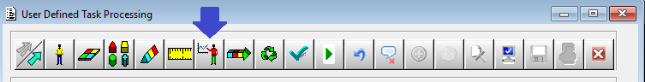

You can check individual students by entering the SPR code or groups of students by entering either route, course or batch code.

The relevant fields to check are ‘Status’, ‘Actual progression’, ‘Agreed progression’ and ‘Decision date’ – see screen shot below.
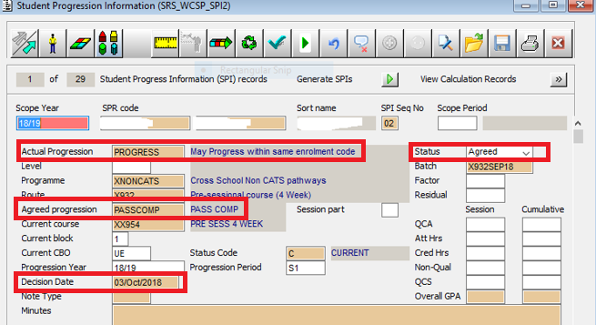

A brief explanation is given below to show each stage of the CSP process and which fields will show what details:

The SPI record has been created and the CSP process has not been started – the fields will display as follows:

Actual Progression = Blank
Status = Incomplete
Agreed progression = Blank
Decision Date = Blank

The SPI record has been created and the stripy arrow process in CSP has been completed – the fields will display as follows:

Actual Progression = should show relevant PIT code eg PROGRESS
Status = Incomplete
Agreed progression = Blank
Decision Date = Blank

The SPI record has been created and the blue tick process in CSP has been completed (after the CAB) – the fields will display as follows:

Actual Progression = should show relevant PIT code eg PROGRESS
Status = Agreed
Agreed progression = should show relevant PIT code eg PROGRESS or NSYPROG or PASSCOMP
Decision Date = Date of the CAB

Return to document (App2)

Appendix 3: Common CSP Problems and Solutions

TIP Start by checking the Message Button (F9) which will provide details of why the process hasn’t worked as expected.

PROBLEM |  | SOLUTION
Not appearing in View SCEs | The data on the SPI record may be incorrect – eg data does not match the SCE data (academic year, status, course code, route code, programme code, etc); the status is incorrect.  There may not be a relevant SPI record. | Contact ASIS Support team if the SPI record needs to be deleted and regenerated. Or, generate a SPI record if there isn’t one.
Staying top right though active SCE status | The student may have transferred to a different course/route since the SPI record was generated.  There may be a mismatch of data on the SPI, SCJ, SCE, SPR eg course code, mode of attendance, route code, award, programme code, etc.  The current SCJ may not be linked to the current SPR. The student may have transferred back to their original course eg transferred from SCJ /1 to /2 then back to /1 | Contact ASIS Support team if the SPI record needs to be deleted and regenerated  Contact Student Records team to make amendments to the relevant SCJ or SCE records
No change to academic year | No current CBO for the occurrence and academic year | Contact Data Returns team to create relevant CBO record

Return to document (App 3)

Appendix 4: Progression Information Type (PIT) Code

NB: The purpose of the PIT code is to denote the outcome of passing or failing the progression rules. The calculated PIT code is assigned to the Student Progression Information (SPI) record once the initial progression process has run (multi-coloured arrow stage). The agreed PIT code is determined at the Confirmation stage (Blue tick stage).

PIT CODE | FULL NAME | POPULATED BY SYSTEM FOR: | COMMENTS
PROGRESS | May Progress | Students continuing to next block in following academic year and have passed all progression points and the funding rules | Can only be used where student is progressing to same course/route or to a different route within the same enrolment code
PROGRESSXF | May Progress Transfer to a different course code | Students continuing to next block in following academic year but transferring to a different course code | An override to be used in place of PROGRESS where student is transferring to another course
DECDEF | Decision postponed | Students who do not pass certain progression rules will be left as ‘Decision postponed’ unless there is a ‘Fail’ outcome in the rules. These students have passed the funding rules | Cannot be used as a confirmed progression outcome. Provisional progression outcome only
NSYPROG | May Progress, student on non-standard year | Students partway through a non-standard year (eg January, April, July, etc) who just need to be progressed into the next academic year | Should not be overwritten at stage of ‘agreeing’ progression unless student has completed year of study in accelerated time period.
REPEAT | May Not Progress but able to repeat year | Students who are allowed to repeat the year | Includes writing up period.
PASSCOMP | Pass Completed | All Students on final block of course who pass both the academic and funding rules | Used by Registry only to agree Student Award and classification. Can also be used if making an award for a dormant student.
Return to document (App 4)

Quick checklist: Calculate progression - Multi-coloured arrow icon

- Click on the Multi-coloured arrow.

- Enter the route and/or course information for the students to be processed

- Check the number of SCEs which appears in the No of SCEs field at the bottom left of the screen is what you are expecting.

- Click on the View SCEs button.

- The relevant students will be displayed on the left hand side of the screen in the Available SCEs section.

- Select the SCEs to be processed. The two ticks button will select all the SCEs; the one tick button will select the highlighted SCE only.

- Click on the green run button to Calculate Progression.

- The SCE records should drop down to the bottom of the screen. (Records that will not drop to the bottom of the screen include inactive students, eg withdrawn, suspended.)

- The SCEs that go into the two SCEs section at the bottom of the screen have been processed. Failed means that they have not gained enough credits to go to the next year, not that the CSP process has failed.

If the record doesn’t drop down and remains in the Selected SCEs section (and the student is an active student) you need to investigate why the progression hasn’t worked. A good place to start is clicking onto the SCE number field to highlight the SCE you want to check and then clicking on the Form Messaging icon to view the message buffer.

Quick checklist: Confirm progression - Blue tick

- Click on the Blue tick

- Enter the route and/or course information for the students to be processed and Retrieve. (When retrieving students to process through Blue Tick, ensure that you retrieve them in the same way you previously retrieved them to make sure you get the exact same students.)

- Overwrite any displayed PIT (progression) codes in the Agreed PIT column that needs to be overwritten. Enter any extra course detail if required, eg level.

- Select the students to be progressed by selecting the tick option in the button at the end of their row of information.

- Enter the date of processing in the Decision Date field.

- Click on the green run button by the student to run each student individually or click on the green run button at the bottom right for all the ticked records.

- The processed records will disappear.

If records do not disappear you need to investigate why the progression hasn’t worked. In some instances, this will be because the PIT code used is a non-progression code eg. DECDEF.

NB: Registry conduct the award stage of the CSP process.

