E-Vision

The University of Huddersfield
Student Maintenance



STUDENT MAINTENANCE via E-VISION

1 ACCESS ‘MY STUDENTS’

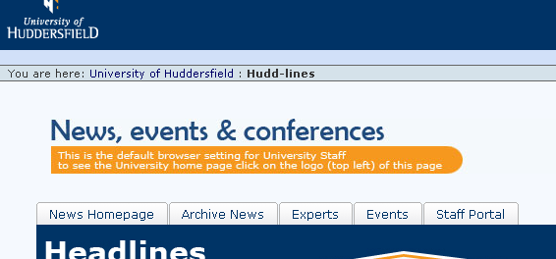
Access My Students via the Staff Portal on Internet Explorer

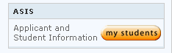
Select New Method
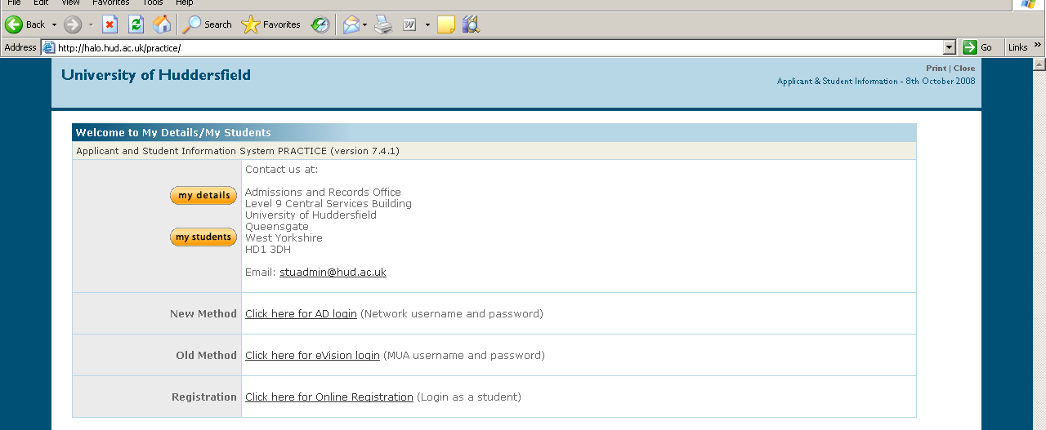

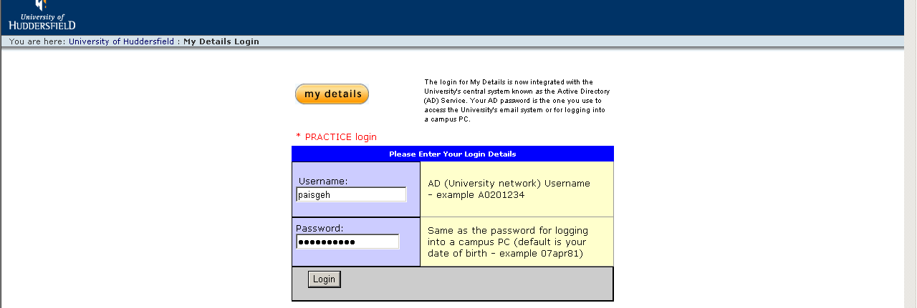
Login – using network Username and Password

2 STUDENT MAINTENANCE PROCESS

Select:

a) SMP (Student Maintenance Process) Status Change

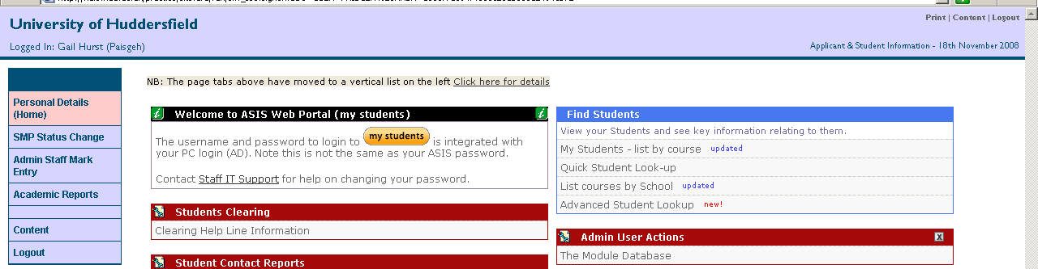

b) Initiate Student Status Change

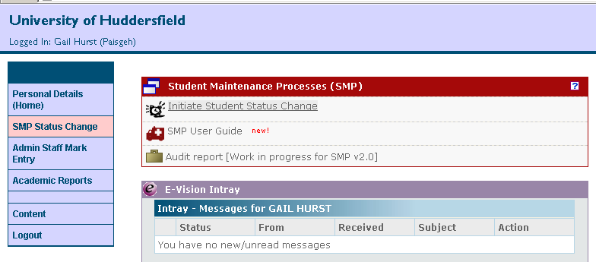

c) Add SPR (Student Programme Route), eg 1234567/2.

0559798/2
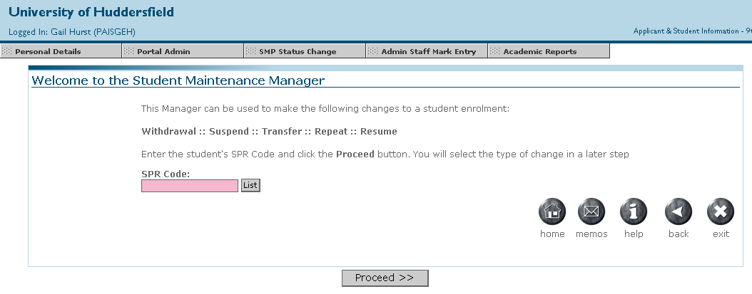
Add SPR code, click List and
Proceed

If SPR not known, enter code followed by * (eg 1234567*) to bring up all records for that student.

If student has more than one SPR, the following screen will be displayed.

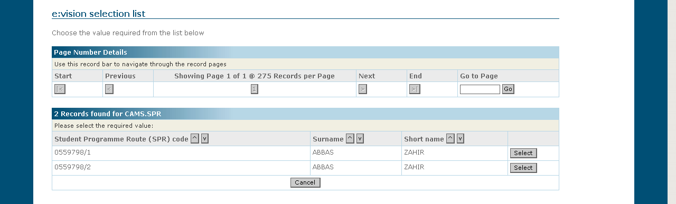
Select correct SPR to amend

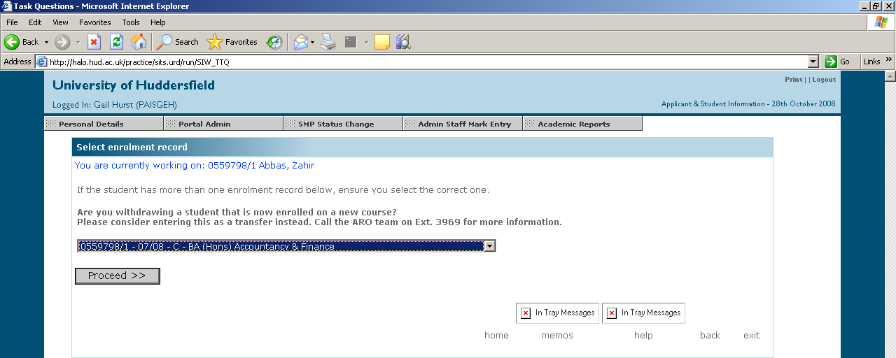

Click Select Record and Proceed

3 SELECT PROCESS

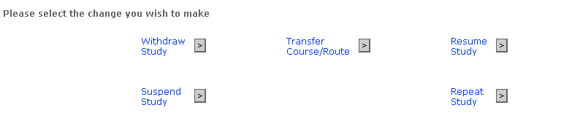

Select appropriate Change and Proceed, ie

a) Withdraw Study

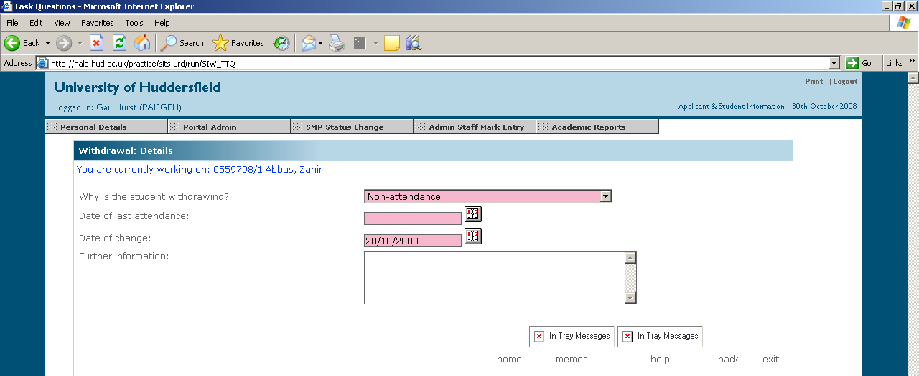
All Pink Fields are mandatory

Complete Details and Proceed

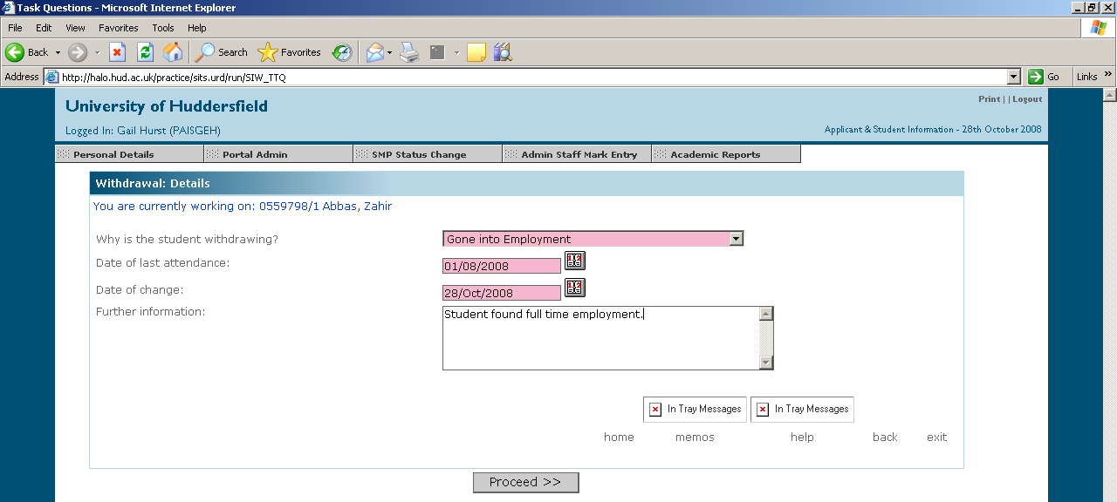

If change of date is after last date of attendance, answer question and Proceed

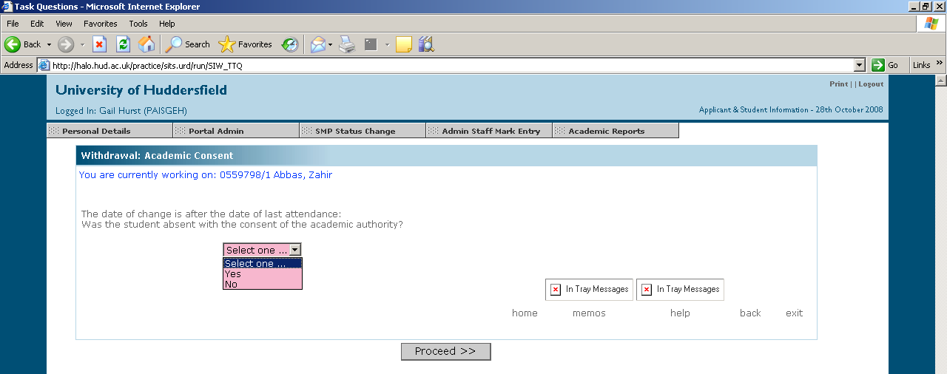
Answer will be Yes in every instance, unless the student has been Withdrawn for Non-Attendance
Withdraw Study (Cont’d)

Option now given to:

Confirm>> – details forwarded to ARO
Amend details – allows you to go back through the screens and make any
necessary amendments
Exit – exits without making any changes

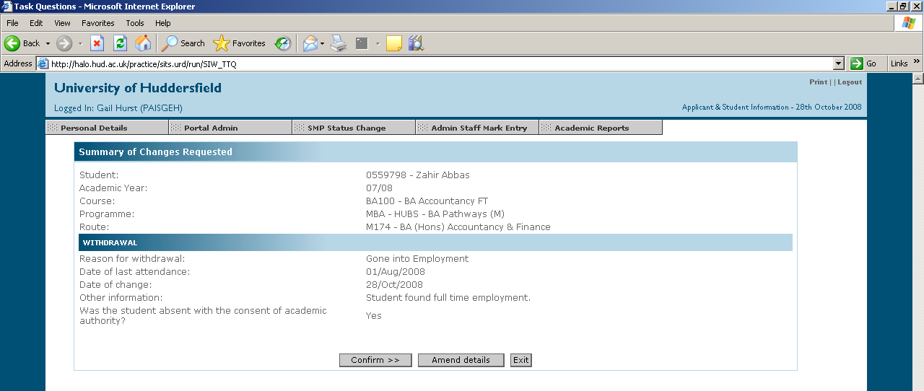

Once Confirmed, message will appear on SPR notes of requested transaction.

______________________________

The remaining options can also be completed in the same way, ie

b) Transfer Course/Route

Select Transfer Course/Route, add necessary detail and Proceed

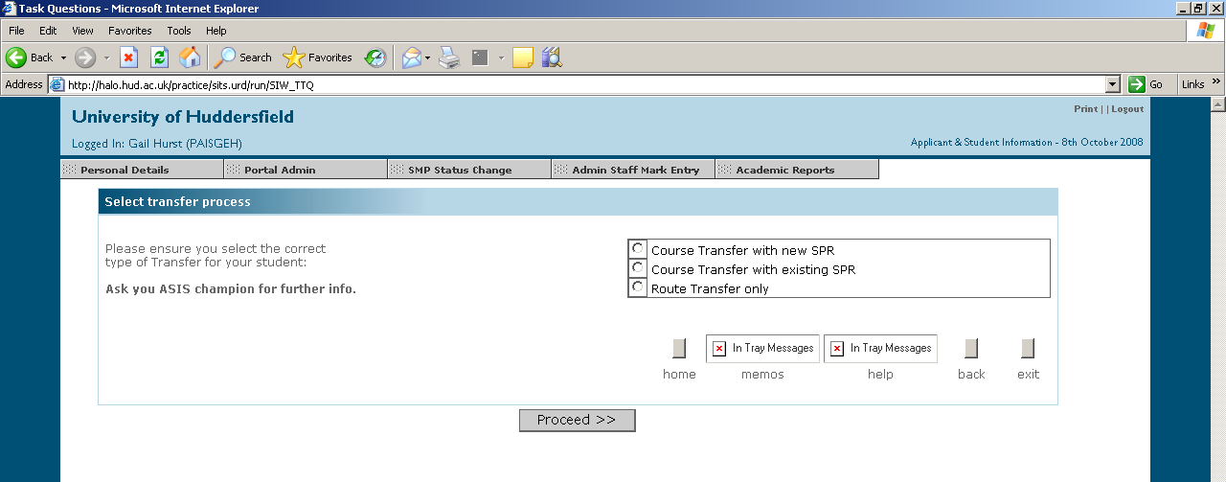

c) Resume Study

Select Resume Study, add necessary detail and Proceed

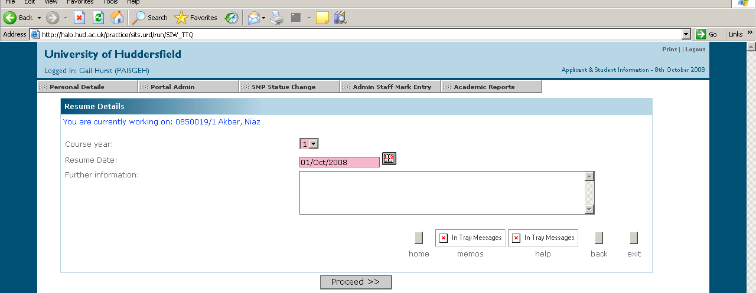

d) Suspend Study

Select Suspend Study, add necessary detail and Proceed

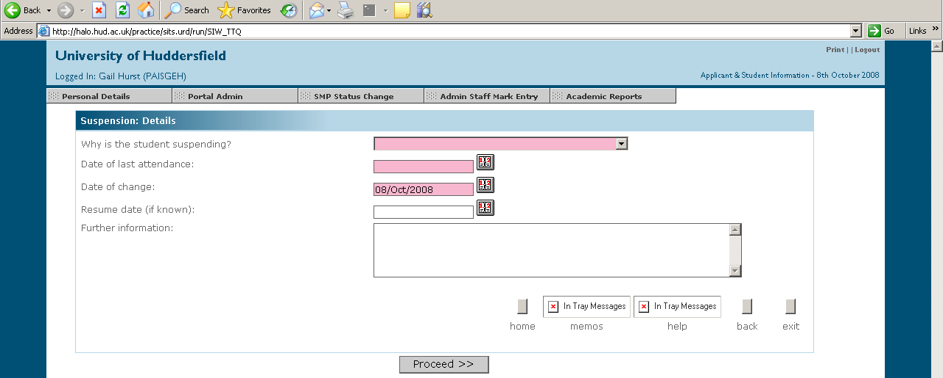

- Repeat Study

Select Repeat Study, add necessary detail and Proceed

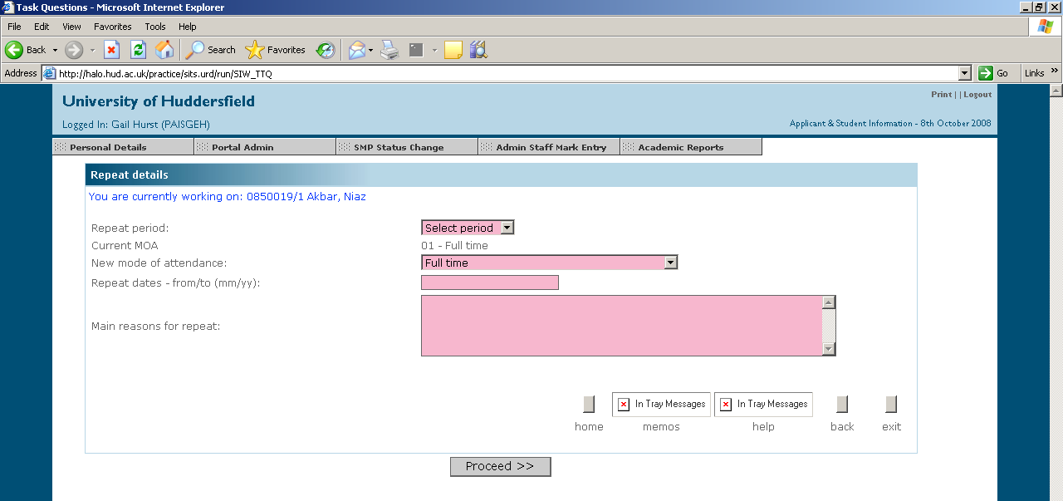

For Information:

ARO

Once Confirmed, details will appear on the main screen for ARO to amend. ARO staff can either Approve or Refuse the transaction (they may need further information to process the transaction), at which time a message will be sent back to your Intray within My Students.

IN-TRAY

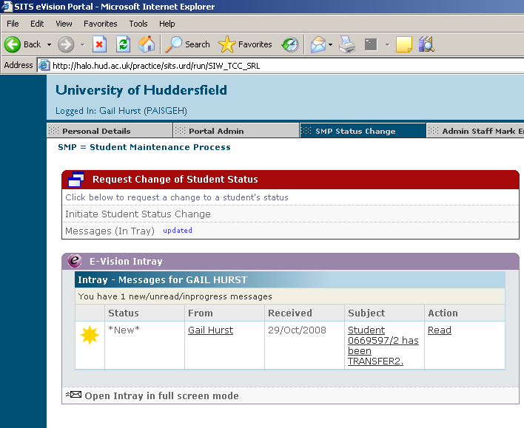
Read Message

Full Screen Mode

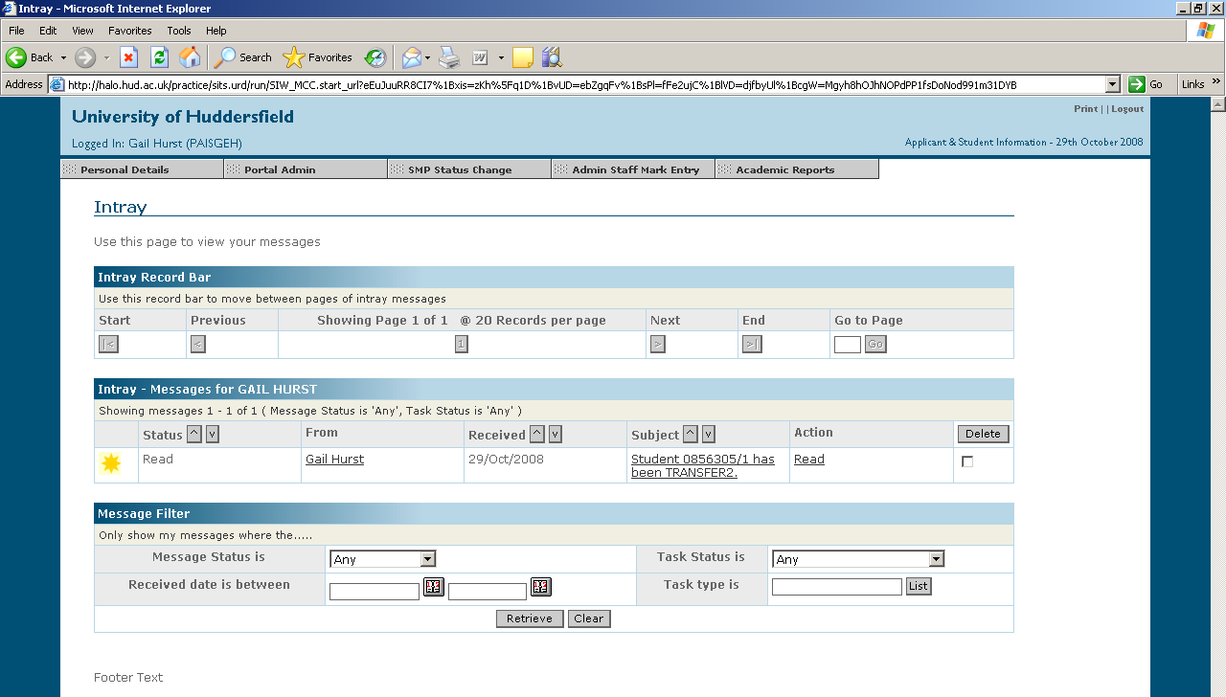
Read Message

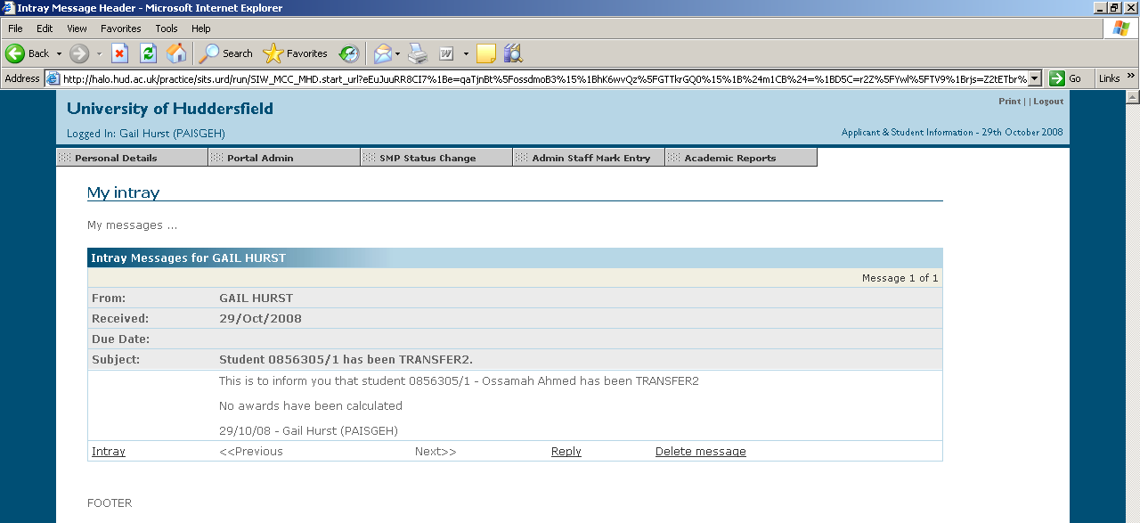

Select Browser Back button 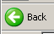 to return to previous page.

3 SMP Reports and Information

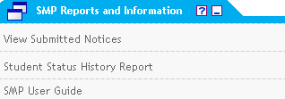

The following reports can be accessed from here:

View Submitted Notices
This can be used to track your own requests to ARO, or to track requests made by colleagues, particularly if they are away from the office. It will allow the user to view any comments where the request has been returned by ARO.

It is possible to retrieve requests by individual or school.

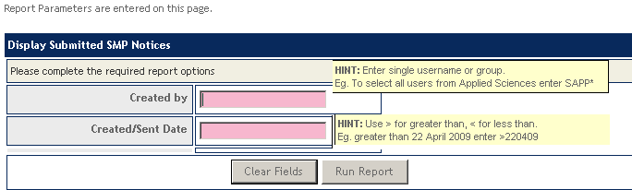

Created by: Enter individual user id or SEPD* for all in Education
Created/Sent Date: Make sure date is in correct format

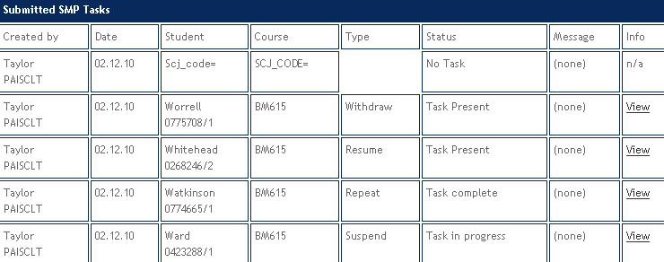

Student History Status Report
Enter a student code to see all the SMP transactions for that student.

SMP User Guide
Access to this user guide!

STUDENT MAINTENANCE - NOTES

CHANGES EFFECTED ON ASIS ONCE APPROVED:

WITHDRAWAL

SPR – Enrolment Status should have changed – Batch Code also changes to identify the change, ie Batch Code changed after first character of Route Code eg BE120C to BE120W (withrdawn) or T (transfer) etc.

Modules are also withdrawn – W appears in AG column

SCE – shows W and end Date and removes next course information

SCJ – shows status W and the reason (RFT)

STU – no change – status remains at C (not meaningful on this record)

TRANSFERS

Transfer Route - Route and Batch changes in the SPR (and adds note) and Route changes in the SCE.

Transfer with new SPR – creates new SPR and closes down the old SPR, SCJ and SCE by adding T to status. New SCJ and SCE are created. (Transfer of module credits will take place if this has been requested in the process – ARO have no control over this and therefore if you are in doubt, say ‘No’ and these can be transferred manually as before).

Transfer without new SPR – changes SPR description, closing down old SCJ and SCE. New SCJ and SCE are created.

SUSPEND

Changes shown in the SCE and SPR, does not change the SCJ. If the resume date is known, please add this for information.

RESUME

Changes shown in the SCE and SPR. If new expected end date is entered, records will be updated automatically. It will be necessary to re-enrol the student, as the student status will be set back to CP.

REPEAT

Changes shown in SCE. If new expected end date is entered, records will be updated automatically.

ARO - ADDITIONAL DETAILS

Details of any transactions appear on the main screen for ARO to amend. ARO in three groups relevant to the schools. On opening their messages, ARO staff take ownership of the relevant transaction.

ARO staff can either confirm or refuse the transaction, ie they may need further information to process the transaction.

Refuse – gives ARO text box to complete so this can be seen in the Mailbox.

