Expenses/Advances

Training Documentation

Finance System Support
Email - financesystemssupport@hud.ac.uk

Expenses/Advances
Contents
Expenses 3
Before logging into Unit4 3
Expenses and Benefits Policy and Procedure 3
Log in to Unit4 4
Inputting an expense 5
Changing subproject after you have input expenses lines 8
Multicurrency claims 10
Mileage claims 11
Upload and match receipts 12
Uploading multiple receipts 16
Progress of expenses and accessing a draft 19
Advances 20
Inputting an advance request 20
Input expenses against advance when back from travels 24
Troubleshooting 28

Expenses

Overview of process steps for claiming expenses
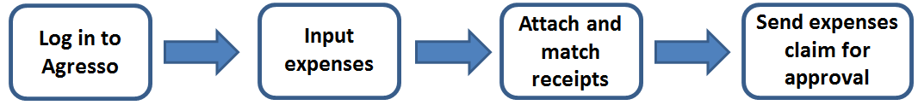

Before logging into Unit4

If you have not used Unit4 in the past please email Unit4 support to obtain access. financesystemssupport@hud.ac.uk
If you have not claimed expenses (online or paper) in the past you need to ask Unit4 support for a form to fill in your bank details. If you ever change your bank details you need to change them in MyHR as well as contacting finance to change them on the expenses system.
Please note that all claimants should claim their expenses within 4 weeks of returning from their travels.
For speed and ease it is far easier if you process claims each time you incur an expense rather than stacking them up. To process one claim can take a minute or two while if you do a number together can make the task onerous
Inactivity timeout
Please note that the system logs you out after 20 minutes of inactivity. If you get disturbed while putting on your expenses claim please remember to save it as a draft or you will lose the whole claim.

Expenses and Benefits Policy and Procedure
Please follow the link below to see the full policy and procedure on Expenses and Benefits. This is the formal policy provided by the Procurement department:
https://www.hud.ac.uk/media/policydocuments/Expenses-and-BenefitsPolicy-and-Procedure.pdf

Log in to Unit4

Use the following URL to access the Unit4 Finance System:

https://agressoweb.hud.ac.uk/MS7_Live_Web/Login/Login.aspx

The following Login box should appear. Enter the details requested and then click the LOGIN button:

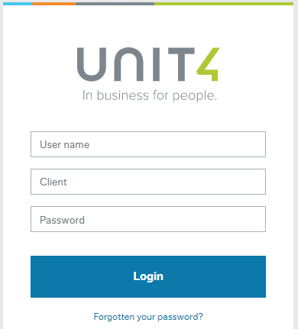
User name: the same as your computer login e.g. FINANN
Client: is the University company to be used select H1
Client H1 - (Main Company)

Password: must be at least 6 digits and include a number.
Forgotten your password? -
Click on to reset

Inputting an expense

Select Your employment - Expenses
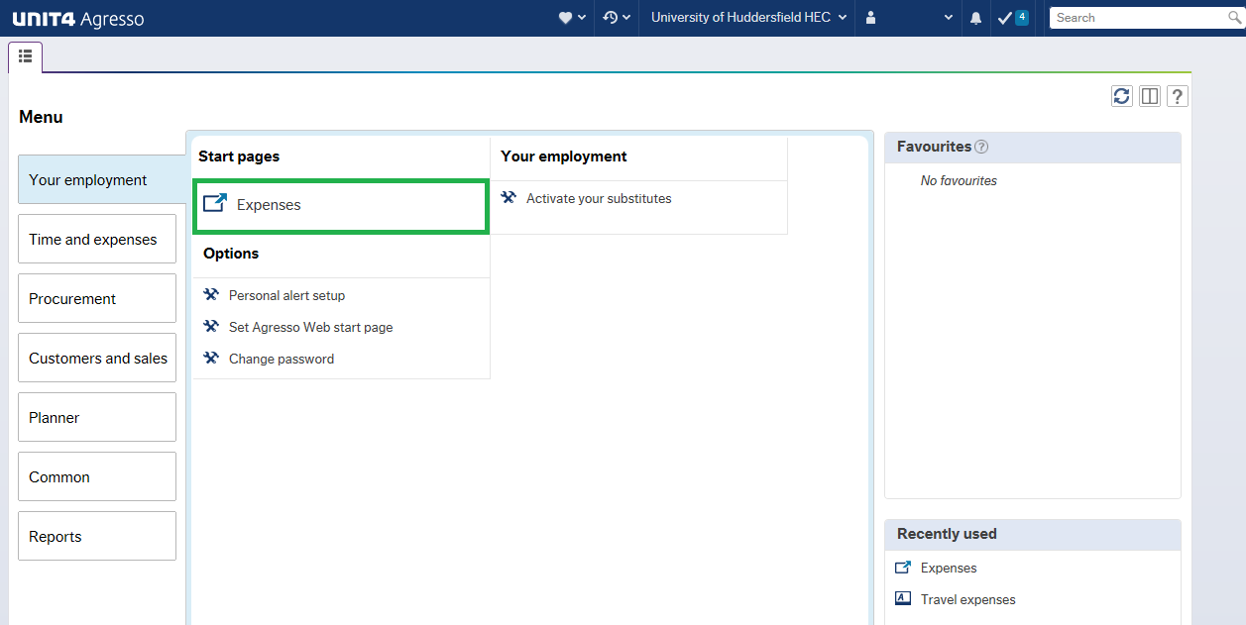

Select Expense
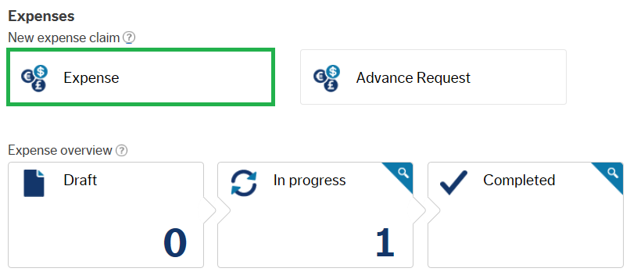

This is the screen where you enter your expenses. To the right is an overview of your progress.
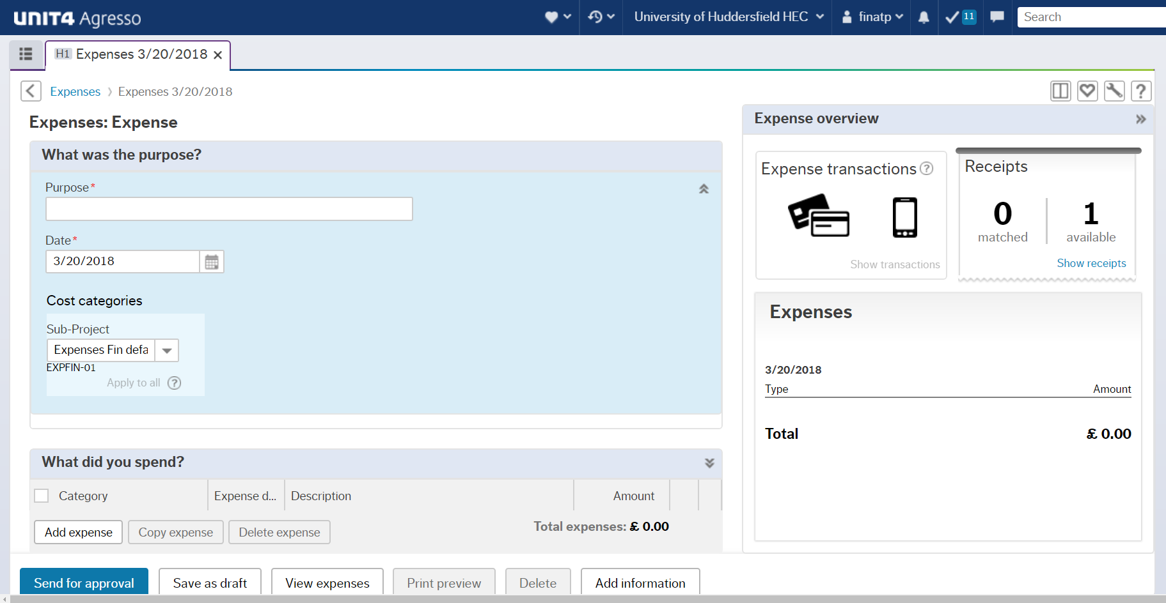

First enter the Purpose and the Date and Subproject of your claim. The date will be the date the first expense occurred.
If you know which Subproject the expense will be claimed against then input/select this subproject from the drop down and all expenses lines added will be coded to this subproject. If you want to see what subprojects are available for you click into the Subproject field and press your space bar to reveal.
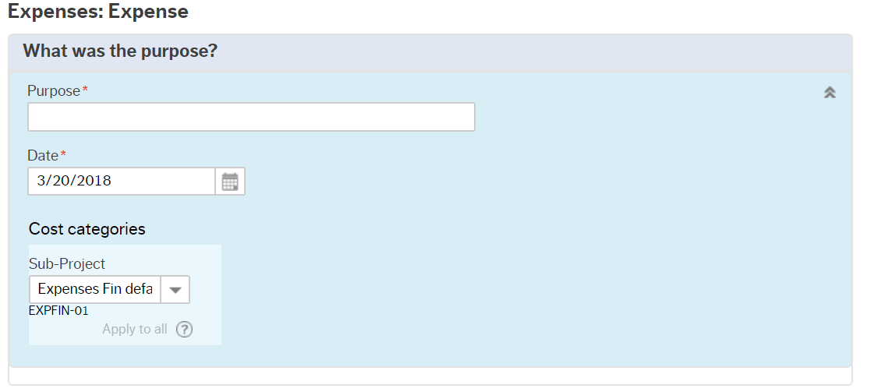

NB: Staff working in ‘Services’ must amend the subproject from a default subproject (which is prefixed “EXP”) to a valid subproject or else the claim will be rejected or come back to you as an “Expense Correction Task” and require you to input the subproject. If you do not know the subproject please get in touch with your finance contact.
IF YOU ARE CLAIMING FOR CAR PARKING FOR OPEN DAY PLEASE USE SUBPROJECT CPK000-01

Add expense
Next click on 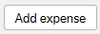 to enter your first expense line.
You must enter one expense line per receipt.

In Category you can press the space bar to see the full range of expense types to choose from. You can also just type ahead e.g. key in “travel” will bring up the different travel expense types.
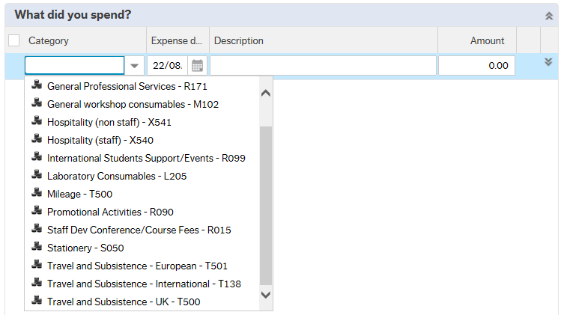
Enter the Expense date – this is the date the expense occurred. Then enter a suitable and accurate Description.
The Amount must be entered in £ - Pound Sterling.

Changing subproject after you have input expenses lines

If you have already input your expenses lines and you need to change the subproject you have two options:

- Under the Purpose section you can change the subproject from the drop down and then click Apply to all.
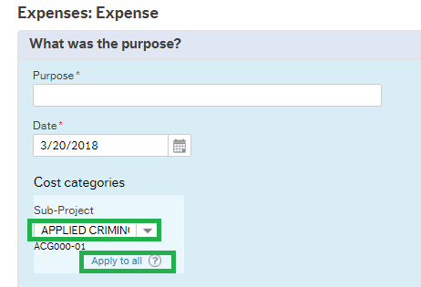
Click OK and this will copy the subproject to all expense lines in your claim.
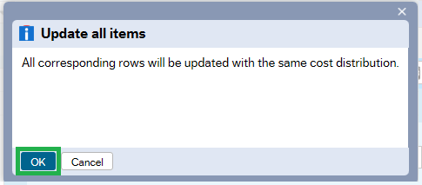

- If you want to change the subproject on a line by line basis you can click to the right of the expense line. The subproject can now be amended.

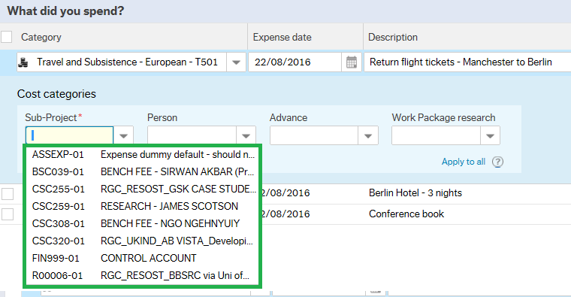

If you want to apply the same subproject to multiple expense lines then enter it for the top line and click Apply to all
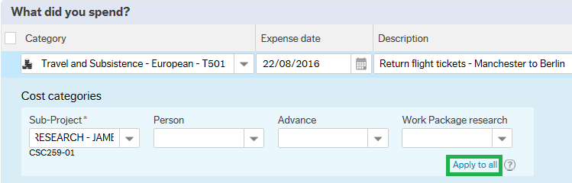
Click OK and this will copy the subproject to all expense lines in your claim.

Multicurrency claims

If the expense occurred in a different currency please convert to £ - Pound Sterling and remember to enter the conversion rate in the Description field or in the Add Information option at the right bottom corner if the exchange rate is the same for all lines in the claim.
If a receipt has been obtained from a currency exchange bureau this can be attached as a receipt to the first expense line to document the exchange rate used in the claim.

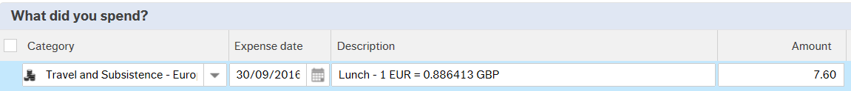

Mileage claims

Please note that the first 1000 mile a year are paid at 40p and 23p thereafter
To add another expense click at the bottom left of the screen
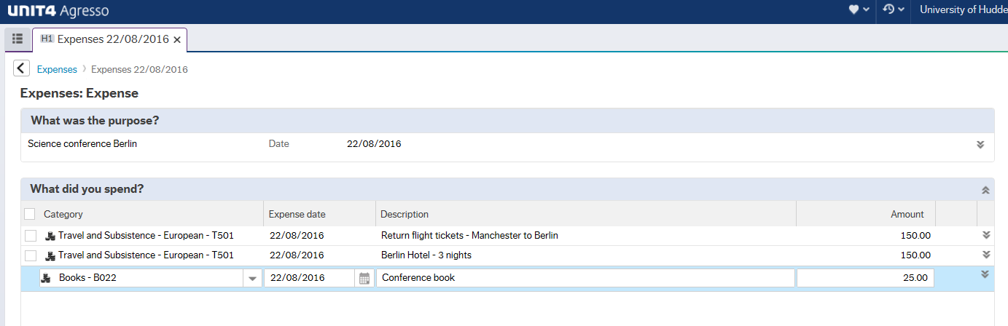

If you have entered a wrong expense line then “tick” the box to the left of the line and then click Delete expense.
If you want to copy an expense line then “tick” the box and click Copy expense. This can save time when you have to enter several expenses lines that are almost identical. The lines can be copied and the amounts and descriptions amended accordingly. 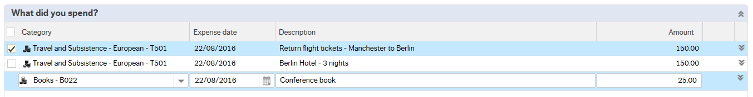
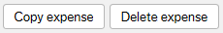

Upload and match receipts

Click on Upload receipts
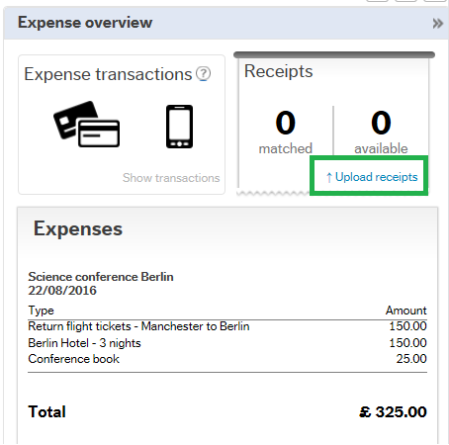
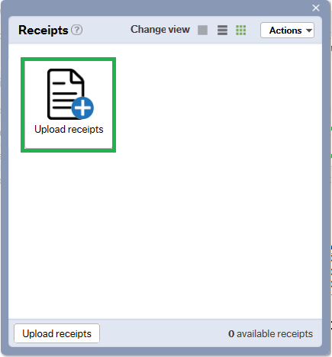

Choose the file you want to upload and click open. Most file formats are accepted including: jpeg, png, tiff, word, excel and pdf but no larger than 4MB.
For word and email template files the image will not show in the preview window, so image files such as jpeg, tiff and png are preferred.
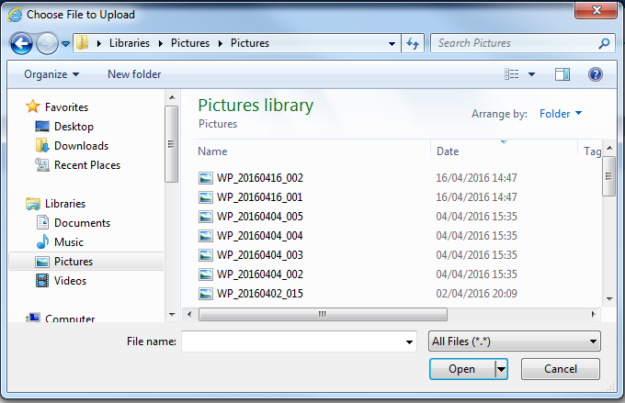

The uploaded image will now show. Click Upload receipts again if you want to upload another receipt.
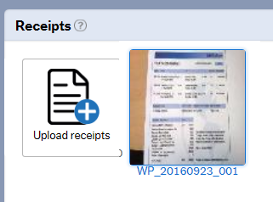

When all receipts are uploaded you need to match up them up to the correct expense lines. Click on the square symbol to right of Change view to go to the screen where you can match your receipts to the correct expenses lines.
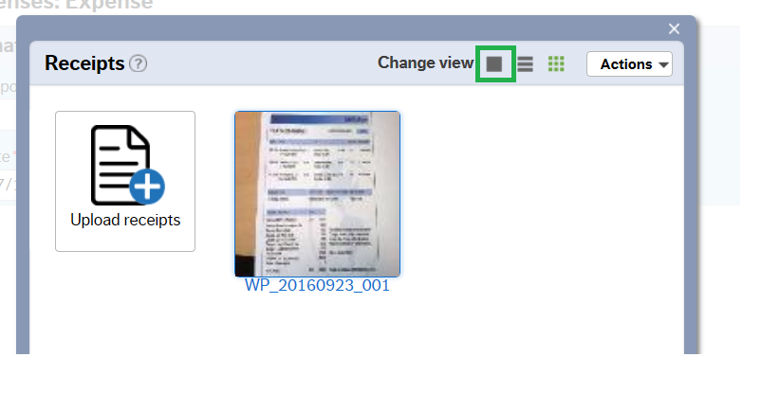
Click the box to the left of the correct line and click Match to receipt. Use the arrows on each side of the screen to navigate between receipts.

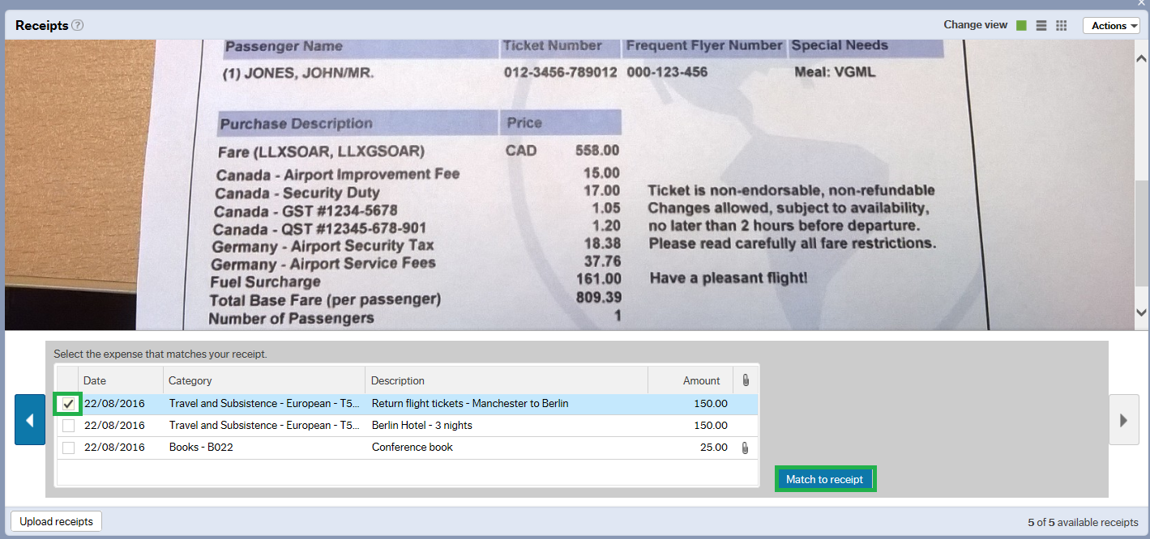

The Expense overview will now show that the number of receipts matched and it will show you a full overview of the expenses that have been input including a the total sum.
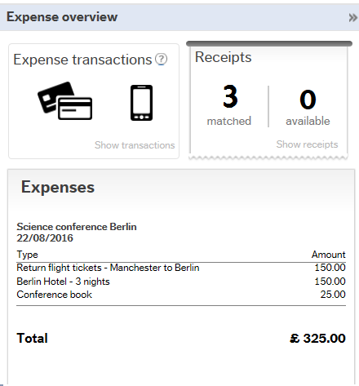

NB: IF THE RECEIPTS ARE RELATED TO A RESEARCH PROJECT YOU MUST KEEP HOLD OF THE ORIGINAL PAPER RECEIPT IN CASE THE FUNDER REQUIRES THE ORIGINAL RECEIPT AT A LATER STAGE. IF THE CLAIM DOES NOT RELATE TO A RESEARCH PROJECT YOU CAN GET RID OF THE ORIGINAL RECEIPT WHEN YOU HAVE BEEN PAID FOR YOUR CLAIM.

Uploading multiple receipts

If your claim has got multiple expenses lines you have the option of scanning multiple receipts in one image file and upload and match it to the first expenses line. The receipts will have to be numbered 1,2,3.... according to the expense line number that they relate to:

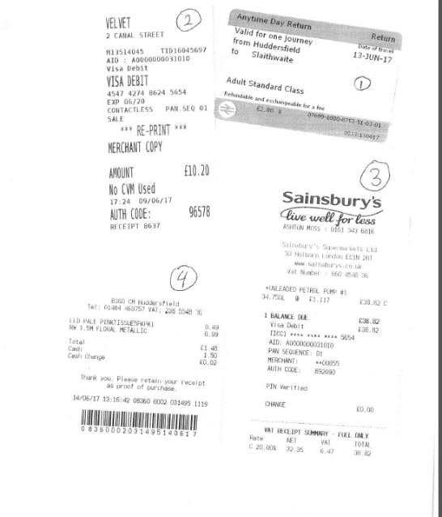
Any support needed in regards to this please email Finance Systems Support:
FinanceSystemsSupport@hud.ac.uk

Add Information
Click on Add information at the bottom of the screen to add relevant information for the school office or budget approver.
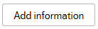
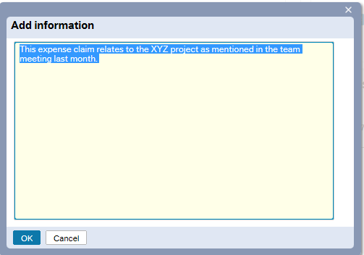

If you have finished the expenses claim then click Send for approval at the bottom left of the screen.
If you want to continue to add on expenses at a later date then Save as draft.
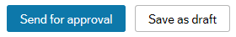

When sent for approval you will be given a transaction number. This number is used for referencing the expenses claim. The expense will now enter workflow for school finance office and/or budget approval and will be paid to you in the next purchase ledger pay run if it gets approved.

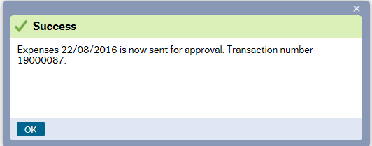

Click on Expenses in the top left corner if you have another expense claim to enter. This will take you to the front screen.
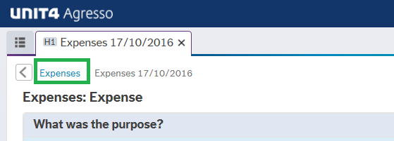

If you have finished entering your claim then you can now just logout of Unit4 by clicking on your user ID drop down menu in the top right corner and then selecting Logout.
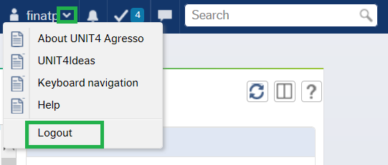

Progress of expenses and accessing a draft

In the Expenses front screen you will find the Expense overview.
By clicking on Drafts you can access and continue to work on any drafts you have previously saved.
In progress will show you any expenses claims you have submitted which have entered the workflow and have gone to School office (the claim only go to School finance office for approval if you work for a School) or Budget holder for approval. You can click into the see the details of the expenses claim via in progress but you will not be able to amend a claim that has entered the workflow/ in progress.
Completed shows claims that have paid to you in the past. This is helpful if you need to check whether you remembered to claim expenses for a certain trip in the past.

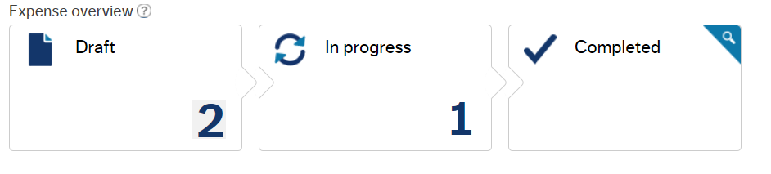
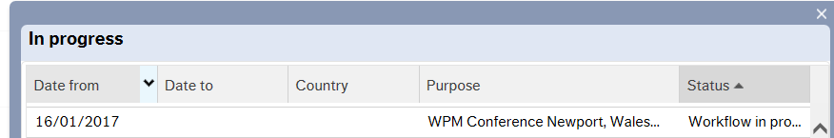

Advances

Overview of process for requesting an advance and matching against expenses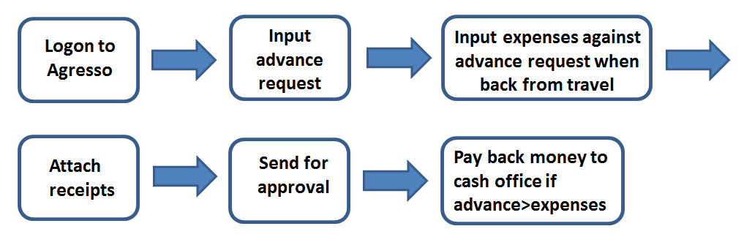

Inputting an advance request

Advance requests are only to be used for international travel and the request should be completed at least 2 weeks before the planned trip.

Select Your employment, Advance request
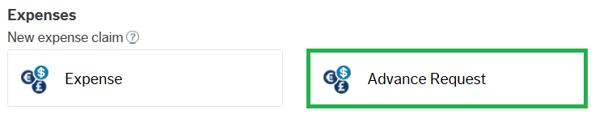

Input the Purpose of the advance request including the date range of the travel and in the Date field enter of the first day of travel.
You must change the Subproject to the subproject that you will be using for your expenses claim when you return from your travels. Subproject is a mandatory field and the system will not allow you to submit your advance request without entering a valid subproject. If you do not know the subproject please get in touch with your finance contact.
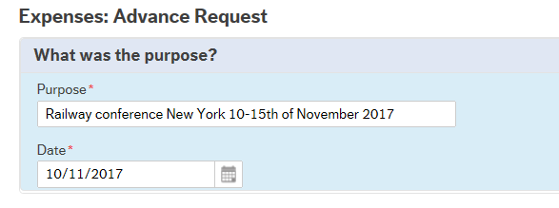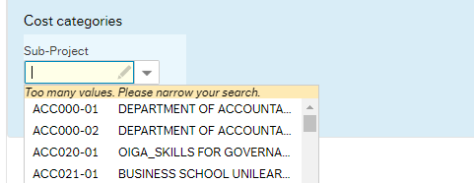

Click Add expense

In Category choose Advance request from the drop down
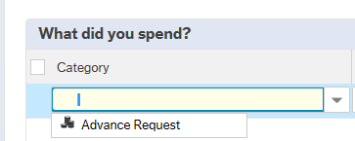

Enter relevant and accurate description including dates and amount in £ - Pound Sterling
Click on Add information at the bottom of the screen to add relevant information for the approver.
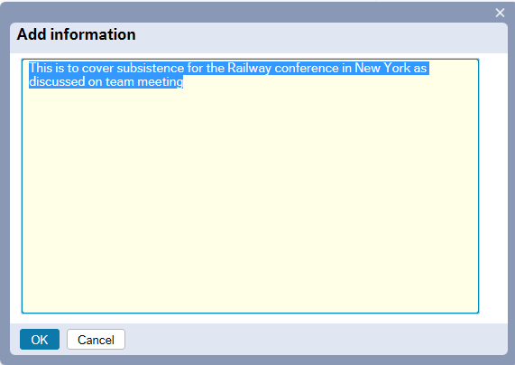

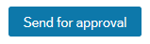
When finished click Send for approval

Note down the transaction number for the advance for future reference.
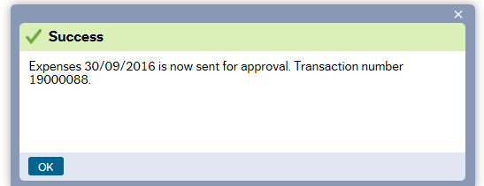

If approved, the advance will get paid to your bank account.

Input expenses against advance when back from travels

When you are back from your travels you need to put on an expense to document what the advance has been spent on. This needs to be done within a month of returning from your travel.

Choose Expense
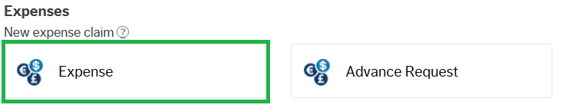
Input your purpose matching what you previously put on the Advance request but enter “Expenses” at the end
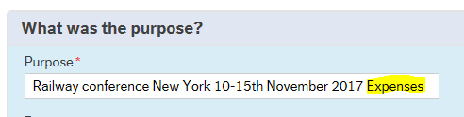

Now select Advance payment
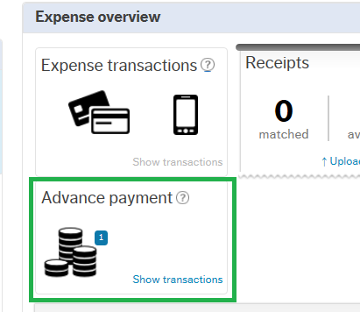

Tick the box for the advance relating to the expense and click Import to travel expense
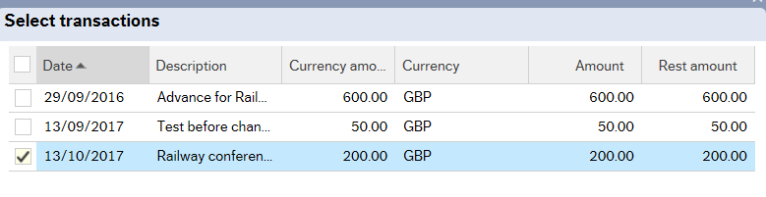
Now enter your expenses as shown as usual (including attaching receipts) 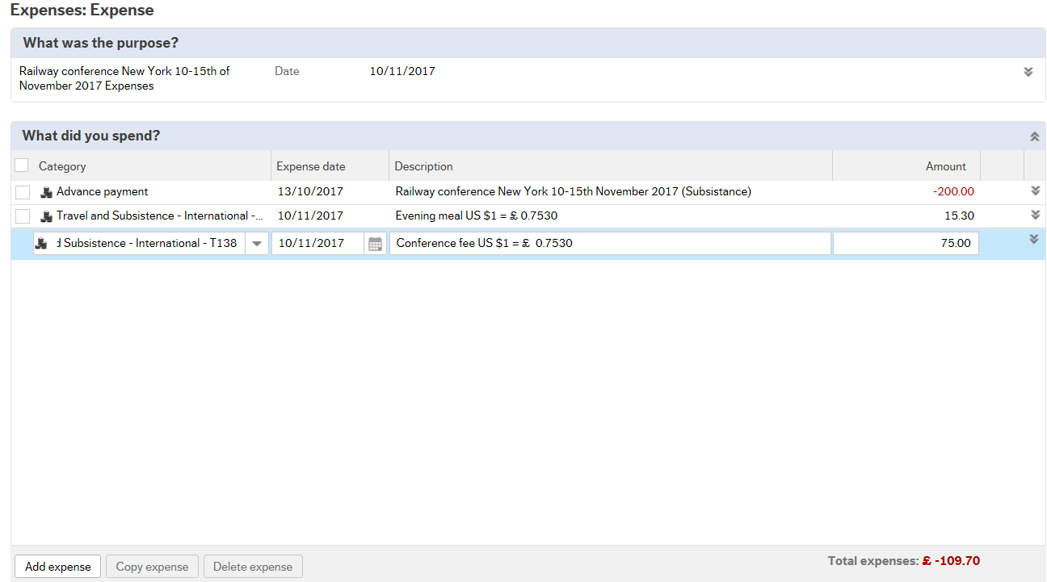

Before sending for approval you need to click apply to all on the subproject for the advance line. This will copy the subproject to all the lines in the claim. You should only be using the same subproject as when you used for the advance request. If you use a different subproject to the advance request this will create an imbalance on the accounts.

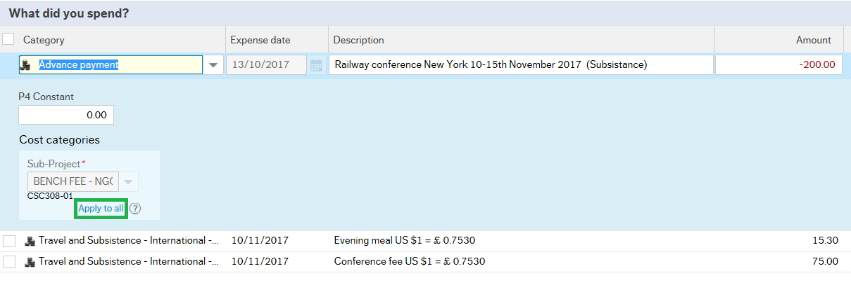
Note! If your advance was for more than the expenses it will show in a red (minus) number at the bottom. This means that this is the sum you owe to Cash office in Central Office. When the expense claim has been approved by School Office/ Budget Holder you will have to pay the rest back to Cash office in Central Finance.
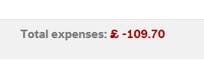
If your advance was less than the expenses from your trip then this amount will be paid to your account as with a normal expense claim.

Troubleshooting

Here are some common situations and how to resolve them (any problems always feel free to email Financial System Support - FinanceSystemsSupport@hud.ac.uk)

1) Expenses claim coming back to inputter in workflow because of subproject (only relevant for people working in services)
If you work in a service then you need to change the subproject from the default for each line in your claim. If you submit your claim without changing the subproject, the claim will come back to you as a workflow task. Access your workflow tasks in Unit4 by clicking the task icon in the top right corner Once you have opened the task please check that the subproject is changed from the dummy subproject EXPxyz-01 to a valid subproject.

2) GBP is Fixed! Error message when sending for approval:
The correct way to fill in an expense line is to start from the left and work towards the right – so starting with Category and finishing with entering the amount. If you fill in the amount first and category thereafter you might get and error message stating that GBP is Fixed.
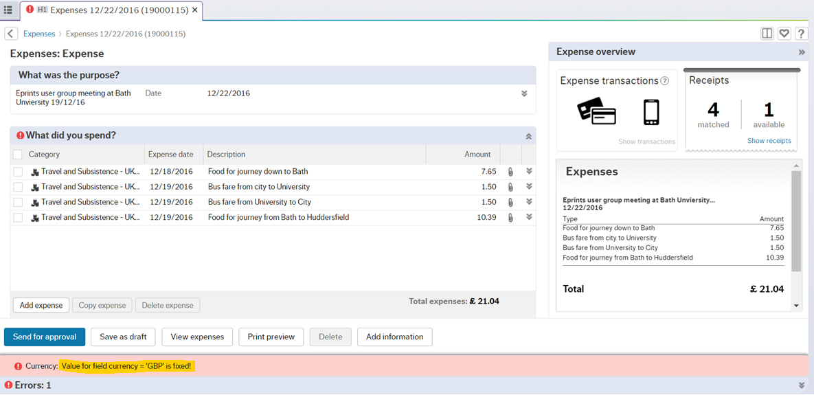
If you get this error click on “Print Preview”.
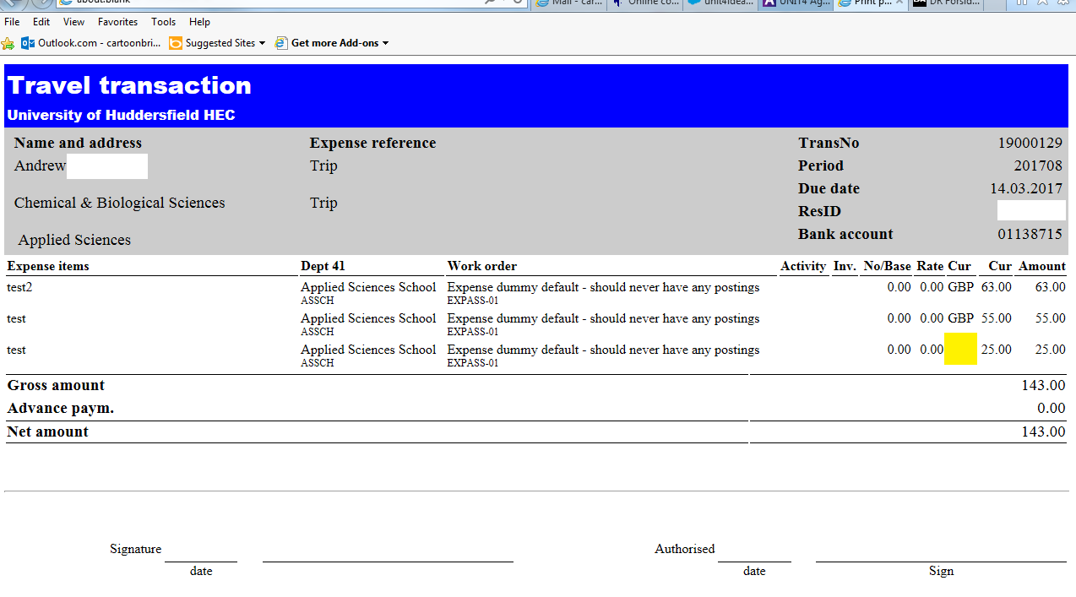
The line that has not got GBP in the currency column must be deleted and re-entered correctly in the expense entry screen. Any problems doing this please call ext. 3833 and the Unit4 support team will help you.

3) Claim rejected by School office because of wrong category used
If you claim has been rejected by School office/ Budget holder you need to correct by accessing your tasks. The below example is for an incorrect category task, but the overall process is the same for any correction task.
If an incorrect category has been used school finance office or budget holder would reject your claim and you will receive a task. You will receive an email confirming that you have a task and when you log into Unit4 and click on the “tick” icon in the right top corner you can access the task.

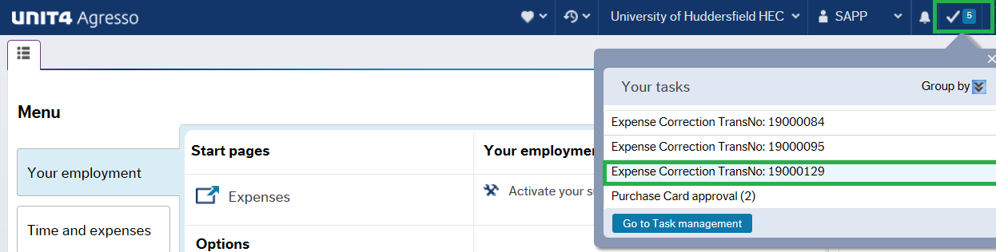

The task will show why it was rejected and what you need to do to amend and getting it approved.
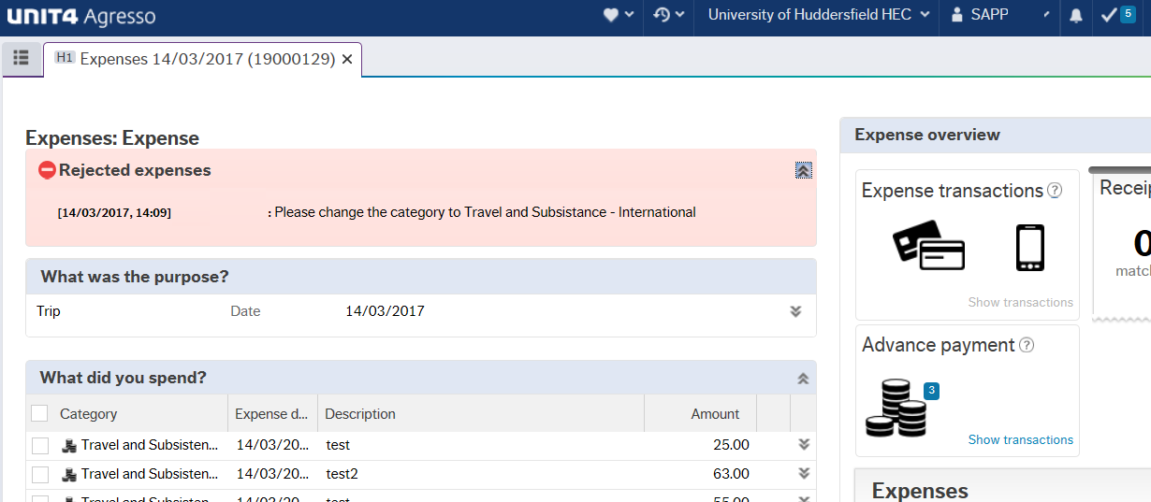

In this case we needed to amend the category to Travel and Subsistence – International.

When the change has been done the claim can be resent to the approver by clicking “Send for approval”
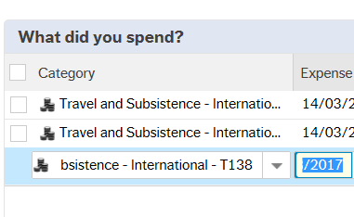

Please note that if you cannot see the full rejection message then please email FinanceSystemsSupport@hud.ac.uk for assistance.

