UNIVERSITY OF HUDDERSFIELD OCCUPATIONAL HEALTH DEPARTMENT
Audiometry surveillance information leaflet
The University’s Occupational Health Department provides health surveillance for University staff exposed to hazards whilst at work. Exposure to loud noise is an example of this. The University has a duty of care to check that hazards are not affecting your health and that the safeguards in place are working correctly to protect your health and safety.
What is the purpose of the Audiometry programme?
- The audiometry health surveillance programme is for employees who have been identified through risk assessments in their work area that they are at possible risk of being exposed to high levels of noise as part of their role.
- It is used to measure the effectiveness of Hearing Protection Devices
- Can enable noise induced hearing loss to be caught in its early stage
- An educational and motivational tool
- The initial test at the start of employment is used as a baseline and the annual test is used to determine if hearing loss has occurred.

What to expect from Audiometry surveillance
- Your hearing will be tested at a range of different frequencies
- You will be given a HSE CATEGORISATION SCHEME following the hearing test and these will be explained to you at your appointment.
- Your audiometry test appointment will last approximately 30 minutes.
- You will be seen by one of the occupational health nurses and they will go through a list of health questions with you.
- Your manager will receive a copy of your hearing test HSE categorisation.
- You will receive a copy of the audiometry results certificate dealing the HSE category and if any further action is required.
- You will also receive a re call date.

Hearing protection devises
- The purpose of hearing protection devices is to reduce the harmful auditory and annoying effects of sound

Care and maintenance of HPD
- Dispose single-use earplugs daily
- Clean multiple-use earplugs with mild soap and water, dry thoroughly
- Inspect multiple-use earplugs for dirt, cracks or hardness, replace if damaged
- Ensure it remains in good, clean condition;
- Earmuff seals are undamaged;
- The tension of the headbands is not reduced;
- There are no unofficial modifications;
- Compressible earplugs are soft, pliable and clean

Wear hearing protection to help save your hearing from damage caused by loud noise at work
For further information see HSE Control of Noise at work regulations (2005)
Control of Noise regulations 2005
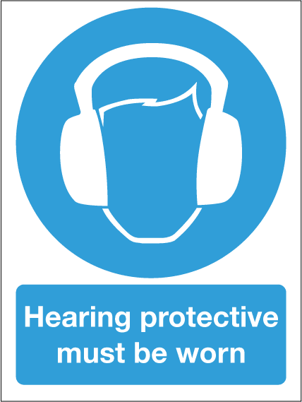

For further information please contact the occupational health department on 01484 471800 or email us at occupational.health@hud.ac.uk

