`Appendix 2
UNIVERSITY OF HUDDERSFIELD

DISPLAY SCREEN EQUIPMENT (DSE) SELF-ASSESSMENT
School / Support Service: | Occupational Health | Department:
Employee Name: |  | Phone ext. no:
Line manager Name: |  | Phone ext. no:
DSE location:
Assessment date: |  | Review date:
DSE GENERAL ADVICE ON INDIVIDUAL SEATING, POSTURE & ENVIRONMENT
please use this information as a guide when undertaking your assessment
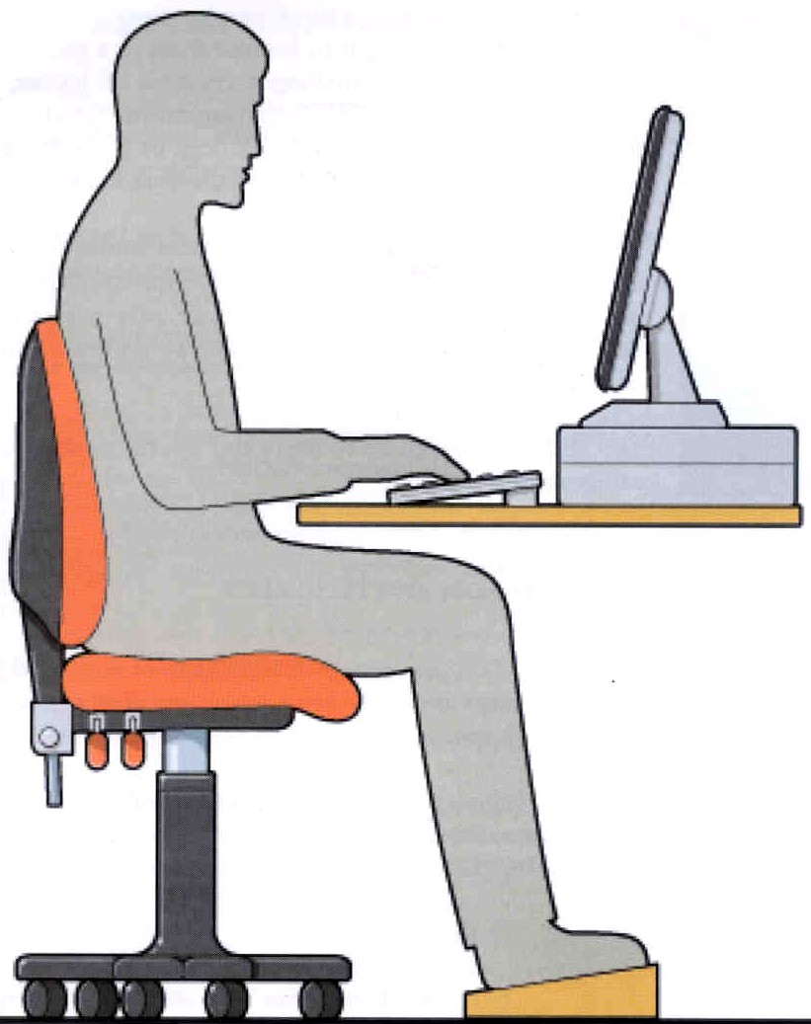
Whole-body facing same direction when using DSE
Space underneath desk to allow posture changes
Space to rest hands and wrists when taking breaks from typing
Keyboard and other input devices within easy reach & easily adjustable
Sufficient space at and around the workstation
Desk: provides sufficient work surface space, glare and reflection-free
Adequate artificial or natural lighting
Additional local lighting, if required
Window blinds to minimise reflections and glare
Monitor/display: adjustable, clear images, glare and reflection-free
Potentially distracting background noise minimised
Screen height level or slightly below eye level to allow comfortable head and neck position – approximately an arms length away
Forearms near-parallel with the floor & elbow at a right angle

Wrists not excessively bent up, down or sideways
Thighs well supported by the seat
Small gap between seat and back of knees
Feet flat on the floor or on a footrest utilised if needed
Back in its natural line and well supported, especially lumbar region
Hip and Knee joints at a right angle

A | CHAIR |  | YES | NO | ADJUSTMENTS MADE
1 | Does the chair provide good lower back support?
2 | Does the seat provide good support to the thighs?
3 | Is the seat height and back support adjustable?
4 | Can you adjust the height and angle of the backrest?
5 | Are there 5 castors which are stable and move easily?
6 | Can you get your chair close enough to the desk without any fixed chair arms getting in the way?
If you answered No to any of the above undertake the following adjustments & record above:
A1 Try adjusting your backrest up & down, forwards & backwards. If no improvement contact your DSE Assessor about a lumbar support cushion
A2 Check whether seat pan will slide backwards or forwards
A6 remove arms from seat (usually bolted on underneath seat) and store somewhere safe
If the seat controls do not work or it is not adjustable, check if there is a spare seat in your office / department that you can use instead. If this is not an option speak to your manager about ordering a new chair.

B | DESK & WORK SURFACE |  | YES | NO | ADJUSTMENTS MADE
1 | Is there sufficient legroom underneath the desk?
2 | Is the work surface a comfortable height?
3 | Is the work surface free from reflections?
4 | Does the work surface provide sufficient space for the work which you undertake?
5 | Can wrists and hands be supported during breaks  from keyboard work?
If you answered No to any of the above undertake the following adjustments & record above:
B1 Clear away any clutter – arrange storage
B2 Check if seat height needs adjusting (refer to diagram page 1)
B3 Use window blinds, speak to manager - replace desk if necessary
B4 See B1 – speak to manager if desk size insufficient for work undertaken on it
B5 Arrange desk differently (refer to diagram page 1)
Clutter management: Move reference materials elsewhere. Only keep items used regularly nearby. Consider use of a document holder next to screen – speak to your manager about this.

C | MONITOR & DISPLAY |  | YES | NO | ADJUSTMENTS MADE
1 | Are screen images clear on the screen with no flicker?
2 | Can you adjust the monitor angle and its display (contrast / brightness) settings?
3 | Is the screen free from reflections and glare?
4 | Is the monitor screen at least an arm’s length away?
5 | Is the top of the monitor at or just below eye level?
6 | Is the screen clean?
If you answered No to any of the above undertake the following adjustments & record above:
C1 – C3 Clean dirty screens. Use window coverings to reduce glare. Flicker present? Difficult to see images? Adjust colour / text size settings Refer to IT helpdesk ext 3737
C4 Rearrange your desk
C5 Speak to manager re screen raiser if required
C6 Clean screen

D | WORKING POSTURE |  | YES | NO | ADJUSTMENTS MADE
1 | Is your whole-body faced in direction of the screen?
2 | Are forearms near parallel with the floor when typing?
3 | Are your feet flat on the floor?
4 | Do you sit back in the chair when working?
If you answered No to any of the above undertake the following adjustments & record above:
D1 Rearrange your desk layout
D2 Alter seat height (refer to diagram page 1)
D3 Alter seat height. If this does not help speak to your manager about obtaining a footrest
D4 Alter your posture – sit back in your seat, consider use of a footrest (refer to diagram page 1), make sure you have nothing placed between yourself and the keyboard. Consider updating your keyboard / touch typing skills – Staff IT support team for information on ext 2955

E | KEYBOARD & OTHER INPUT DEVICES | YES | NO | ADJUSTMENTS MADE
1 | Is keyboard stable & are you able to adjust the tilt?
2 | Is the keyboard & mouse separate from the screen?
3 | Are individual keys legible?
4 | Is the mouse or other input device within easy reach?
5 | Do you use the whole forearm in using the mouse?
6 | Does your mouse / other input device move freely?
If you answered No to any of the above undertake the following adjustments & record above:
E1 & E3 see your manager regarding replacement
E2 If working on a laptop computer regularly request supply of a docking station, separate detachable mouse and keyboard
E4 & E5 Rearrange desk layout & alter your practices
E6 Clear debris from underneath / inside roller type, replace mouse mat

F | WORK ROUTINE | YES | NO | ADJUSTMENTS MADE
1 | Do you take regular short breaks to change posture?
2 | Are individual DSE sessions shorter than 1 hour?
3 | Do you have some control over your work routine?
If you answered No to any of the above undertake the following adjustments & record above:
F1 – 3 Reflect on your personal work scheduling. Discuss problems with your manager. Consider use of free software to remind re changes in posture: www.workrave.org/

G | WORKING ENVIRONMENT | YES | NO | ADJUSTMENTS MADE
1 | Is movement easy to, from and at the work area?
2 | Is lighting suitable and sufficient?
3 | If windows blinds are required, are they installed?
4 | If yes, do the blinds work properly?
5 | Is temperature generally comfortable?
6 | Is there natural or mechanical ventilation?
7 | Can you work without distraction from background noise?
If you answered No to any of the above undertake the following adjustments & record above:
G1 Tidy area around workstation and if your manager agrees, consider rearrangement of the office area.
G2 Consider individual desk lamp / remove bulbs / tubes from local lighting if too bright.
G7 Speak to manager regarding office layout / work schedules / rotas to avoid proximity to noisy equipment / interruptions in workflow.
NB Heating / lighting / ventilation problems should be referred to Estates Helpline ext 2550 and if unresolved to your manager.

H | SOFTWARE | YES | NO | ADJUSTMENTS MADE
1 | Are you comfortable with software packages used?
If you answered No to this question discuss your training requirements with your manager.

I | YOURSELF | YES | NO | ADJUSTMENTS MADE
1 | Are you aware of arrangements for DSE eye tests?
2 | Your current weight? (Optional, see notes below) | st. | lb.
3 | What is your height? (Optional, see notes below) | ft. | in
I1 DSE users are entitled to an eye care voucher once every 2 years. These vouchers can be obtained on Occupational Health’s website:
Display Screen Equipment (DSE) - University of Huddersfield
I2 The DSE assessor may need to know your weight to ensure the equipment supplied is appropriate for you. Also if needed they can advise on alternative chairs.
I3 Knowing a person’s height may assist the assessor when making decisions about the correct equipment and adjustments to available equipment.
FURTHER ADVICE & GUIDANCE:
If you have any health problems that you believe to be related to DSE work, you are advised to bring these to the attention of your manager.
If your work involves using more than one PC: alternate desk(s), laptop computer or working from home you should undertake & record this assessment for each location.
This assessment should be repeated after two years or immediately if any of the following applies:
- you work on computers at any other desks or
- you undertake your occupation at home or
- you change your workstation location or
- you start to have health related problems which you believe could be related
to working with DSE or
- you use a laptop computer/portable device for more than 1 hour per day.

