**A guide to recording your personal development activities**

*(For research staff only, bespoke guidance exists on the process to follow that can be* [***found here***](https://staff.hud.ac.uk/rike/traininganddevelopment/10-days-of-development/)*)*

**How to record development activities on ‘My Learning’**

* Log into My HR <https://myhr.hud.ac.uk>
* Select the ‘**My Learning**’ icon from the left-hand side of your dashboard:
* Select the ‘**My courses**’ tab at the top of the page:



…this will show any learning and development activities you have booked internally via [P&OD](https://staff.hud.ac.uk/hr/pod/) (NB: these activities are included on your record automatically).

* To add any additional personal learning and development activities you have undertaken (e.g. attending an external conference or workshop), scroll down to find the ‘add personal learning’ button:



* Add and save the details of your learning:

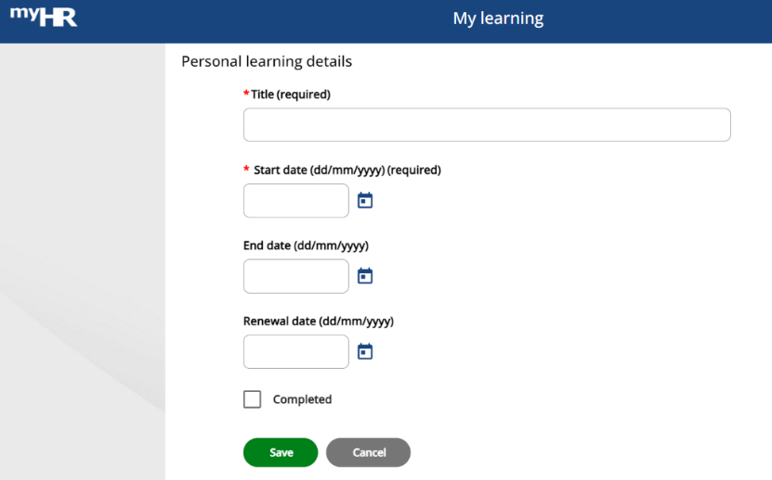

(NB: this online learning record shows a title and dates only – you might wish to keep a separate record of what you gained from the learning and how you will use it in future. For research staff, use your researcher development log to capture further details and reflections).

Further information about using ‘My Learning’ can be found in the [MyHR User Guide](https://staff.hud.ac.uk/media/intranet/content/hr/downloads/myhr/MyHRUserGuide.pdf).

**How to record development hours on ‘My PDPR’**

*(For research staff only, specific bespoke guidance exists on the process and can be* [***found here***](https://staff.hud.ac.uk/rike/traininganddevelopment/10-days-of-development/)*)*

As part of the annual Personal Development and Performance Review (PDPR) process you are asked about the CPD you have undertaken over the past year.

Your ‘My Learning’ online record will help you with thinking about this, alongside any additional information.

When preparing for your PDPR discussion:

* Log into My HR <https://myhr.hud.ac.uk>
* Select the ‘**My PDPR**’ icon from the left-hand side of your dashboard:

* Locate the PDPR that is relevant to the current period, use the “All” tab to do this.
* Depending on your role, the PDPR form will include a variety of questions for you to reflect upon your CPD undertaken. These are different for professional service and academic staff. Please ensure these are completed in full and not left blank.

This is an example of one of the questions:

***‘Which learning and development opportunities have you undertaken in the last 12 months and how useful were they?’***

* Finally, you will also be asked to think about and record future development needs. This is a good opportunity to list what you hope to achieve over the coming year and your reasons, then discuss this with your reviewer at your PDPR meeting.

Full guidance on completion of the PDPR forms can be found in the [MyHR User Guide](https://staff.hud.ac.uk/media/intranet/content/hr/downloads/myhr/MyHRUserGuide.pdf).