If you follow the link from the e mail, this will take you to the following log on screen:-

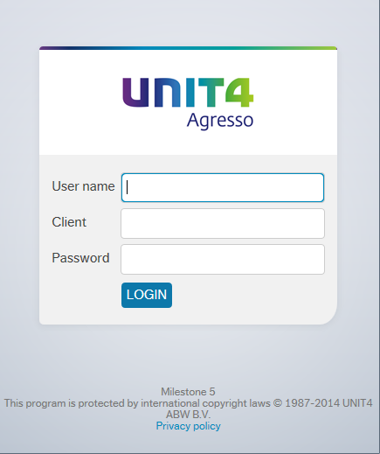

User name – your usual log on id
eg FINAMT

Client – H1 [H3 for Enterprises]

Password – this has to be alpha - numeric and minimum 7 digits

Once logged onto the Agresso system you click on the “Tick” icon on the top tool bar to access your tasks. If you have several tasks click on “Go to Task management” to get the best overview of your tasks.

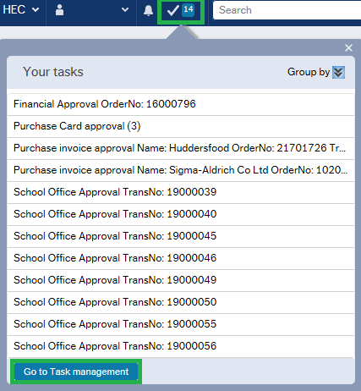

In Task management you click on the relevant task category in your left hand side menu. The list of tasks then opens up in the middle and you double click on the line to open up the task.

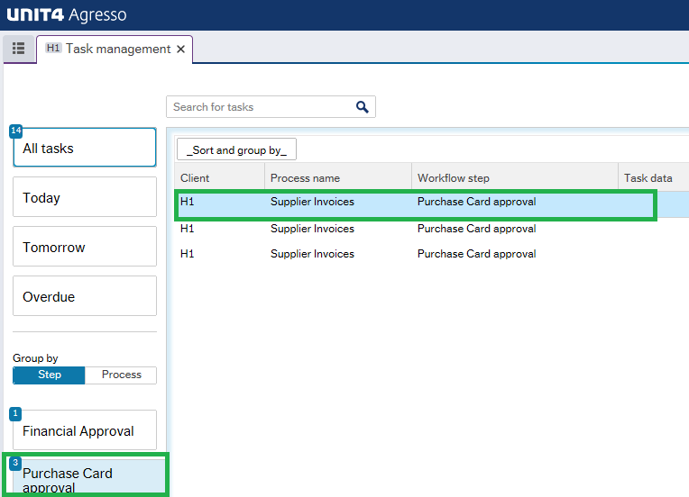

This is the view of the task:
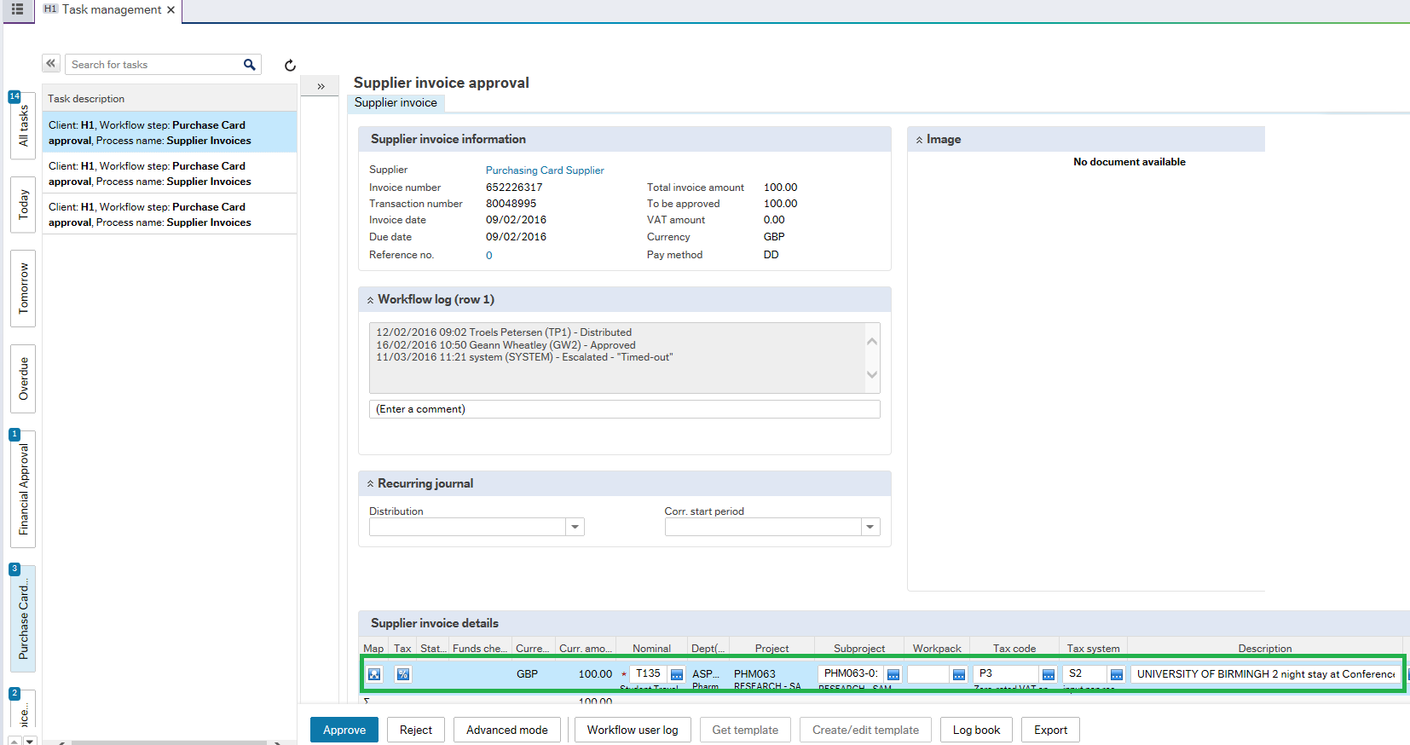

Items to check here are:-

- Nominal
  - do you agree with the coding?
- Cost centre

- VAT - Has the VAT been coded correctly – P8 for 20% VAT, and P3 for no VAT, and

- Description – is this meaningful and relevant?
If you agree with the coding and the text, simply click the button bottom left of the screen. You will then get a message across the screen telling you have successfully approved the transaction.

Now click on the next task in the list. [If you minimised your task menu, you will need to bring the menu out again from the left side by clicking on the arrows again].

BUT WHAT IF?

I disagree with the nominal? Simply overtype the nominal to be what you want, and press the Tab key. NOTICE This will also amend the Tax code, so you will need to amend it accordingly.

I disagree with the cost centre?
- If you have access to the cost centre you want to charge this expenditure to, simply overtype and Tab.
- If you are the budget holder for the amended cost centre this will then post to the accounts when you click approve.
- If you are not the budget holder for the amended cost centre, workflow will then route this task to the relevant budget holder for his/her approval.

  - If you do NOT have access to the cost centre you were wanting to charge, the system will not allow you to overtype with this value. You will have to click the Reject button bottom left on the screen

and it is mandatory to type an explanation for the rejection – such as – “please amend cost centre to XXX000”. Workflow will then route this task back to the originator for them to amend. Once the originator has made the amendment, the workflow will then route the task to the ‘new’ budget holder for approval.

