Costing Approval for PI
Once a project has been created a costing is set up. As you are the Principal Investigator you are required to approve the costing. You will receive an email asking you to log onto Agresso to action the outstanding tasks.
If you follow the link from the email this will open up the following log on screen for Agresso
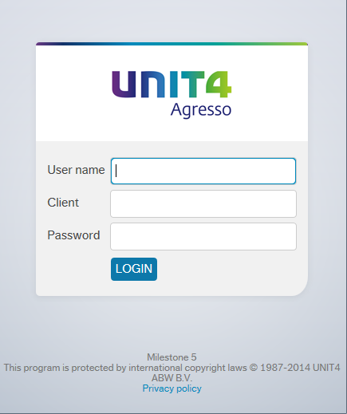

User name – your network log on id, e.g. FINAMT
Client – H1
Password – this has to be alpha - numeric and minimum 7 digits
Note: if you do not know your log in details please contact the Agresso team (ext 3833 / 01484 473833) and they can let you know.
Once logged onto the system you can see your outstanding tasks by clicking the task icon in the right top corner 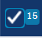. You can see in the example below there are a few tasks waiting to be approved. If you click on one of the tasks (e.g. AAM000089) this will open up the Approval on the right of the screen with the relevant detail in.
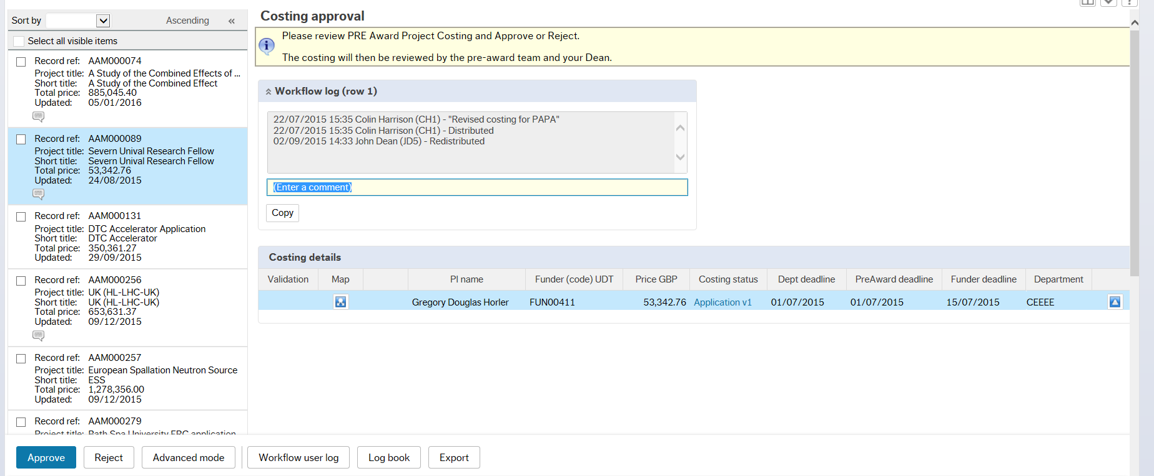
There is a yellow textbox which provides some basic information as to what is required for you to do.
The Costing details section will show the basic information for the costing, i.e. who the funder is, the Total Price for the costing, deadline dates and the relevant department.
If you want to see the full detail then click on the costing status 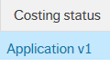 and this will open up the costing in detail, where there are a number of different tabs with various information. Check that you are happy with the details.
You can then click on the 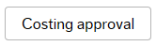icon at the bottom of the page which takes you back to the costing approval screen where you can select to authorise the costing.

Rejecting a task
If you do not agree with the information on the costing screen, you can click on the Reject button at the bottom of the screen 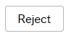
This will bring up a screen asking you to enter an explanation for the rejection.
The costing will then exit workflow and be available for editing and re-submitting for approval or for cancellation.
Depending on the action taken the costing may or may not come back to you for re-approval.

