E-Market Place Requisitioning

Training Documentation

Finance System Support
Email - FinanceSystemsSupport@hud.ac.uk
URL- https://agressoweb.hud.ac.uk/MS7_Live_Web/Login/Login.aspx
Training- https://staff.hud.ac.uk/finance/financesystems/training/

E-marketplace Requisitions

Log in to Unit 4

By following the URL you can log on to the Live Unit4 system: https://agressoweb.hud.ac.uk/MS7_Live_Web/Login/Login.aspx
Alternatively, via the Staff Hub internet page login:
On the black navigation bar near the top of this page, locating the link Online Systems.
This opens a new page which you will need to scroll down to locate the link for Unit4 (campus only).

To note: OFF campus you will need to login via Unidesktop to access.
The following Login box should appear. Enter the details requested and then click the LOGIN button:

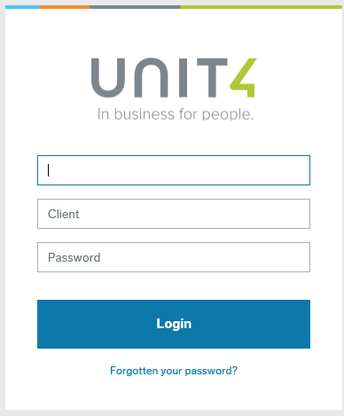
User name: the same as your computer login e.g. FINANN
Client: is the University company to be used select either H1 or H3
H1 - (Main Company)

Password: must be at least 6 digits and include a number. If you have forgotten your password, please use the ‘Forgotten your password?’ option

This will open up a screen similar to the one below. The ‘book ends’ available at the left of the screen will vary according to your role.
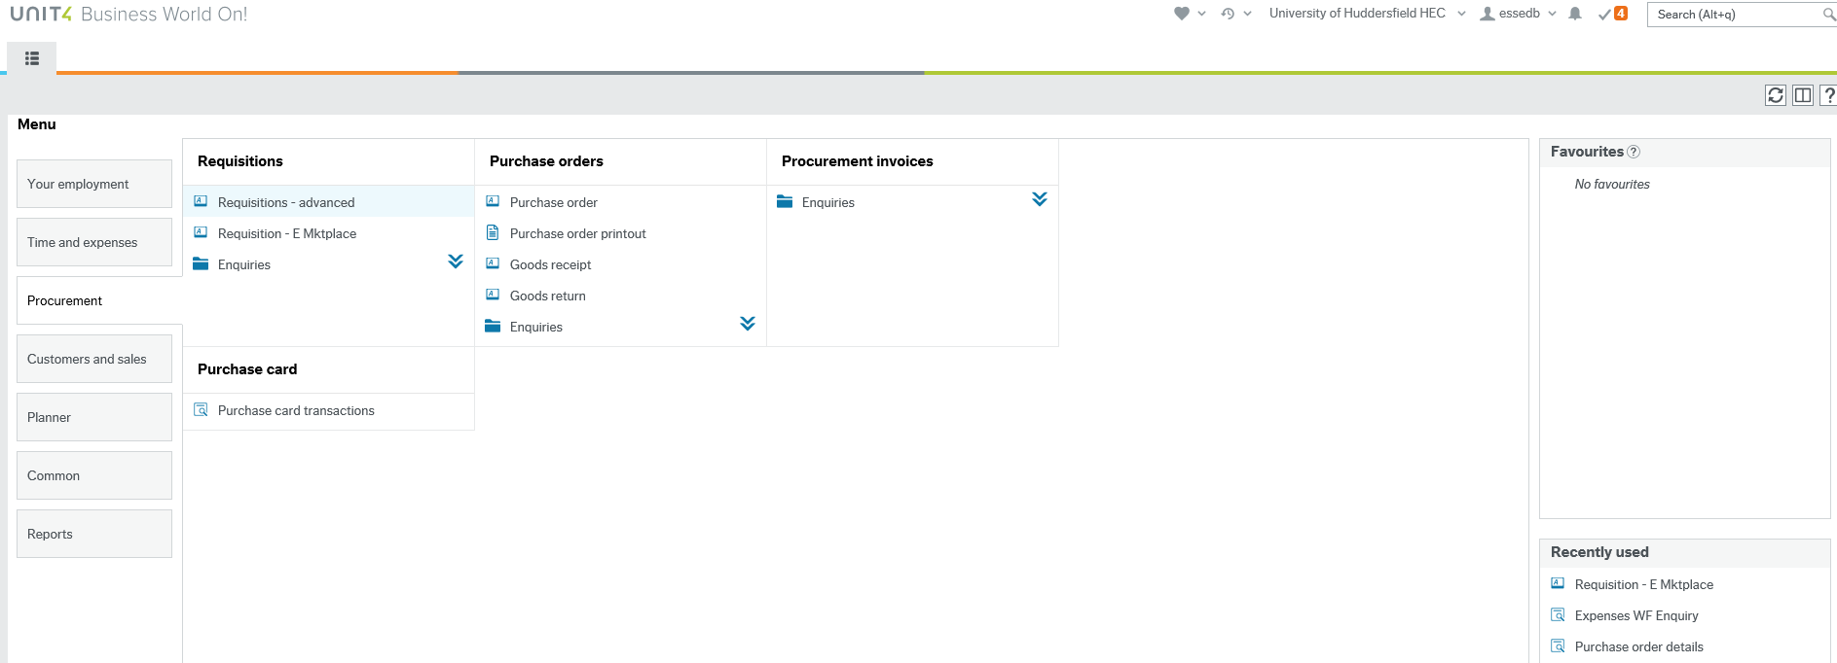

Create the Requisition

Select Procurement, Requisitions, Requisition – E Mktplace.
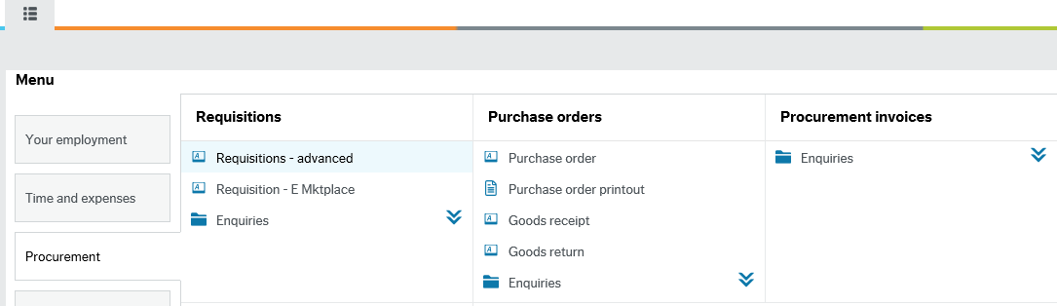

Your name and the current period will be defaulted into the Period and Requisitioner fields.
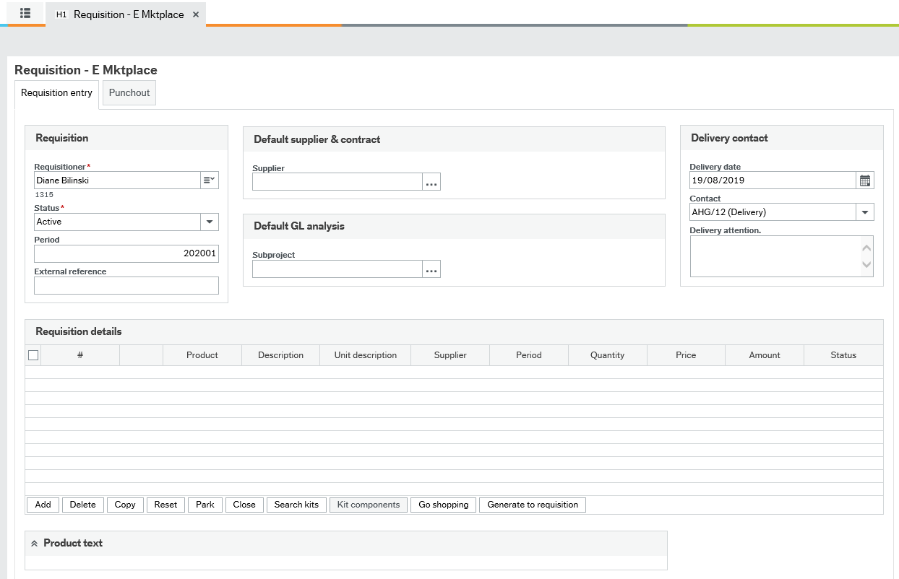

Enter the E-marketplace Supplier ID if known and press tab or click on the search icon .
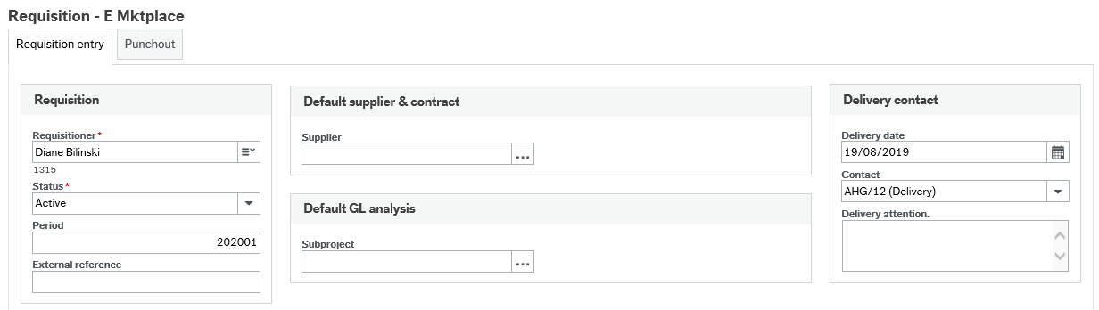

If using the search icon: When the field help appears, click on the arrows to open the Advanced tab.
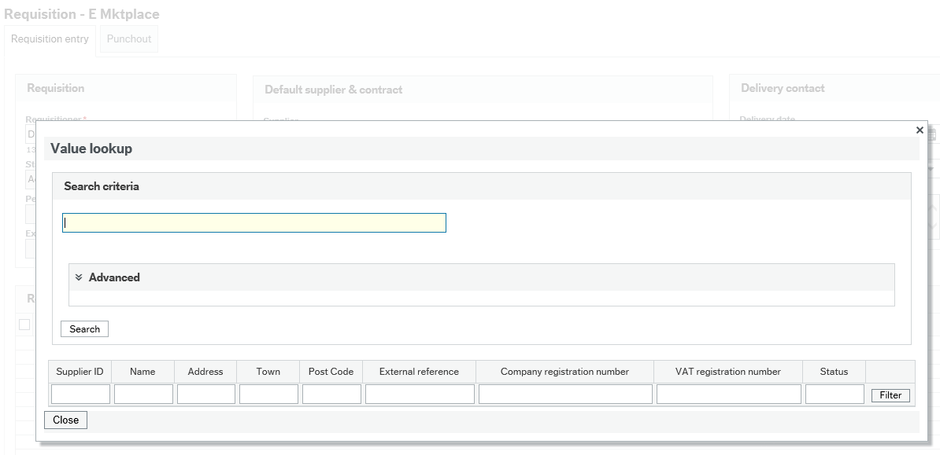

A search can be performed on any of the fields shown. To find all marketplace suppliers type M* in the SuppID field and click on search. All E-marketplace suppliers will be listed.
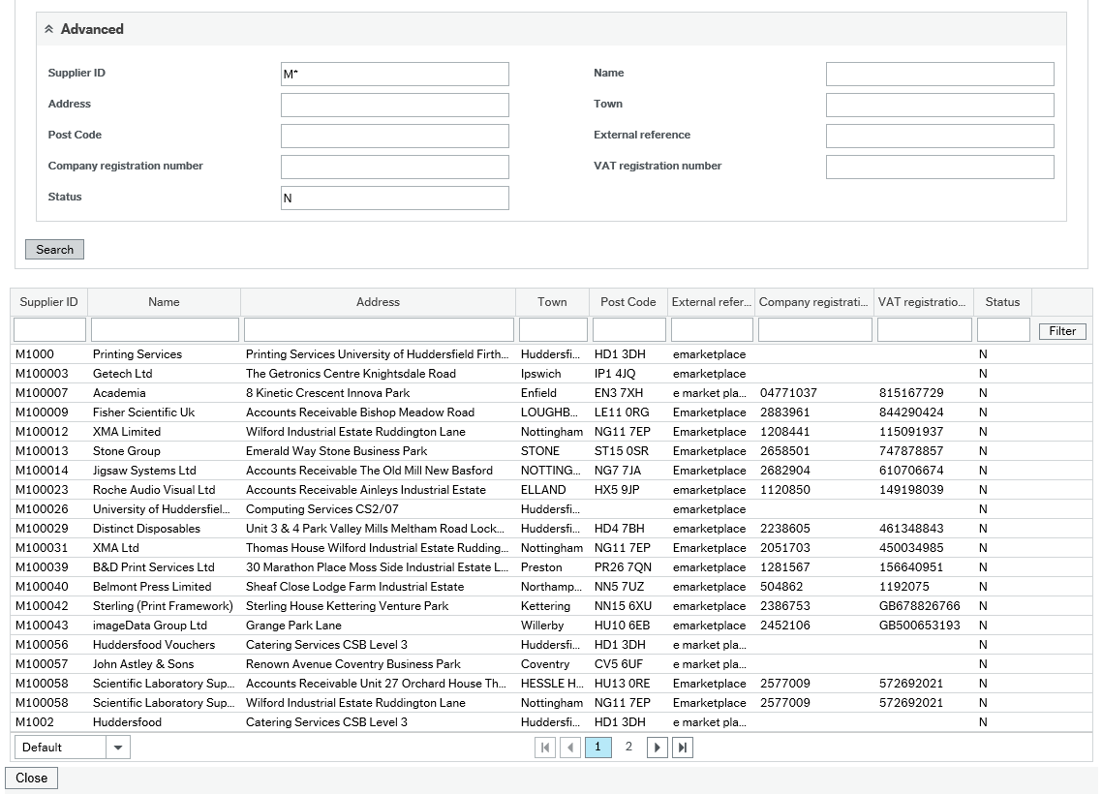

Further suppliers can be viewed by clicking on the page number or the list can be filtered by entering part of the supplier name or address in the relevant field (eg. *purch*) and then clicking on the Filter icon as shown below:
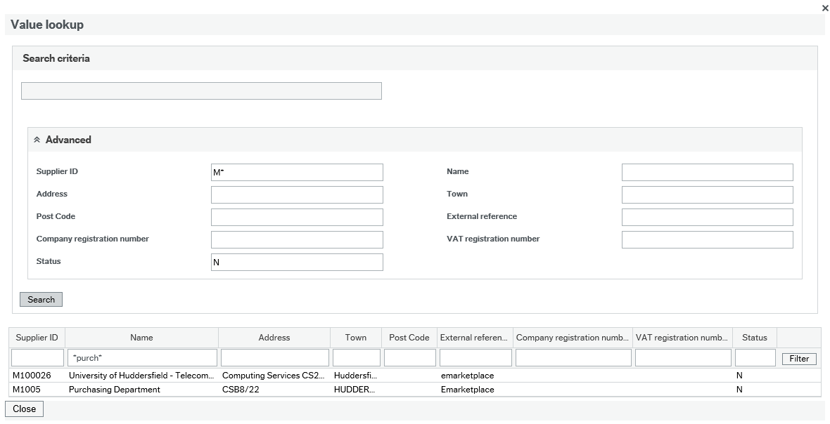

To select a supplier click on the supplier name and this will transfer to the Requisition entry screen.

Enter the Sub-Project (where the items will be paid from) and press tab.
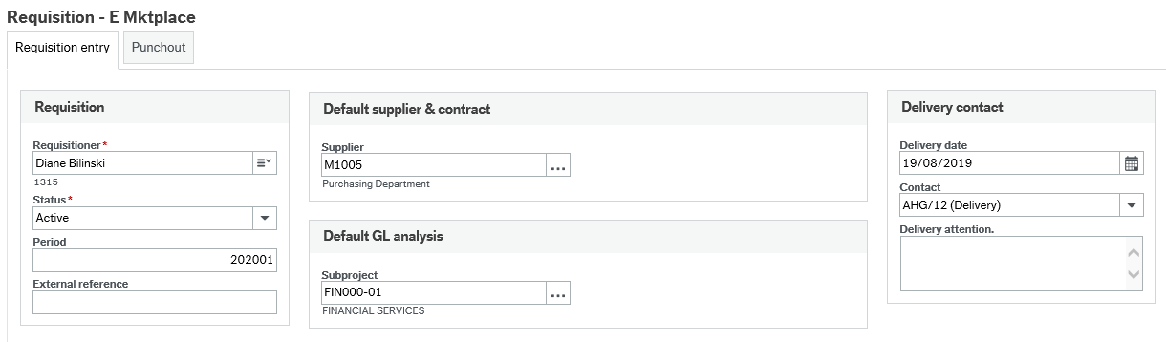

Now select the Delivery date and Contact address from the drop down list and press tab.
All items on the requisition will be delivered to this address. You can also add an external reference; it is advised to be unique for each order so it makes it easier to identify previous requisitions.

NOTE: If different products need to be delivered to separate locations, a new requisition will be needed for each delivery location (except for Catering and Hospitality orders – see below). If the delivery address you require is not available in the drop down list, contact Unit 4 Support.
DO NOT free type or amend the address, as the order will be rejected on the E-marketplace.
(For requisitions to Catering and Hospitality Services the address you select here can be your main delivery address as they will use the delivery address on the product questionnaire not this address).

Click on the Punchout tab and then click Go Shopping
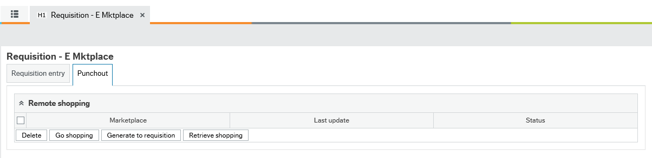

A new Window will now open as below (the window will sometimes appear behind the current screen so you may need to minimise it to see the E-markeplace):

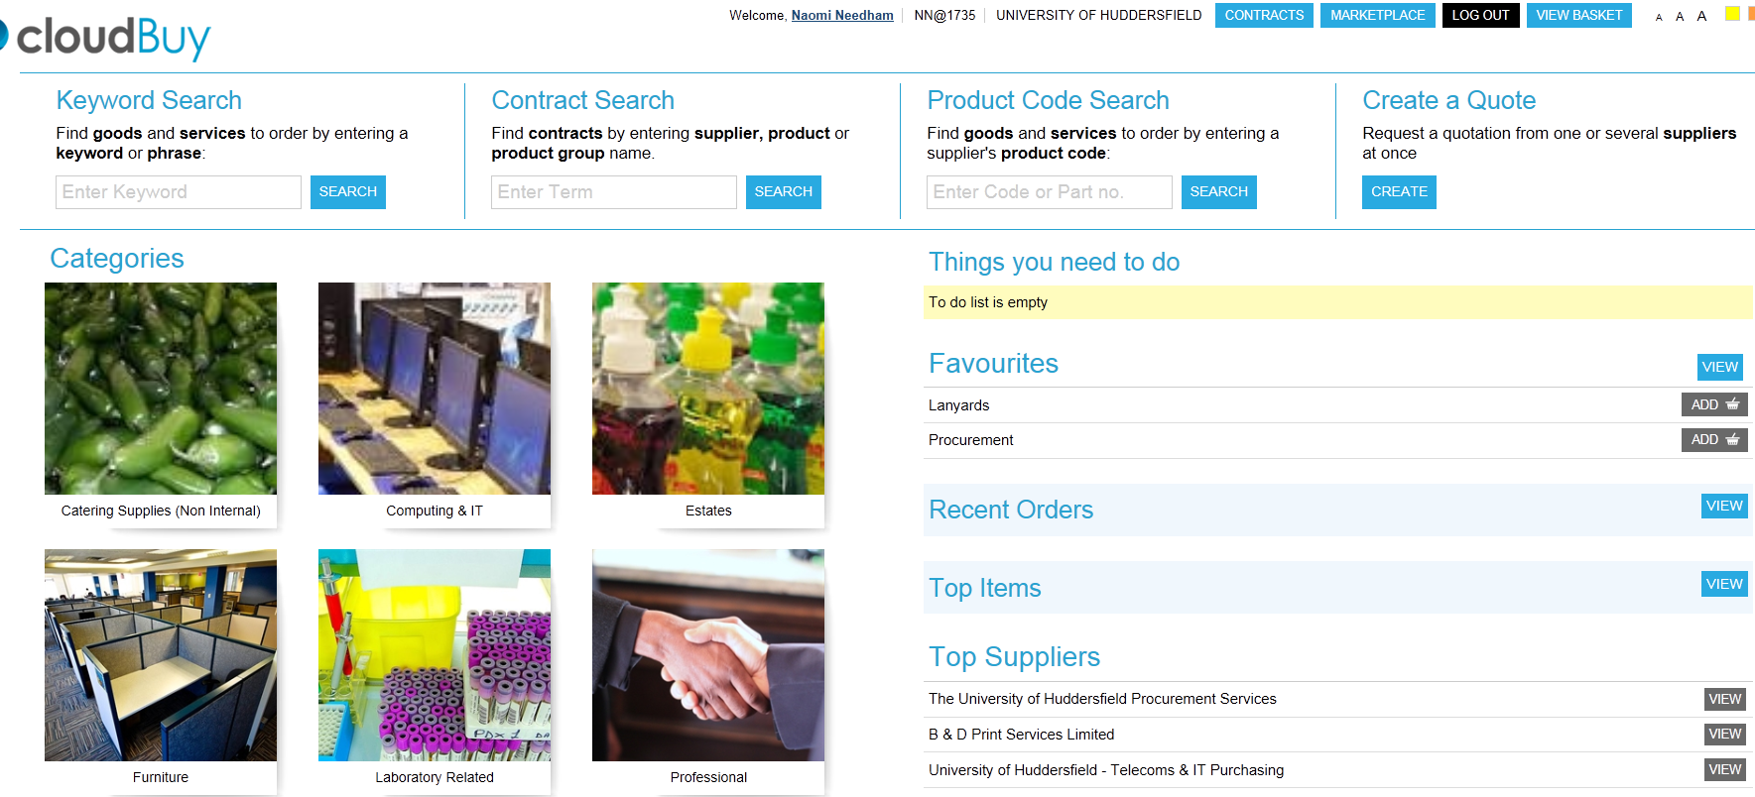

NB: if you are not directed to this screen, hold down the shift and the Ctrl keys simultaneously and click on Go Shopping. If you are then directed to the screen below this means your pop-up blocker is on and you may wish to amend your pop-up settings to allow you access to the site in future.

You are now on the E-marketplace home page.

Select a Product

On the E-marketplace home page should look similar to that below. Suppliers are listed according to the category of products they mainly supply. To view the supplier’s webpage, click on the name of the supplier in this example The University of Huddersfield Procurement Services is selected.

This will take you to the Home Page of the selected supplier. From here you can browse the items available.

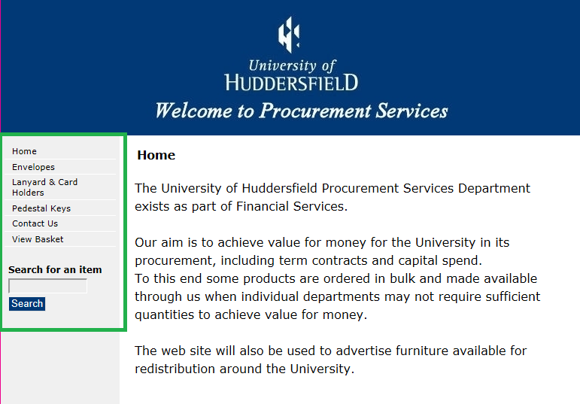
Select the products required in this example Lanyard & Card holders. Enter the Quantity needed and then click on Add to Basket.
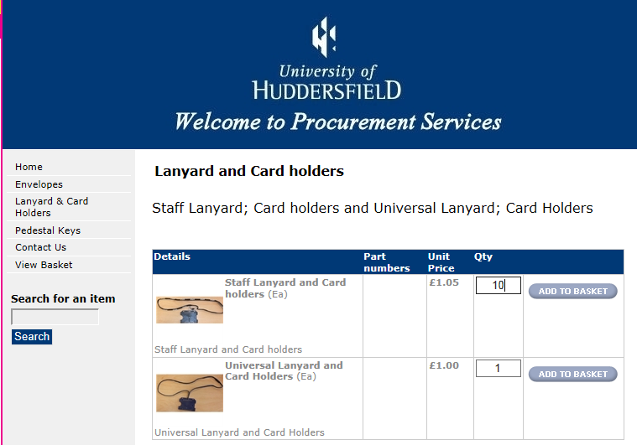
The items you have currently added to your basket will be shown. You can amend the quantity in the basket by changing the Quantity and then click on Update to change the cost. If other items are required, click on the add more to basket button.
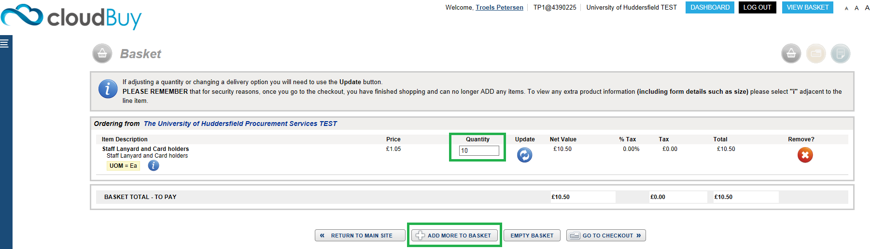

Viewing Your Basket and Checking Out

Once all the items you want to purchase have been added to your basket, check thoroughly before clicking on Checkout. If you need to remove an item from the basket click on the Remove button at the side of the line you wish to delete.
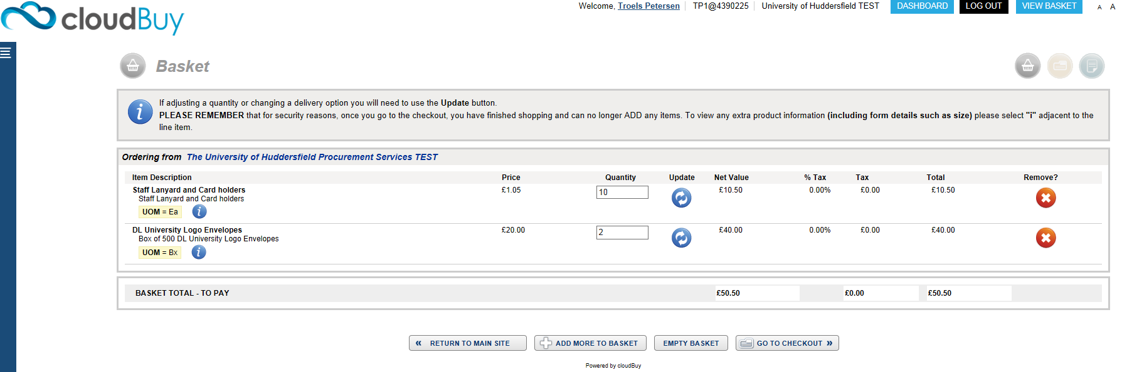
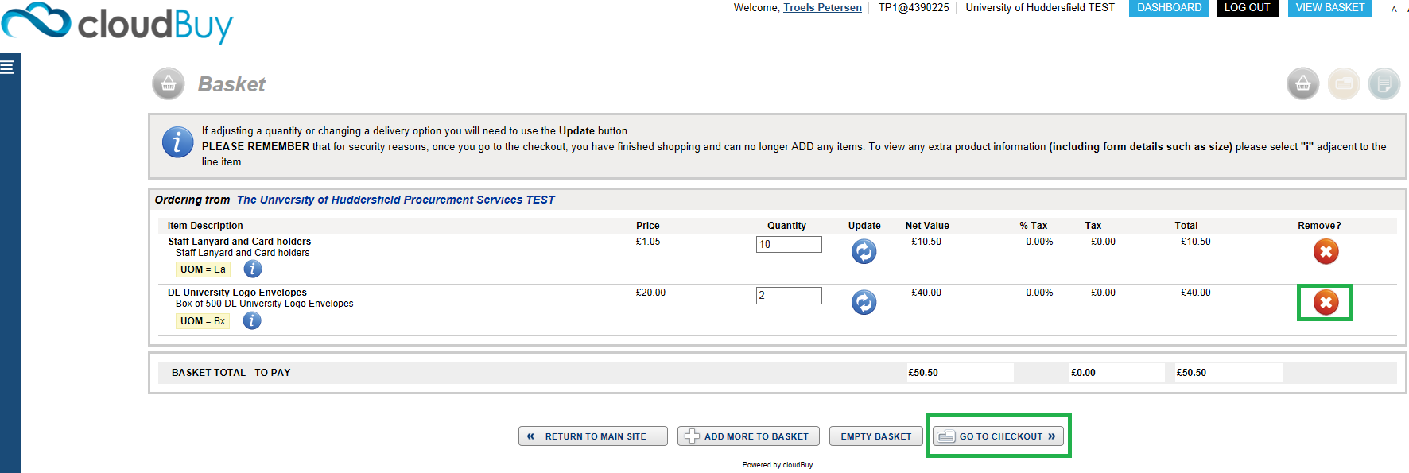

Once your shopping is complete click Go To Checkout this will close the E-marketplace tab and return to the requisition screen in Unit 4 as shown below. Click on Retrieve Shopping.

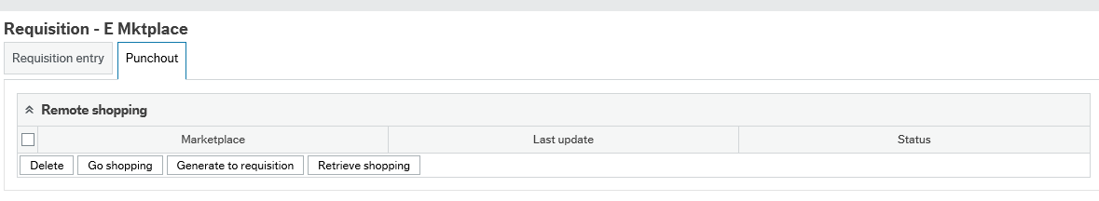

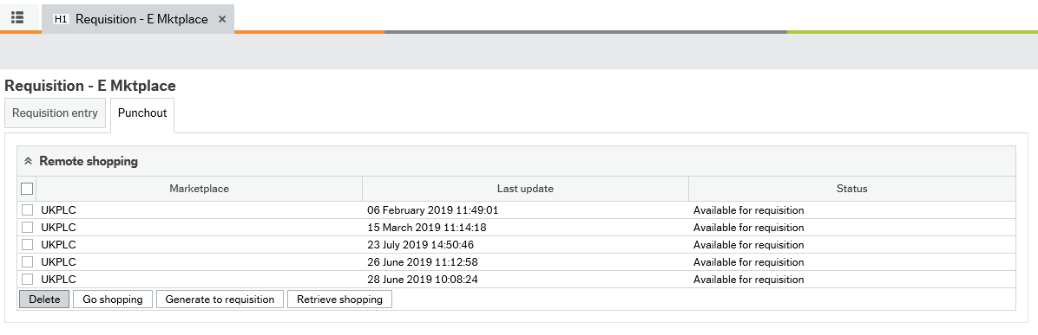

A new line will appear to show the basket you have just checked out:
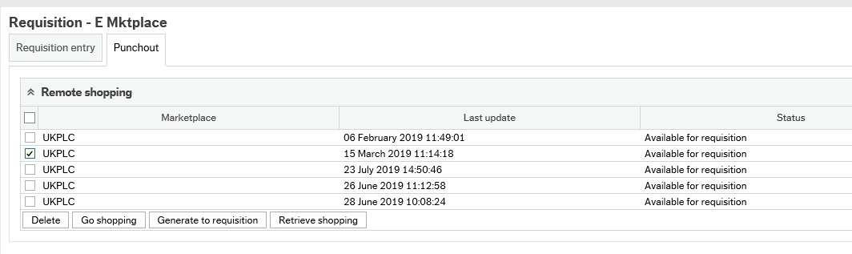

Click in the tick box and this will insert a tick against the relevant line to select the products from that basket, next click on Generate to Requisition.
The items that were in the basket on the E-marketplace will now be shown as items on the requisition:

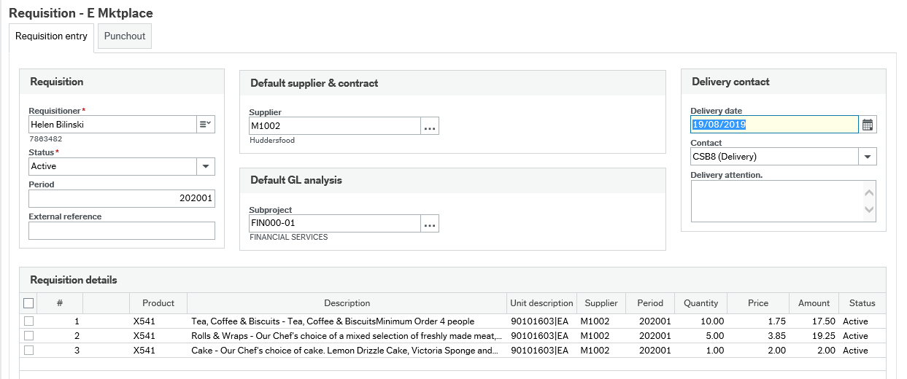

Completing the Requisition

Click on the requisition details line to enter additional details in the Product text. You will need to do this if you want to enter additional information regarding the product. Click on the arrows at the side of an option to open it.
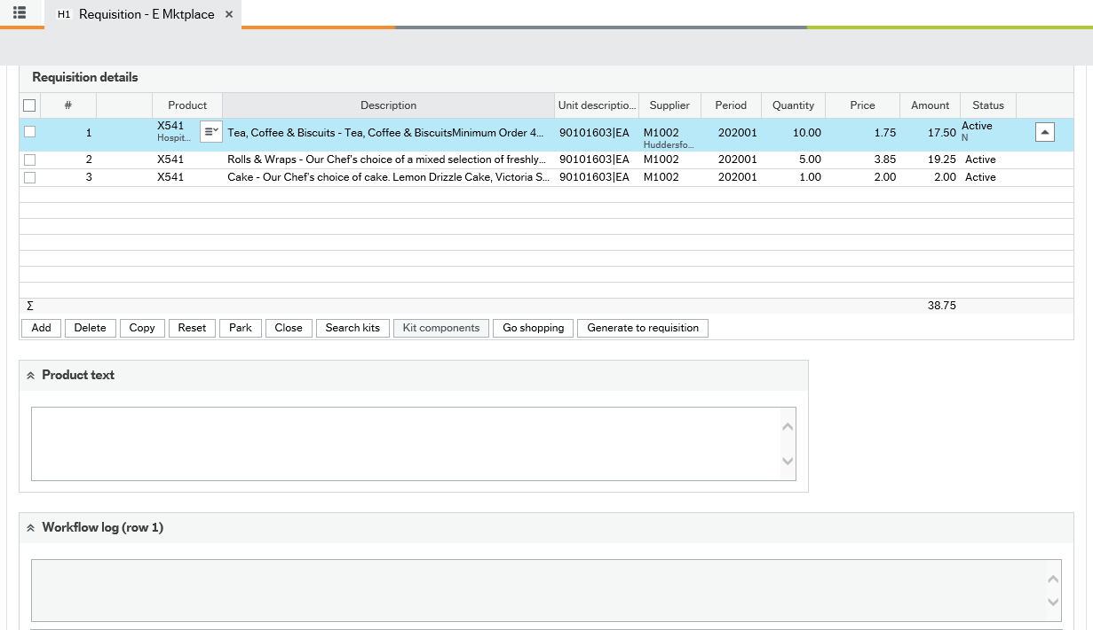

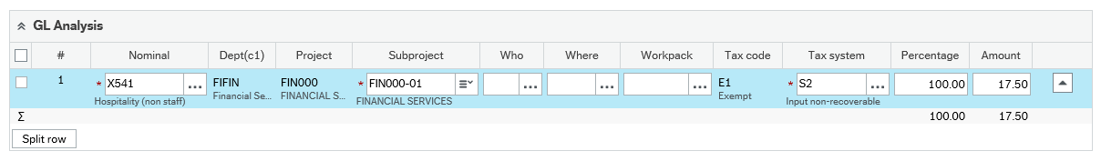

Product Text - enter any extra information about the product which you want to appear on the purchase order that goes out to the supplier.

Workflow Log - enter any relevant information here which you want to be seen by the budget holder. To duplicate the explanation for each product onto different lines, put a tick in the tick box for the relevant lines in the Requisition Details section and then select Copy under Workflow log.

NOTE: For Catering and Hospitality Services orders you will need to enter brief details of the event as the questionnaire information is not accessible in Unit 4.
GL Analysis - shows the accounting information where the purchase of the product will be charged. To change this, click into the field where the current Nominal is and type over the details with the new nominal.

NOTE: The GL Analysis line will now show the new nominal to be charged. The Requisition details line will NOT change as this is the product code to be sent to the supplier and must be the same as the one from the E-marketplace (see below).
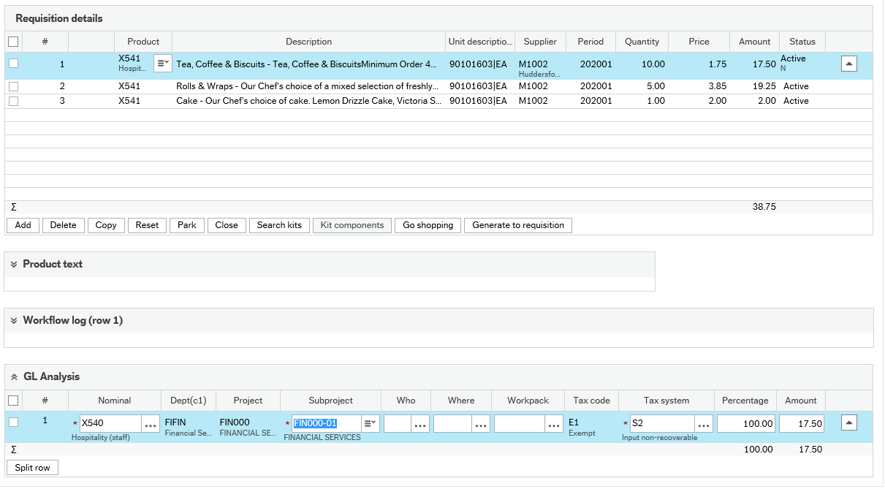

The catering nominal can be changed depending on the hospitality;
X540= Hospitality (staff)
X541= Hospitality (non Staff)
X545= Hospitality exceeding 3:1 ratio (more than 3 external to 1 internal staff)

When the requisition is correct and no further changes are required, click Save. Select the appropriate requisition type for the order to be raised, which in this example will be I O (Internal Order). Click OK.

- Req - (Standard Purchase Order) for orders to external suppliers
- Req IO - (Internal Purchase Orders) for orders to Internal Suppliers
- Req PC - (Petty cash Order) for orders to reimburse petty cash expenditure
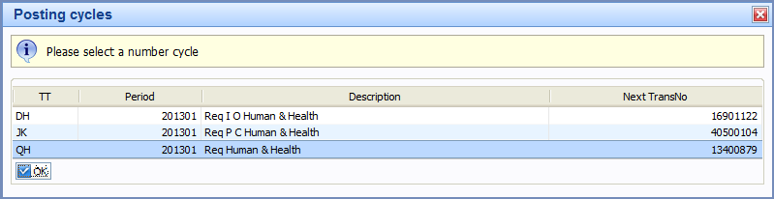

A Requisition Number will then be produced and will show in the green box at the top of the screen.
Each line on the requisition will go through a workflow process to be approved by the subproject budget holder. Where the cost is split over different subprojects, the lines will go separately to the budget holder for that subproject.
NOTE: The requisition will not convert to an order until all lines have been approved.
The progress of a requisition through workflow can be checked by running a workflow enquiry (see the section on Making an Enquiry on a Requisition).

Making an enquiry on a requisition

If you would like to enquire on the progress of a requisition you can select
Procurement/ Requisitions/ Enquiries/ Workflow enquiry - Requisitions from the main menu and the following screen will appear.
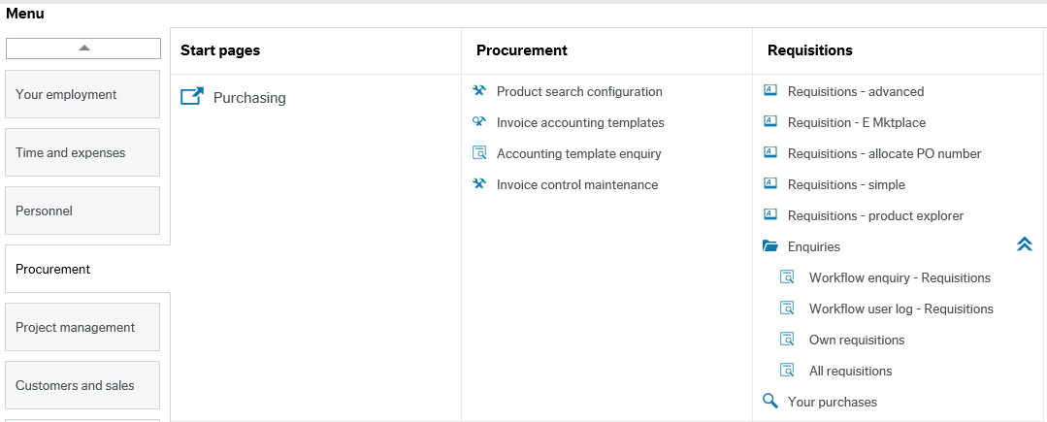

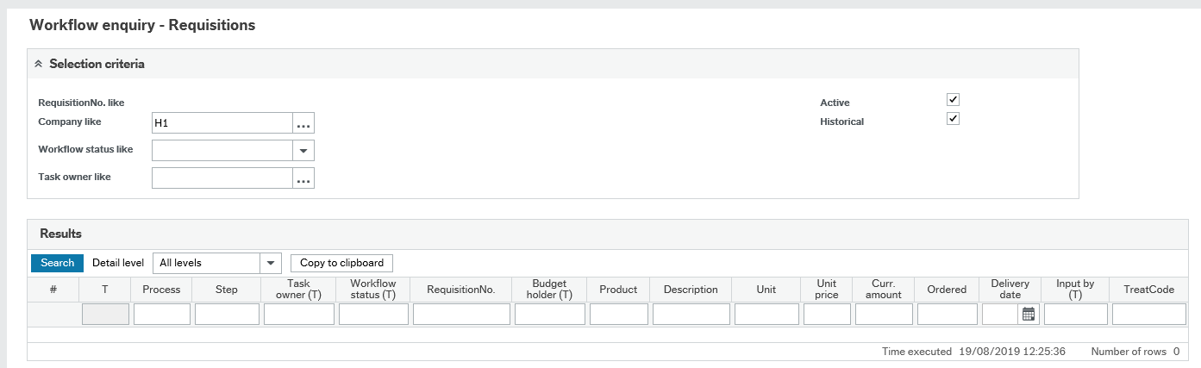

To filter down your search, you can type your requisition number in the RequisitionNo column.
Then click on search
This brings all lines relating to the requisition number.
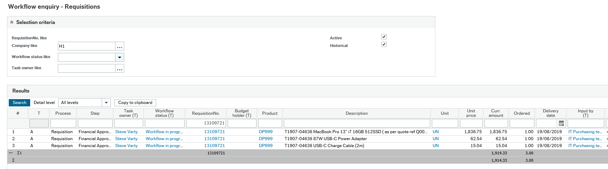
Using the example below, you can see this requisition is currently waiting for Financial Budget Holder Approval. You can identify the name of the approver under the Task Owner column.
You can also view the work flow map by clicking on the Workflow status hyperlink. This shows a pictorial view of the workflow and indicates to whom the requisition has been routed for approval.
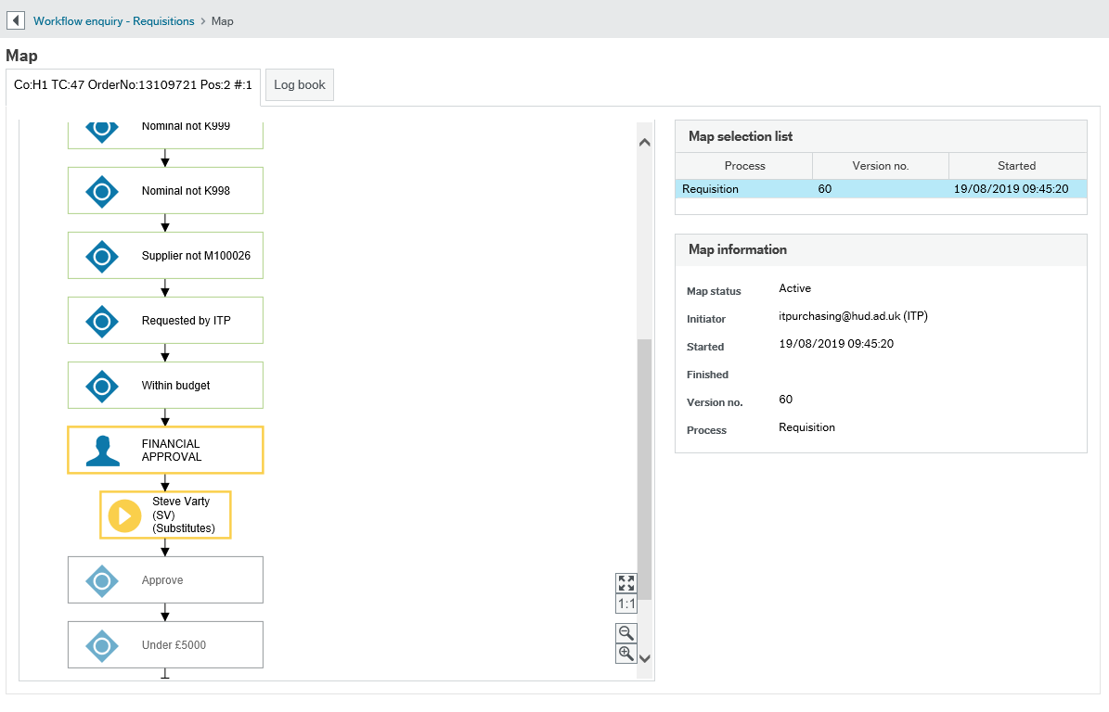
Green - These steps have been completed.
Yellow – This step is awaiting action and has not currently been completed.
Red – The steps highlighted in red indicate that the budget holder has rejected the requisition; therefore the requisition has been routed back to the inputter for amendments. For example, an incorrect Subproject could have been entered or there could be no value on the order.
If you move your mouse over a box it will provide information on when the step started and finished and the person who actioned that step.

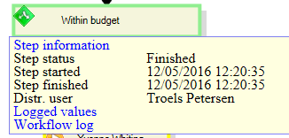

Sending the Order to the Supplier

Once the requisition has been through workflow and converted to a purchase order, you will receive two confirmation emails, one from Unit 4 to confirm the order has gone to the supplier and the second from the supplier confirming receipt of the order. E-market place orders DO NOT need to be printed, they are sent electronically to the supplier via the e-market place.
Example Unit 4 Confirmation
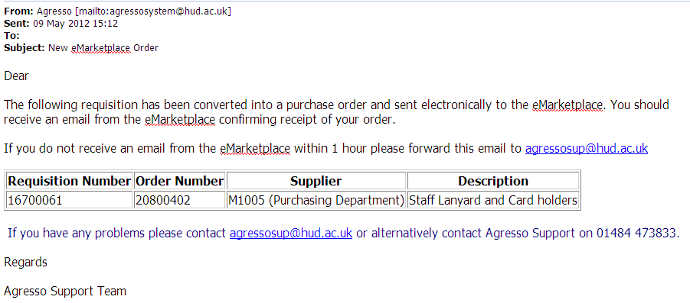
Example Supplier Confirmation
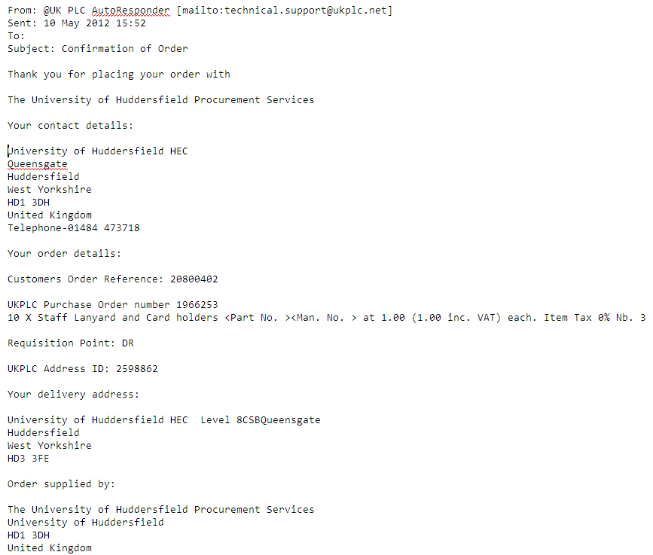
NOTE: If you have not received the supplier confirmation email as above within 15 minutes of receiving the first e-mail, please contact Finance System Support.
Now wait for the goods/service to arrive and then make a Goods Receipt Entry (see below).
NOTE: Do not wait for the invoice to arrive to enter a delivery.

Making a Goods Received Entry

From the Menu select Procurement/ Purchase Orders/ Goods Receipt
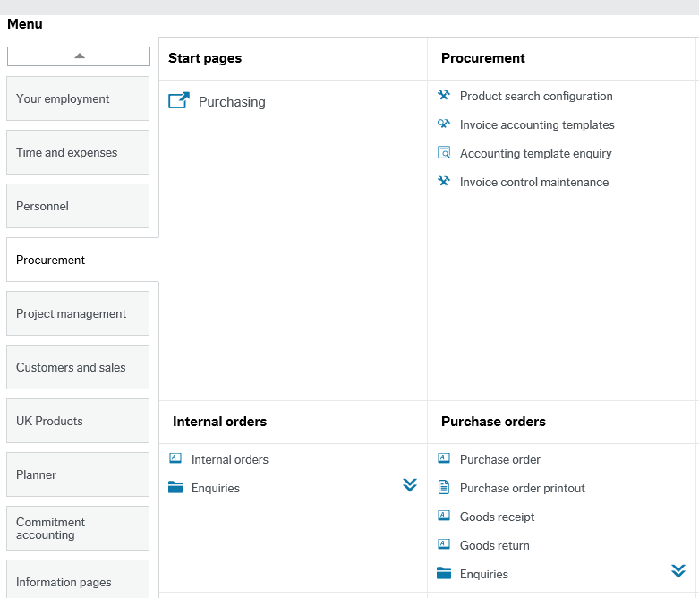

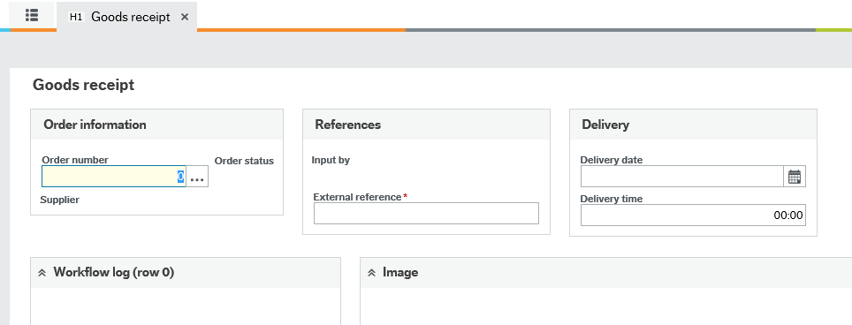

- Enter in your order number and tab
- Scroll down the page to the Order details and then, for each line enter the amount you wish to deliver in the Qty Received column.
- To confirm the changes click on the at the right hand side of the order line.

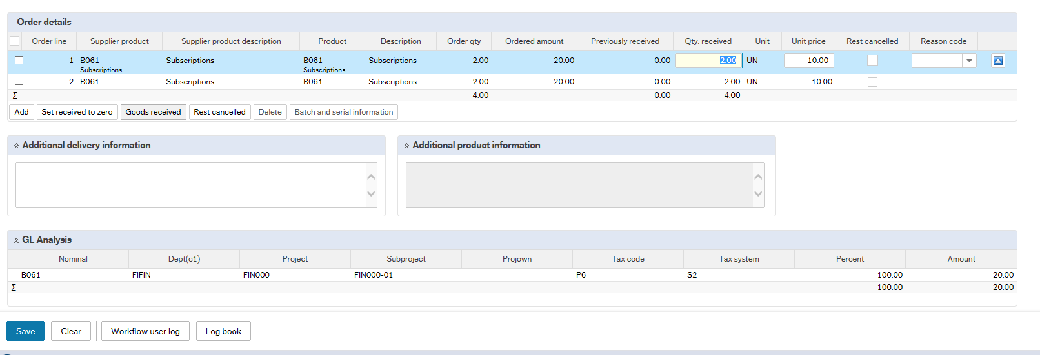
Once you have entered in the correct delivery amounts you can click Save
Goods Received If you are receiving the full amount of an order line(s), instead of typing in the amount in Qty Received, you can tick the check boxes at the beginning of each relevant line and then click This will put the total Ordered Qty into the Qty. Received column (useful if there are many lines to an order). You can then click on the save icon to save the changes.

Rest Cancelled If there are more items outstanding for that order line and you are not going to receive them, you can cancel the remainder by ticking the first column of the order line and selecting ‘Rest Cancelled’ 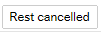
This will close the outstanding quantity on that line. Once the invoice is posted, it should close the line and show as ‘Finished’.
If the amount that you deliver is the same amount on the invoice, the system will then post the invoice to the ledger ready for payment.

Missing Goods (GRN) Task

If you have not delivered the goods on your purchase order and the invoice has already arrived into Finance, it will be scanned into the system and you as the inputter will receive a Missing GRN Task in your Task List and an email notifying you that there is a task waiting to be action.
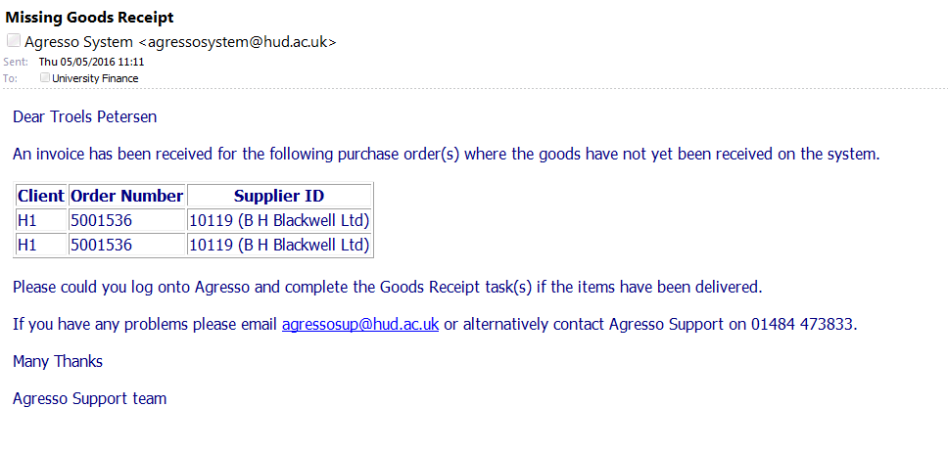

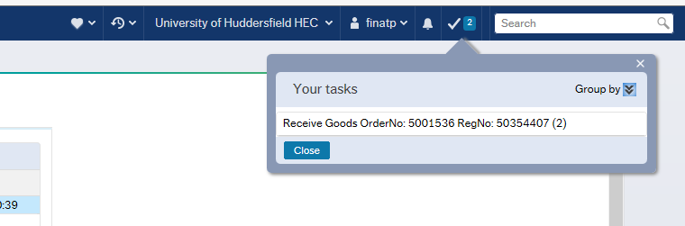
You will find your Missing Goods tasks looks like this in your task bar in the top right corner.
Click onto the task and the following screen will appear.

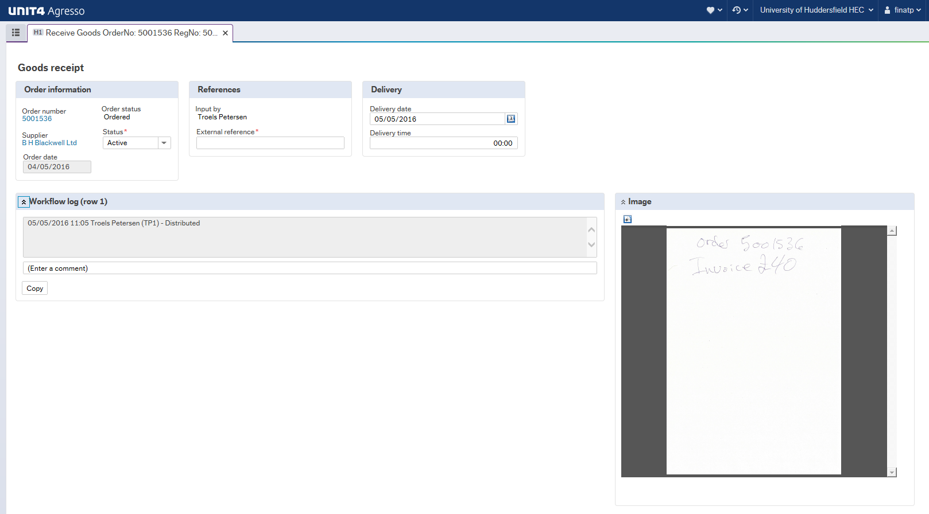
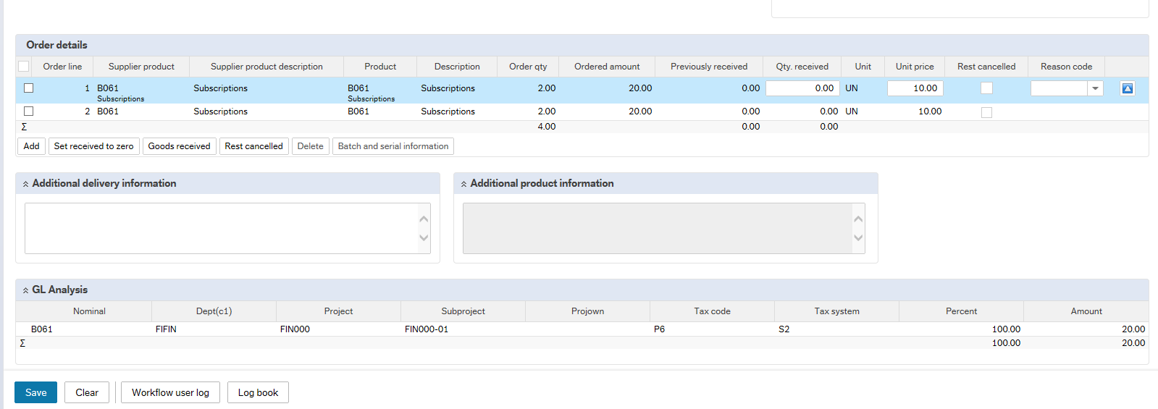
The invoice can be seen on the right hand side of the screen. You can enlarge this by clicking on the open/download icon.
Goods Received If you are receiving the full amount of an order line(s), instead of typing in the amount in Qty Received, you can tick the check boxes at the beginning of each relevant line and then click This will put the total Ordered Qty into the Qty. Received column (useful if there are many lines to an order). You can then click on the save icon to save the changes.
Rest Cancelled If there are more items outstanding for that order line and you are not going to receive them, you can cancel the remainder by ticking the first column of the order line and selecting
This will close the outstanding quantity on that line. Once the invoice is posted, it should close the line and show as ‘Finished’.
If the amount that you deliver is the same amount on the invoice, the system will then post the invoice to the ledger ready for payment.

Sending a Request for Quote to a Supplier

If the product required does not appear or differs from that on the supplier website, there is the facility to request a quote from a supplier or to request quotes from several suppliers who supply the same goods/services.
When you have clicked on the Punch Out tab and then Go Shopping you will see the Marketplace home page. Here you can click on Create under the heading Create a Quote or select Orders, My quotes, Create quote request.
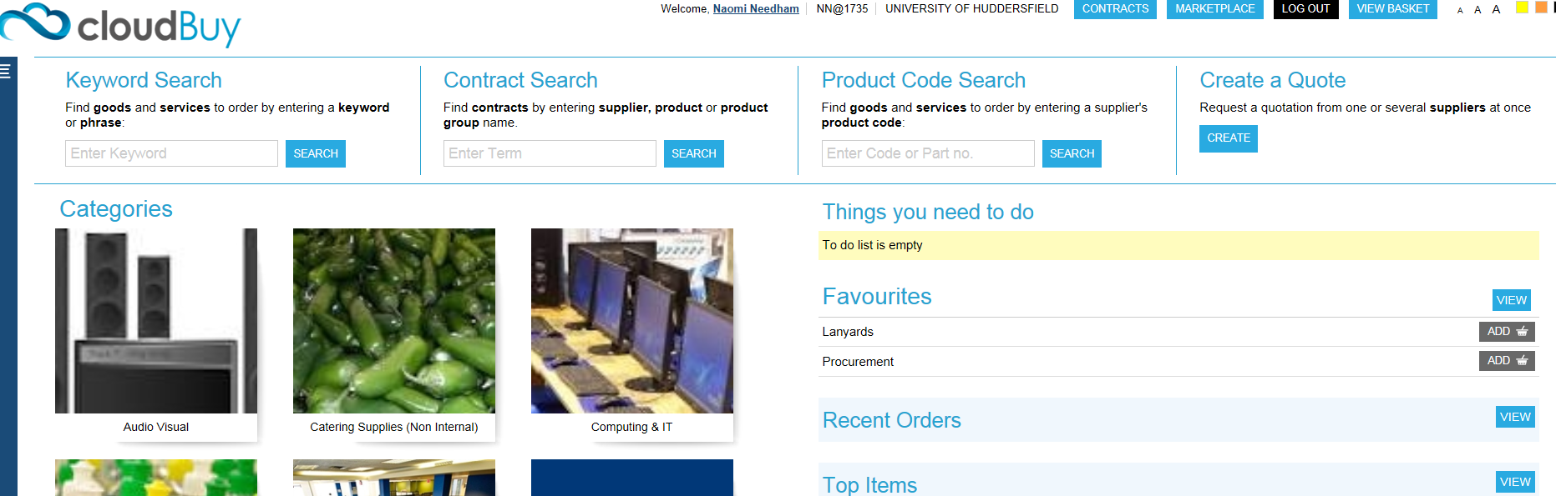
You now need to read the information on the types of quotes and decide which one is most suitable for the items you require a quote for.
NOTE - Open and Sealed quotes are non-negotiable and once the supplier has replied you can only accept or cancel the quote. A Negotiated quote is the only quote where you can respond to the suppliers reply to your quote and is the recommended quote type.

Click on the circle at the side of the type of quote to select it. A Sealed Quote will require a Close by date so you will need to select the date by clicking on the calendar at the side.
If you want to Allow responses from any supplier you will need to click in the tick box to the side (this option is not available for Negotiated quotes). Click on Save and Continue.
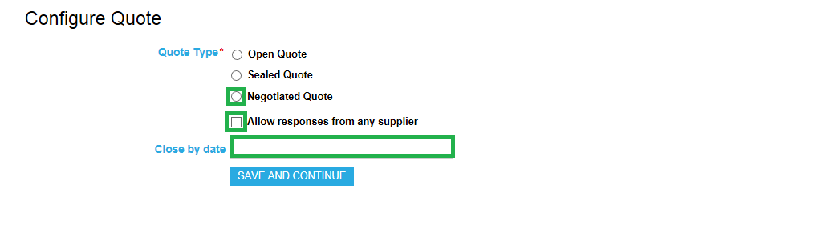
You can now search for the supplier(s) you wish to receive a quote from. In the Search Term type the name of the supplier or the type of goods you are looking for and click on Search for Suppliers.
The supplier or list of supplier(s) will appear. To select the suppliers you want to receive a quote from:
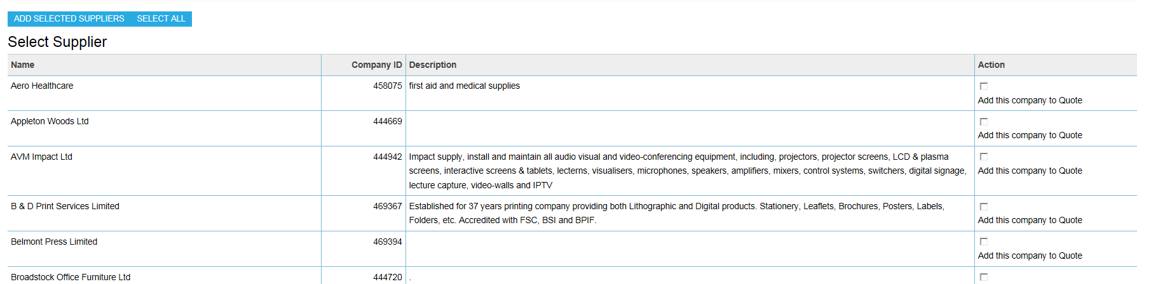

1 - Click in the box under the Action column if you want to select that supplier.
2 - Click Add Selected Suppliers

Once you are happy with the supplier(s) you have chosen click on Save and Continue.
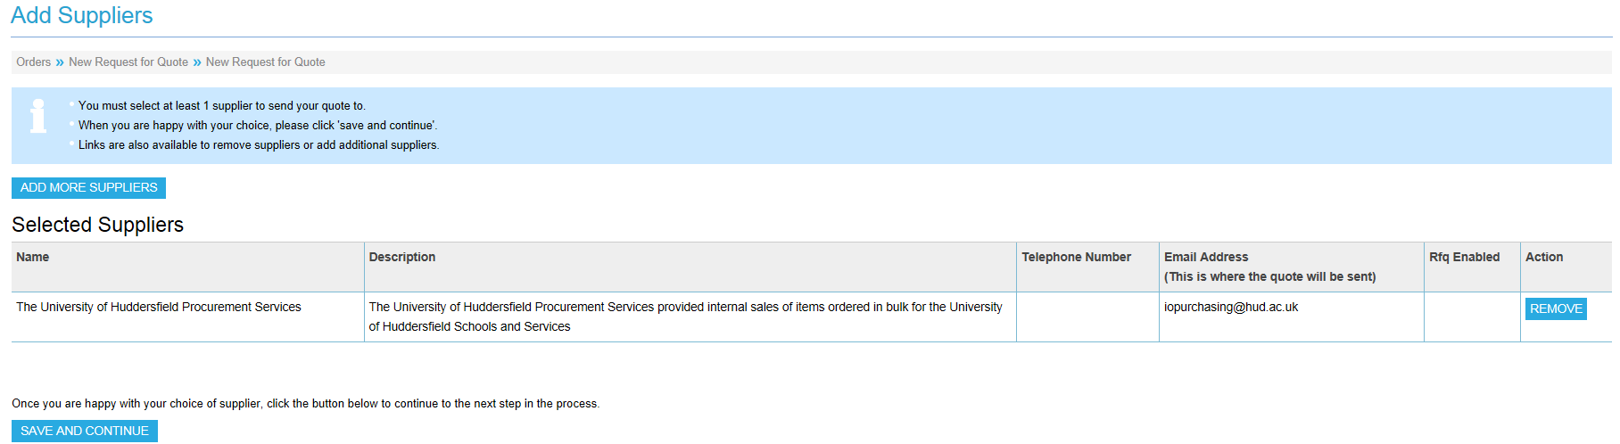

List Template Quotes

There are two types of templates you can use for the quote. The recommended type is a List template which allows you to enter details of the items you want to a quote for in list format.
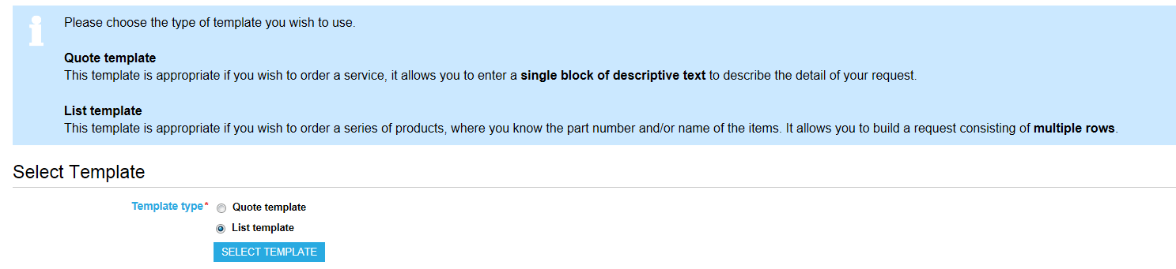

You should enter the supplier Part Number of the items you want (if known), then you must enter the Quantity and Description. You can add extra rows if necessary.
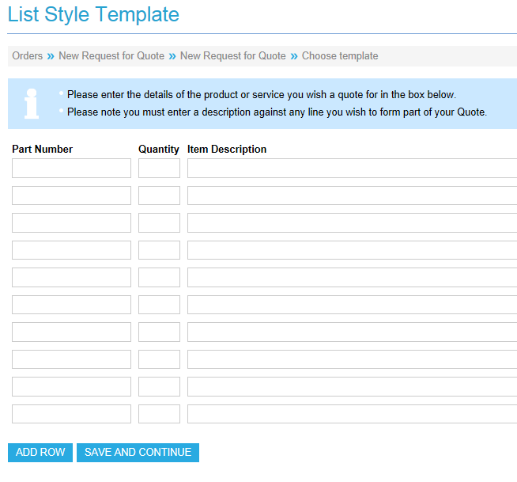 Click on Save and continue and you will be given the option of attaching a file if required. To do this click on Attach Files and then click on Continue.

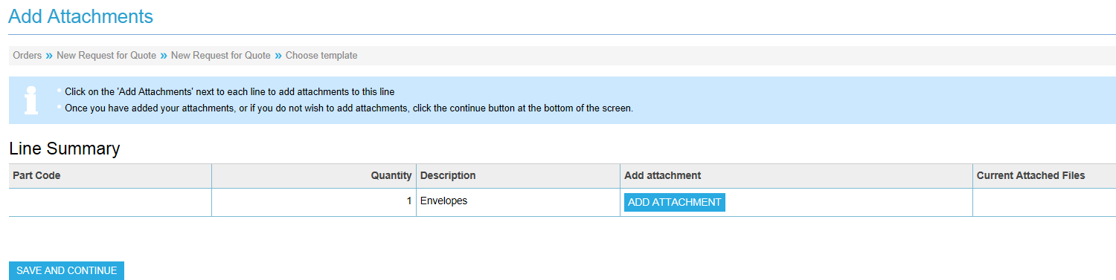

You will then need to click on Browse and select the name of the file to be attached. Then click on the upload button to add the link to the relevant file. If you have attached an incorrect file or wish to remove the file click on remove.

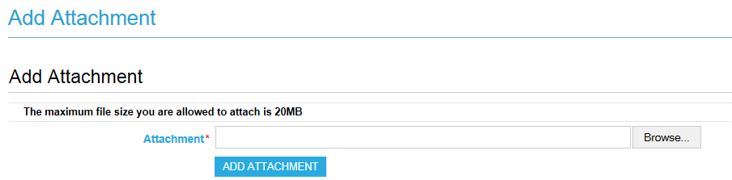
The name of the file you have attached will be confirmed and you can click on close window to see a summary of the quote details.
Please take note of the quote ID at this point.
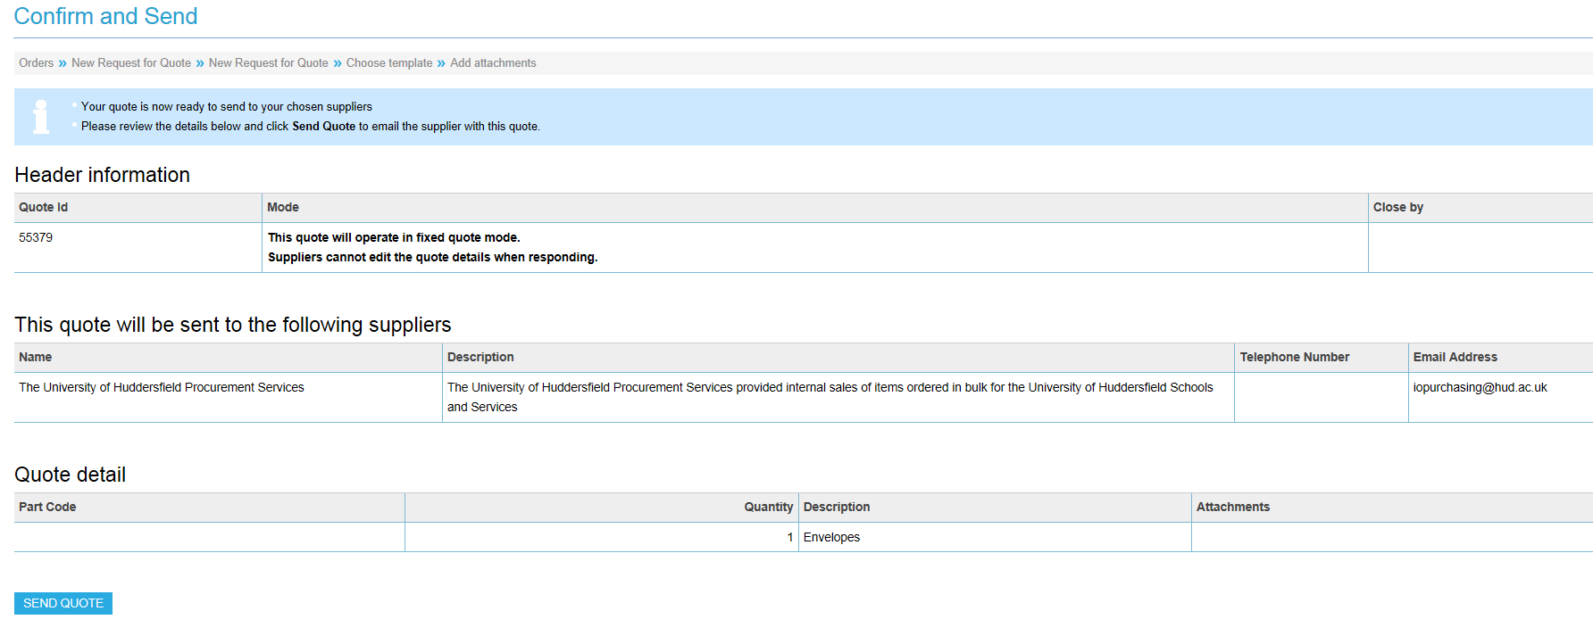

Finally, to confirm the quote, click Send Quote and you will receive an on-screen confirmation that the quote has been sent.

Quote Template

The second type of quotation is a Quote template which allows you to enter details of the items you want to receive a quote for in a single block of descriptive text:

NOTE - when this is converted to a requisition the quantity will always be one so if several invoices expected do not use this template type.
Click on Save and continue and you will be given the option of attaching a file if required. Continue as the instructions for Quote template.

Accepting/Cancelling a Quote and Setting up a Quote Template
Once the supplier has responded to the quote you should receive an e-mail as follows:
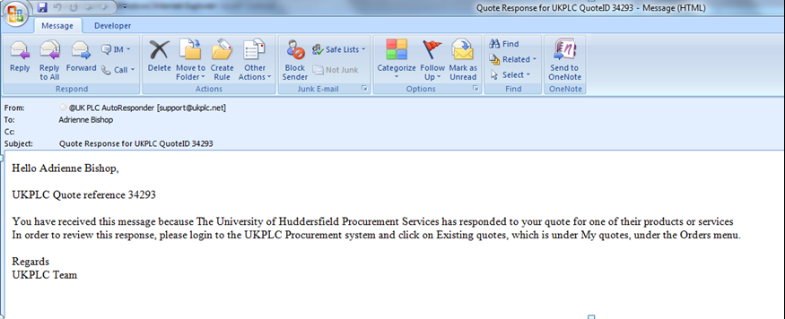
To review the quote you will need to log into Unit 4 and select Procurement , Requisitioning, Requisition – E Mktplace and follow the instructions in Requisition E-Mktplace at the beginning of this document.
Once you reach the @UK marketplace you can view the response(s) to your request for quote by selecting:
Your ‘Things you need to do list’ on the Market place homepage on the right hand side, where any outstanding quotes will be waiting to be processed.
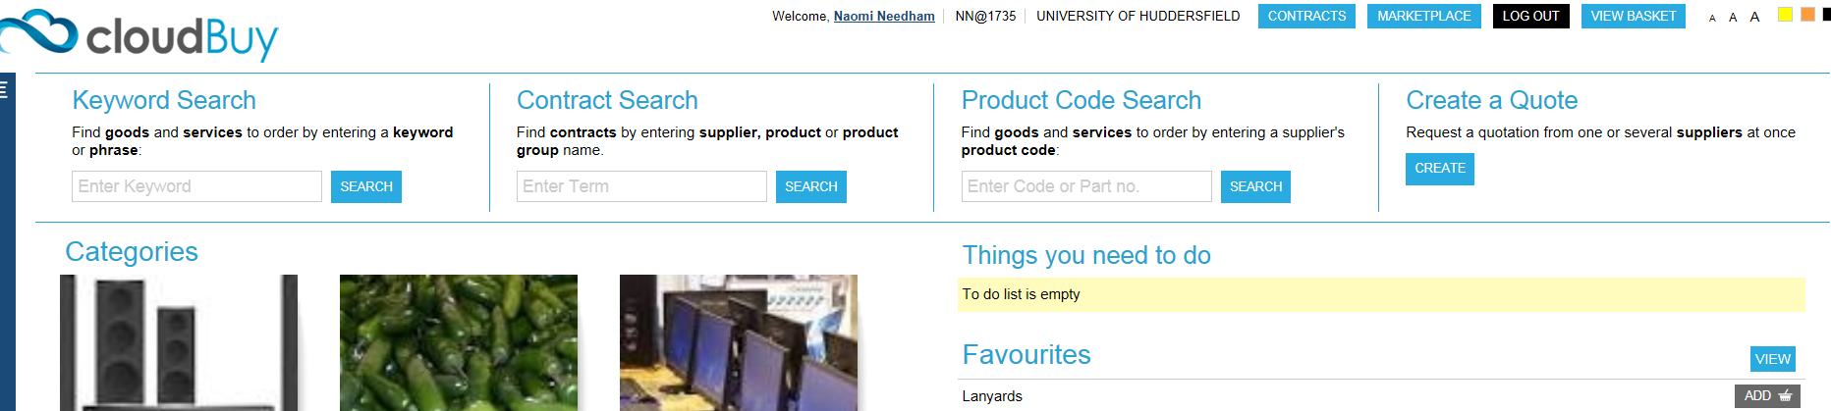

Or Orders, My Quotes, Existing Quotes. Use this process to view existing quotes, particularly if you have been logged out and need to go back.

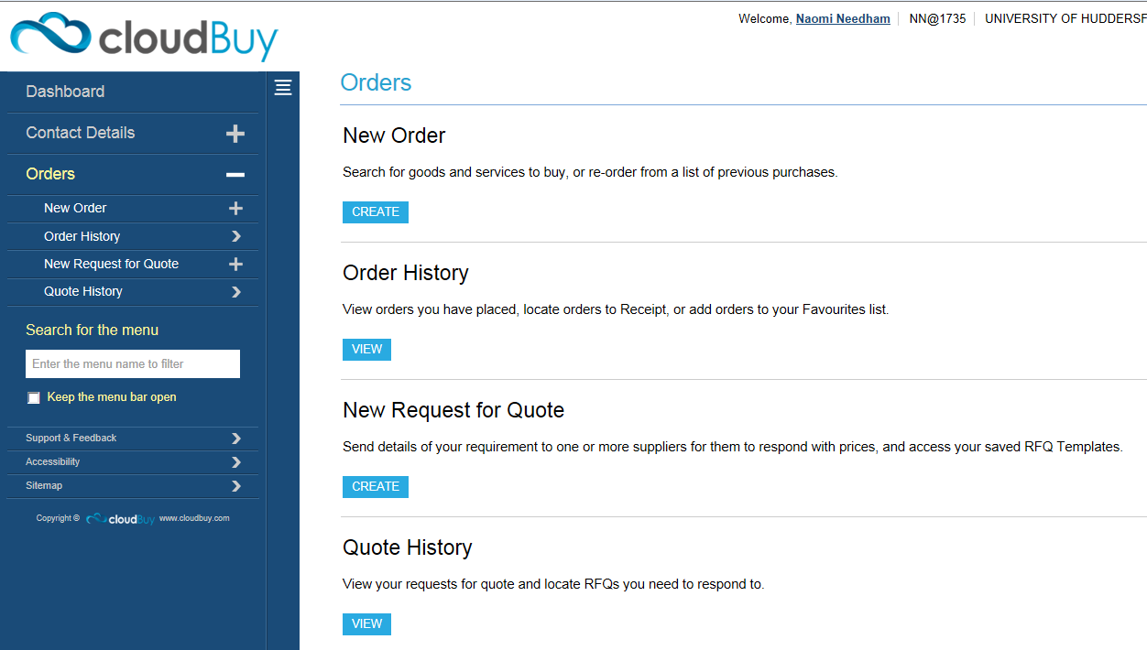
You can search using the description, a date range, closing date, status or the quote ID number and click Search (NOTE leave both the Available to all users box blank).
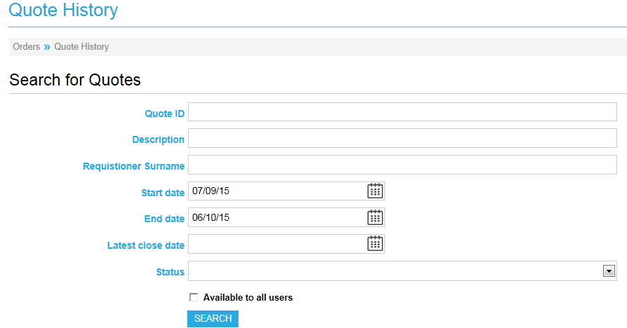

Your search results will be displayed as follows:
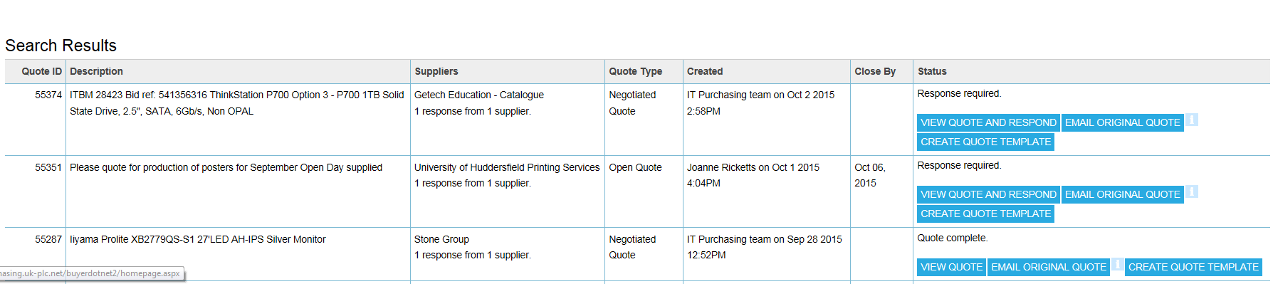

The number of responses will be shown. If you want to save the quote as a template for future use click on Create Quote Template enter a name for the template and click on Save Quote Template.
To view the responses to the quotation click View Quote. You will then see an overview of the original quote with the supplier responses showing price and any attachments.
If you want to reject the quote click on the Back button on your browser and then click on Cancel This Quote.
When you have decided which supplier you would like to place your order with, click Select Winning Supplier on the corresponding row and then click the Select The Winning Supplier button.
You will then have the option to write an internal note (this is not visible to the supplier), recording why you decided to choose that particular supplier then click Send Mails And Add Winning Quote To Basket.
Emails will then be sent to all suppliers involved in the quote process, notifying them whether or not they have been successful. (NOTE you may be asked by suppliers who were unsuccessful to provide feedback when they have received the e-mail).

The items on your quote will then be added to your Basket and you can then checkout and Generate to Requisition.
