ENQUIRING ON ACTUAL EXPENDITURE AGAINST BUDGET
The only place that you can view actual expenditure against budget is on pre-defined enquiries that you can access via Full Picture by Subproject under the Reports Tab, Global Reports.

Double click on the year that you wish to see your budget in.
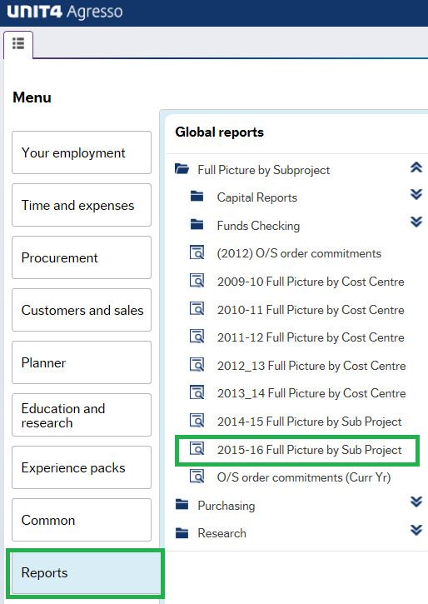

The following screen will open. You will need to enter the subproject and then click “Search”

The report will show you the Current Budget, the Amount of expenditure already paid, the Orders which have already been committed to and the Variance which is the amount left available.

