Web-based Requisitioning

Training Documentation

Finance System Support
Email - FinanceSystemsSupport@hud.ac.uk
URL- https://agressoweb.hud.ac.uk/MS7_Live_Web/Login/Login.aspx
Training- https://staff.hud.ac.uk/finance/financesystems/training/

Inputting a Web Requisition
By following the URL you can log on to the Live Unit4 system: https://agressoweb.hud.ac.uk/MS7_Live_Web/Login/Login.aspx
Alternatively, via the Staff Hub internet page login:
On the black navigation bar near the top of this page, locating the link Online Systems.
This opens a new page which you will need to scroll down to locate the link for Unit4 (campus only).

To note: OFF campus you will need to login via Unidesktop to access.
Enter the following information:
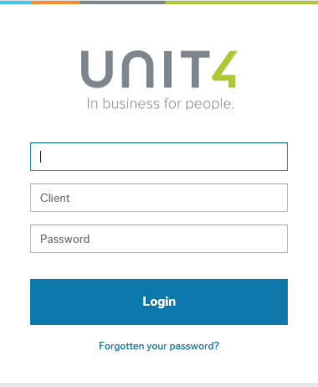
NAME: e.g. FINANN
CLIENT: H1 (Main Company)
H3 (UHEL Company)
PASSWORD: must be at least 6 digits and include a number.
If you have forgotten your password, please use the ‘Forgotten your password?’ option
Click the Login button

Considerations before raising a Requisition

If the purchase value is below £5000 – a requisition can be raised (without quotes or tender)
If the purchase value is above £5000 – 3 quotes must be obtained before raising the requisition
If the purchase value is above £50,000 – the purchase must be put out to tender before raising the requisition

Opening a page similar to the following screen shot. The ‘book ends’ available at the bottom left of the screen will vary according to your role.
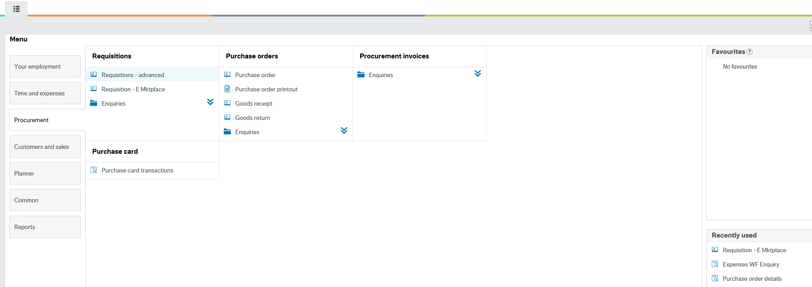
Go to Procurement/ Requisitions/ Requisitions – Advanced and click.
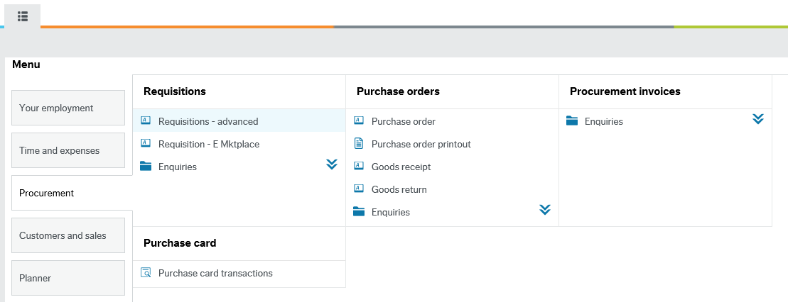

Requisition Entry
This brings up the following screen.
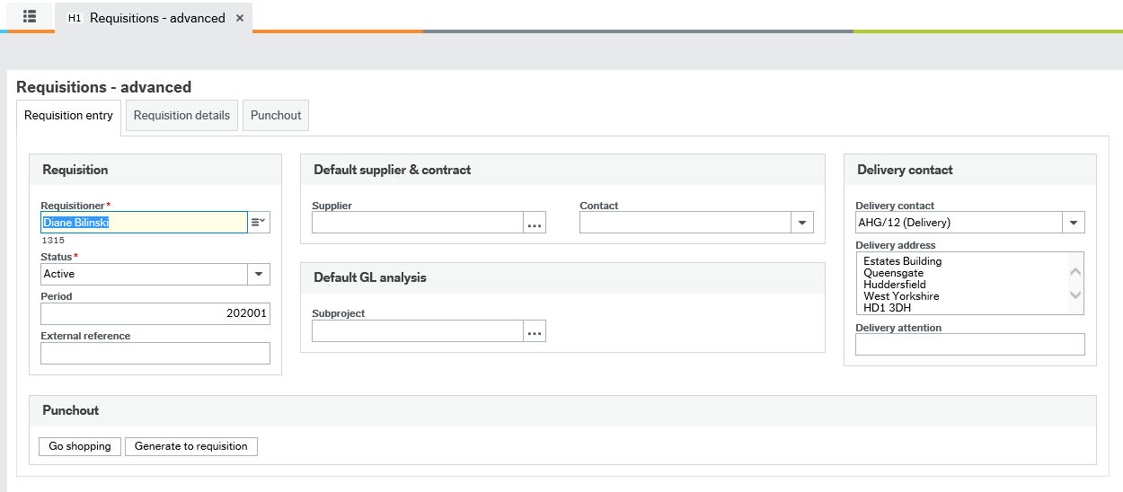

Requisitioner: This defaults in with your name. If your name is not defaulted in, please contact the Finance System support team who will enable it.
Status: This shows you the status of the requisition.
Period: This will default with the current period.
External Ref: This can be used for a contract number [if applicable]. Otherwise this can be left blank.
Supplier ID: Enter the supplier code of the supplier you want to use. See the next page to ‘search’ if you are unsure.

Supplier ID: type ahead and choose the correct supplier from the list
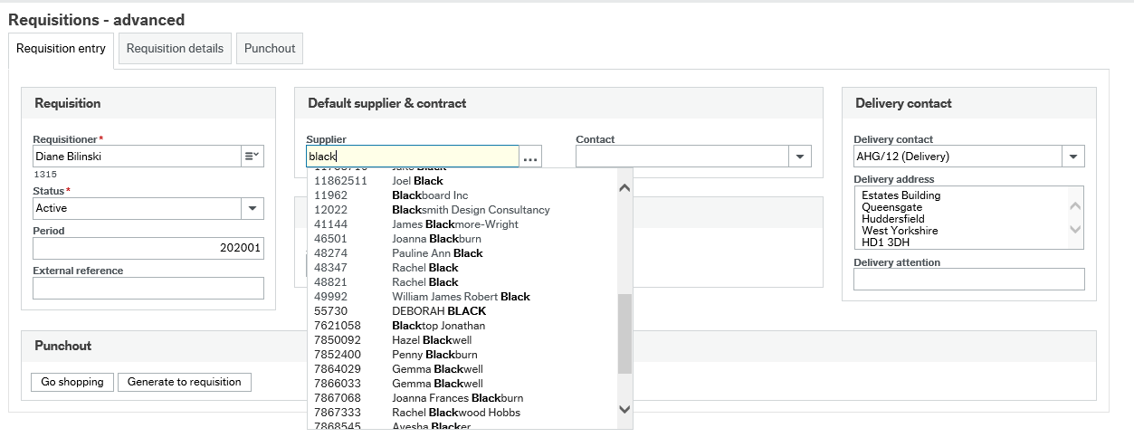
Click on the supplier account you want to use and the Supplier ID is displayed in the SupplierID field.
Subproject: This is the Subproject against which the expenditure will be recorded. It will be in the form AAAnnn-01. Type ahead using the subproject number.

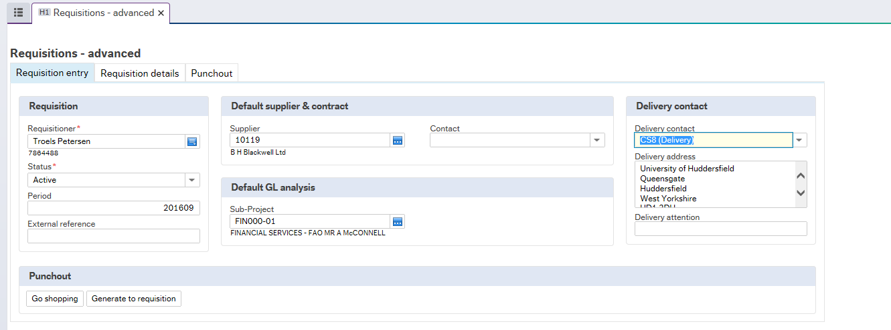
Delivery
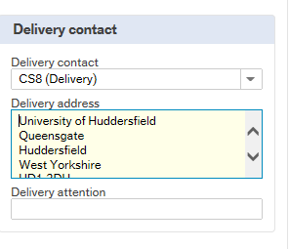
Delivery Address: this will default with the university’s address. You can amend it by overtyping the delivery address.
Delivery Description: you can type in additional delivery descriptions if required.
Delivery Attention: enter the name of the person who this product is for the attention of.

Requisition Details (Next Tab)
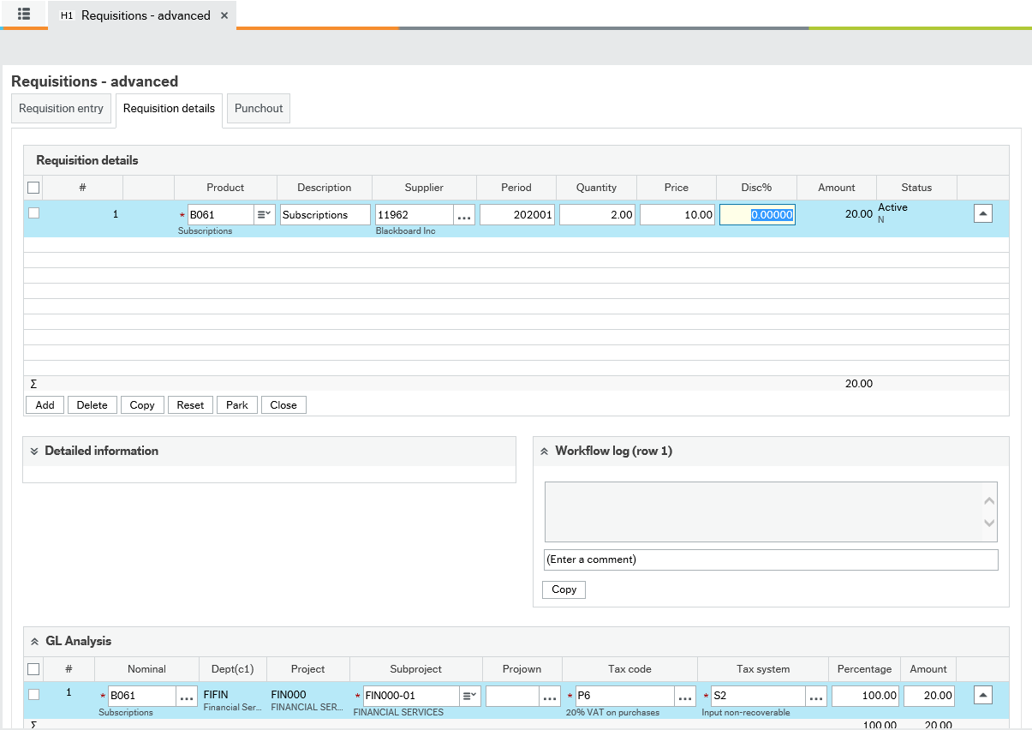
To add another line to the requisition, simply click on line below or click the Add button
Product: if you know the code, you can type it in, however if not, then you can click on the search icon to search for an appropriate code.
This code is the same as the Nominal code you want to use. This code is used to analyse how the university spends its money between various categories of expenditure. The product code will automatically allocate the nominal code.
Description and Detailed Information: a generic description will default in from the product code. You will need to make this more specific for the product you are ordering.
Supplier Id: this will default in with the Supplier Id code that was entered on the Requisition Entry screen.
Quantity and Price: enter the quantity and price, net of any VAT. The system will calculate the total value of the order.
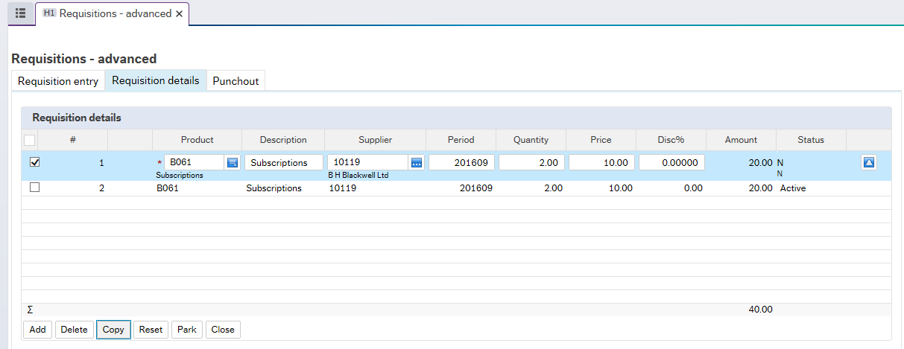
To copy a line, tick check box on the line that you wish to copy and then select the Copy row button . This will create a duplicate line on the requisition.

You can see that when a line has been ‘ticked’, the Delete button becomes available. So if you wanted to delete a row, simply tick the check box on the relevant line and click ‘Delete’ 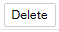
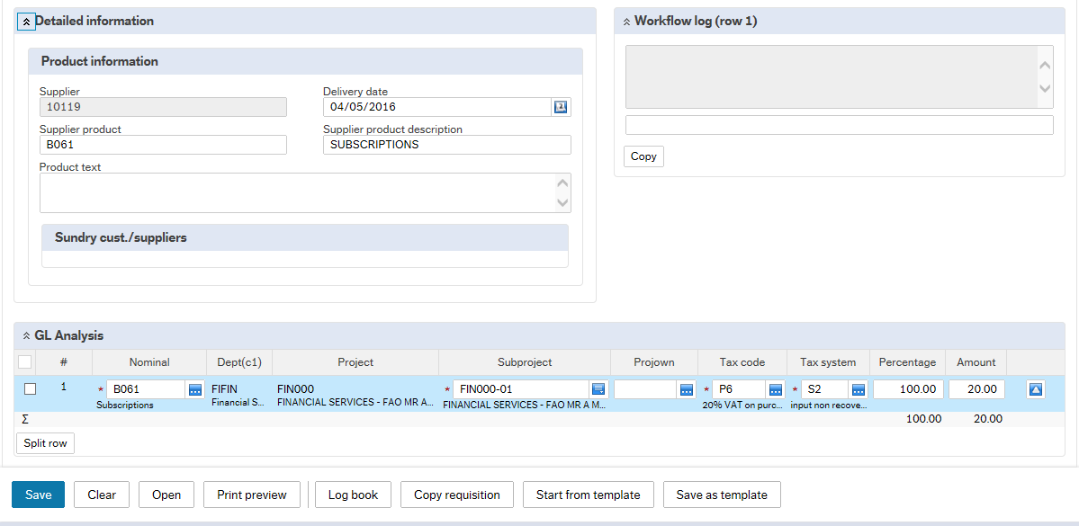

Detailed Information
Product Text: this is where you can enter extra information about your product, as mentioned earlier. If further information is required to show on the order, you can add this in the Product Text, under Detailed Information. Please note: The details that are typed here will appear on the purchase order that goes out to the supplier, so it is important that the description is relevant. In Product information you can also input the delivery date

GL Analysis
This shows you the accounting information for your product.
Nominal: this will default in from the product code that you have entered.
Subproject: this will have defaulted from the requisition entry screen.
TC (Tax Code): this is the VAT treatment and defaults in from the product code. Check whether this is as you would expect.
Each product has a default VAT treatment, based on what is usual for the product.
Most purchases will have the code P6 - 20% vat on purchases.
If there is no VAT on the product, the code should be P3 – zero rated VAT on purchases.
If you are in doubt whether VAT applies or not please leave as P6 - 20% vat on purchases.
TS – Tax System: this determines whether the VAT is recoverable by the university. Most purchases will have the code S2, Input non-recoverable. You do not need to alter this.
Split requisition
If needed one requisition line can be split into two or more lines in the GL analysis. The reason for wanting to split a requisition line could be that the requisition line is charged to two different subprojects. Another reason could be that VAT only applies partially to the requisition line.
To split the order click the 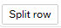 icon under the GL analysis section
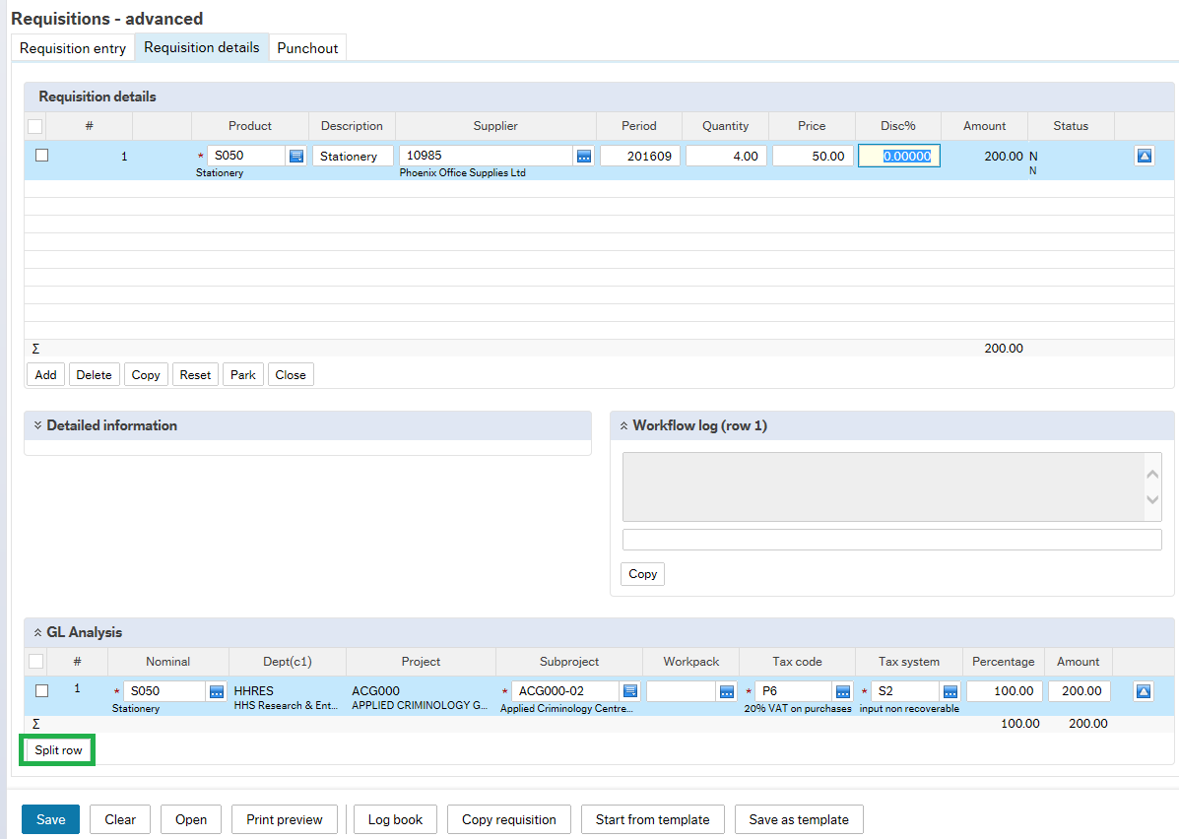
The two GL Analysis lines can now be filled in as appropriate with subproject and Tax code. In this example the requisition is committed 50/50 between two different subprojects and VAT only applies to the 50% which is committed against HHS000-01.
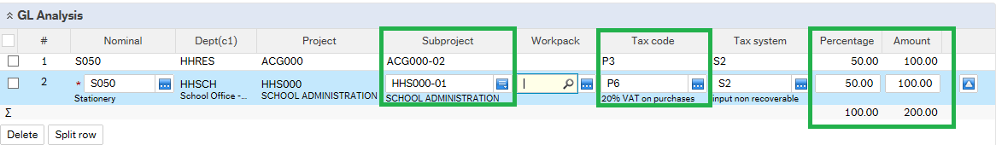
The lines can either be split by entering the percentage or amount and then tab. NOTE: The percentage total must be 100 and the total amount must match the requisition line amount.

Workflow Log
Information entered here will be seen by the budget holder. For example, for a conference you could enter the date and time that the order relates to.
Please note this is the first time the budget holder will see the requisition, so any relevant information with regards to the requisition should be entered.

Quotes
If the requisition is over £5000 you will need to provide at least 3 quotes and attach these to the requisition. On the Requisition entry screen, click on the paper clip icon in the top right hand corner of the screen.
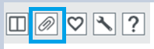
Select the 3 Quotes for Requisition and click on the Add a Document icon.
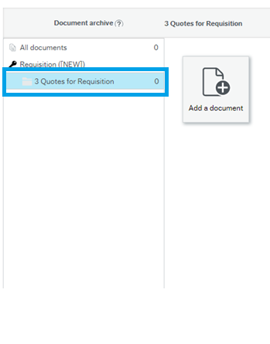
You can then find and attach the documents to the requisition.
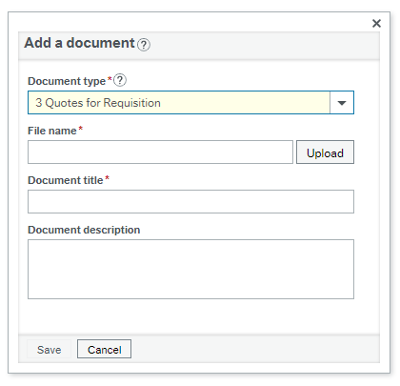
The inputting of the Requisition is now complete, check the details and then click the save icon. (Bottom right corner of the screen)

Posting Cycles
You will now need to select the type of order that you are creating. The options will be relevant to the school you are in. The options will be as follows:
- Req for orders to external suppliers (Standard Purchase Order)
- Req I O for orders to Internal Suppliers (Internal Purchase Orders)
- Req P C for orders to reimburse petty cash expenditure (Petty cash Order)
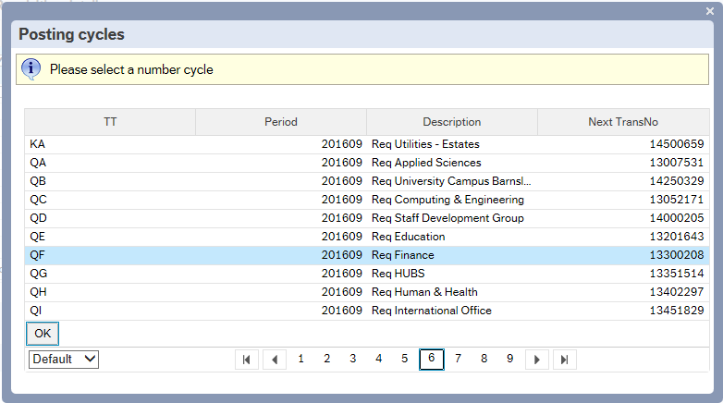
You will then be given a requisition order number – write this down on your input form for your future enquiries.
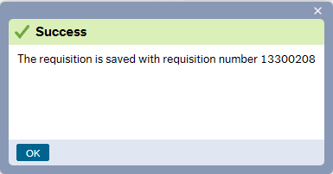
Once the order has been saved, workflow will route it to the budget holder of the Subproject used, for approval.

Printing a Purchase Order
Once the Budget Holder has approved the requisition, you as the inputter will receive an email to say that the requisition has been converted into a purchase order and is ready to print.
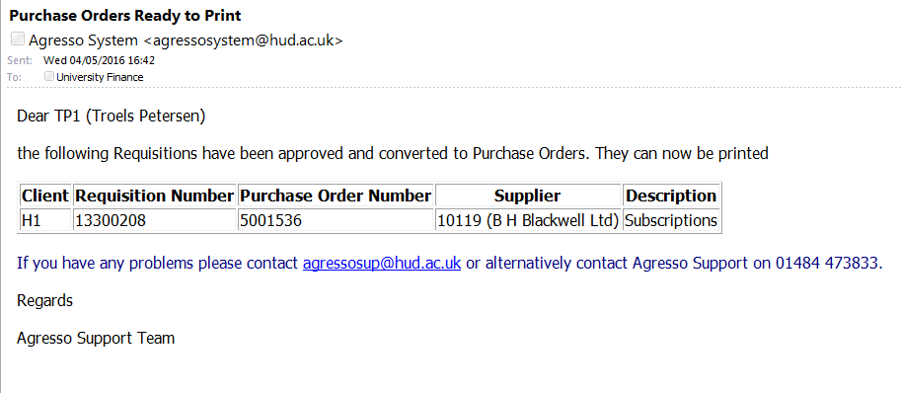
To print the order, you will need to log on to Unit 4 and select the following from the menu.
Procurement/ Purchase Orders/ Purchase Order Printout
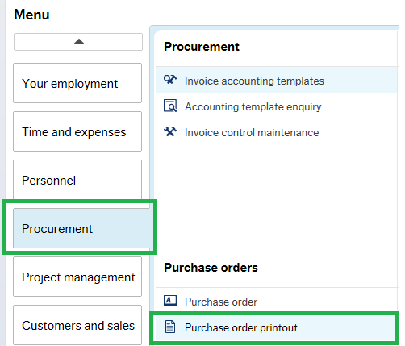

Select the Variant - Standard variant for External Supplier Orders
Petty Cash orders
Internal for Internal Supplier Orders (The Internal Order variant automatically prints 2 copies.)
International variant for International Supplier Orders
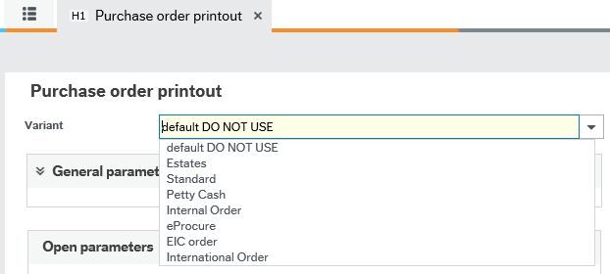
Complete the following fields:
Printer: click on General parameters
If your printer has been networked to Unit 4, then select the room number from the drop down list. Otherwise, type in TEST to print to a local printer.
Order Number From: put the number of the first order you want to print in ‘Order number from’ field.
Order Number To: put the number of the last order you want to print in ‘Order number to’ field

If you are only printing one order the same number must be input in both fields.
Once these fields have been filled in, click on the save icon.
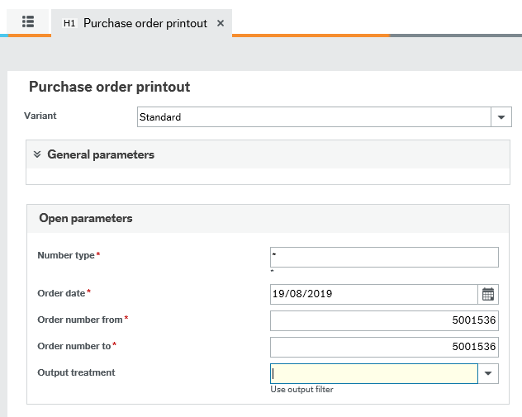
A pop up window will show that it has been successful.
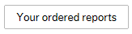
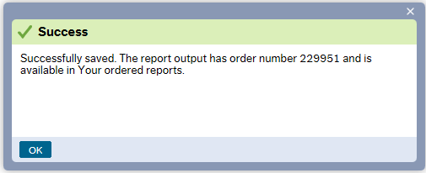
You can now open up the Ordered Reports screen by clicking on this icon This is found within the Purchase Order printout Screen.
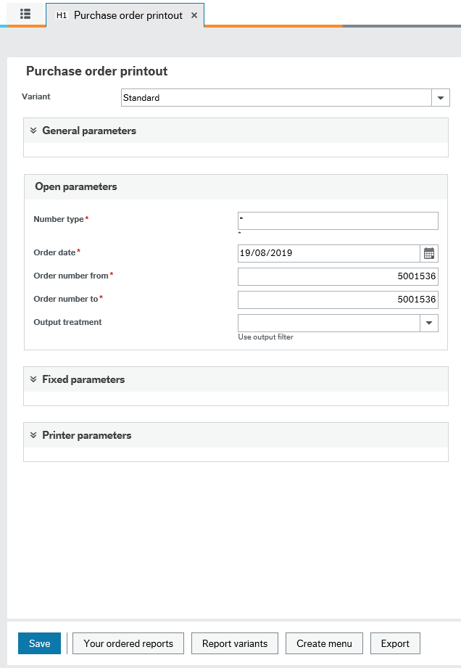

This will open up all the reports that you have requested to run. The status column will show if the report is still running or if it is finished. Press the 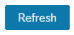 button in the bottom left corner to restore the page.
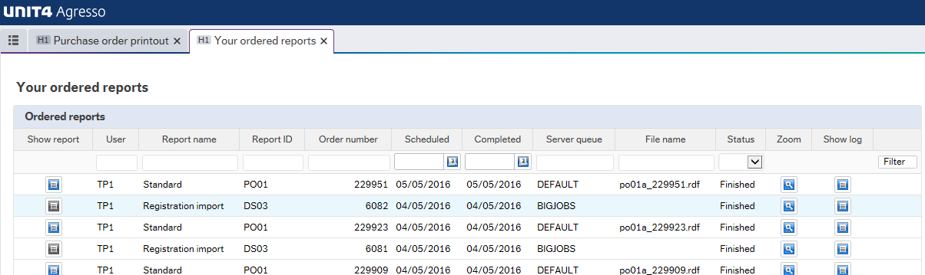
Once it is ‘Finished’ click on the icon on the left hand side your chosen report, which will open up the image of the purchase order.
You can then print from this screen to a local printer, or click on File and then Save to your documents.
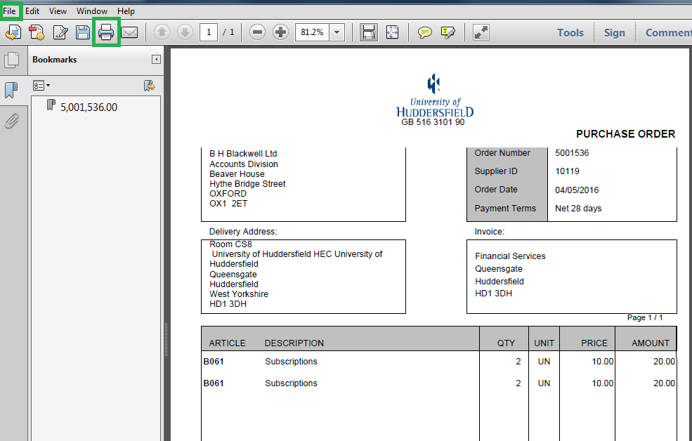
Making a Goods Received Entry
From the Menu select Procurement/ Purchase Orders/ Goods Receipt
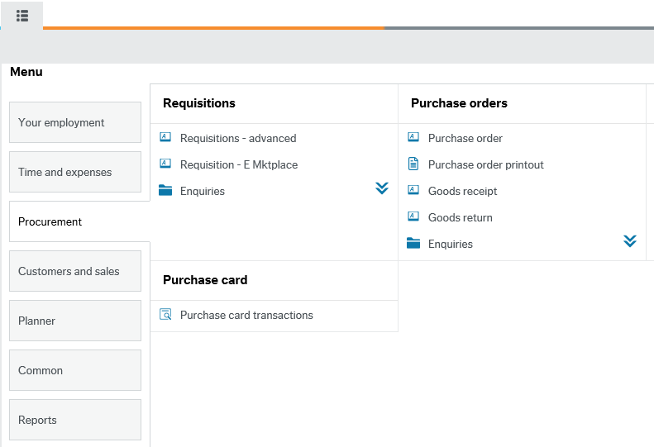

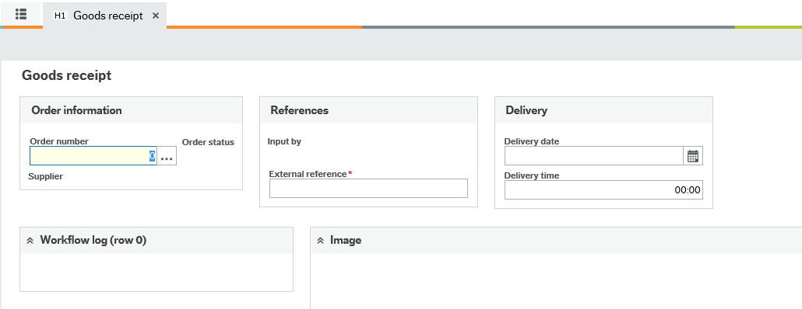
- Enter in your order number and tab
- Scroll down the page to the Order details and then, for each line enter the amount you wish to deliver in the Qty Received column.
- To confirm the changes click on the at the right hand side of the order line.
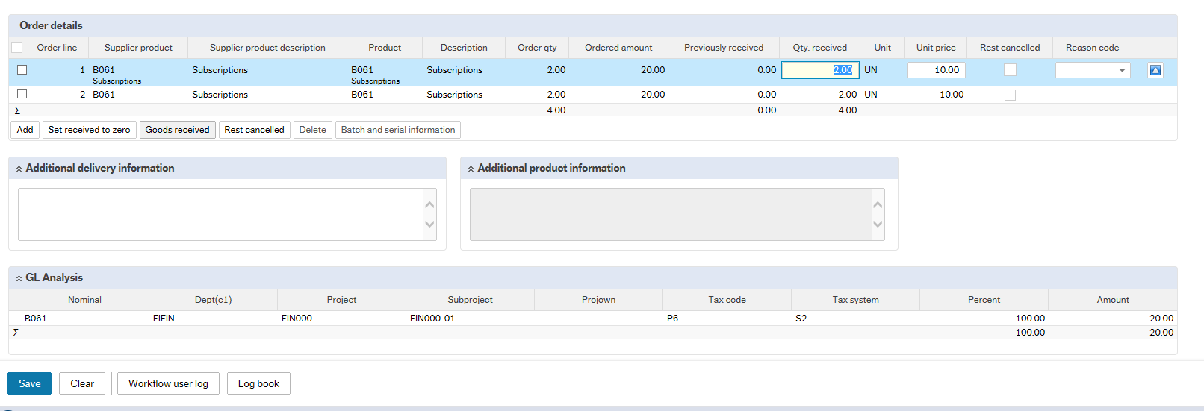
Once you have entered in the correct delivery amounts you can click Save
Goods Received: if you are receiving the full amount of an order line(s), instead of typing in the amount in Qty Received, you can tick the check boxes at the beginning of each relevant line and then click This will put the total Ordered Qty into the Qty. Received column (useful if there are many lines to an order). You can then click on the save icon to save the changes.

Rest Cancelled: if there are more items outstanding for that order line and you are not going to receive them, you can cancel the remainder by ticking the first column of the order line and selecting ‘Rest Cancelled’ 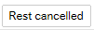
This will close the outstanding quantity on that line. Once the invoice is posted, it should close the line and show as ‘Finished’.
If the amount that you deliver is the same amount on the invoice, the system will then post the invoice to the ledger ready for payment.

Missing Goods (GRN) Task
If you have not delivered the goods on your purchase order and the invoice has already arrived into Finance, it will be scanned into the system and you as the inputter will receive a Missing GRN Task in your Task List and an email notifying you that there is a task waiting to be action. If you have a task to do, please ensure you do the task via the Your Tasks and not via the menu and goods receipt option. If you do not action the task and complete via the menu this will create a ‘ghost task’ which do not automatically disappear.
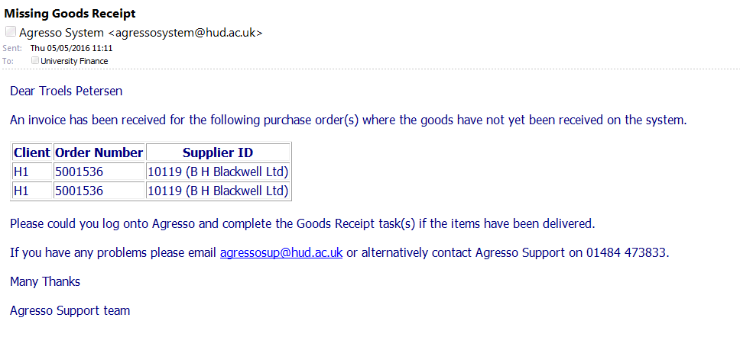
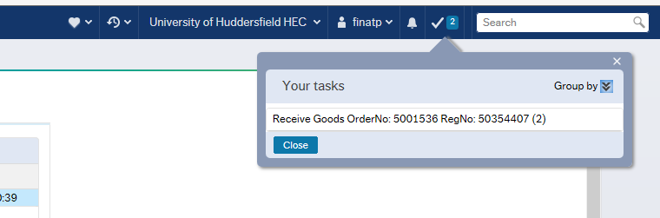
You will find your Missing Goods tasks looks like this in your task bar in the top right corner.

Click onto the task and the following screen will appear.
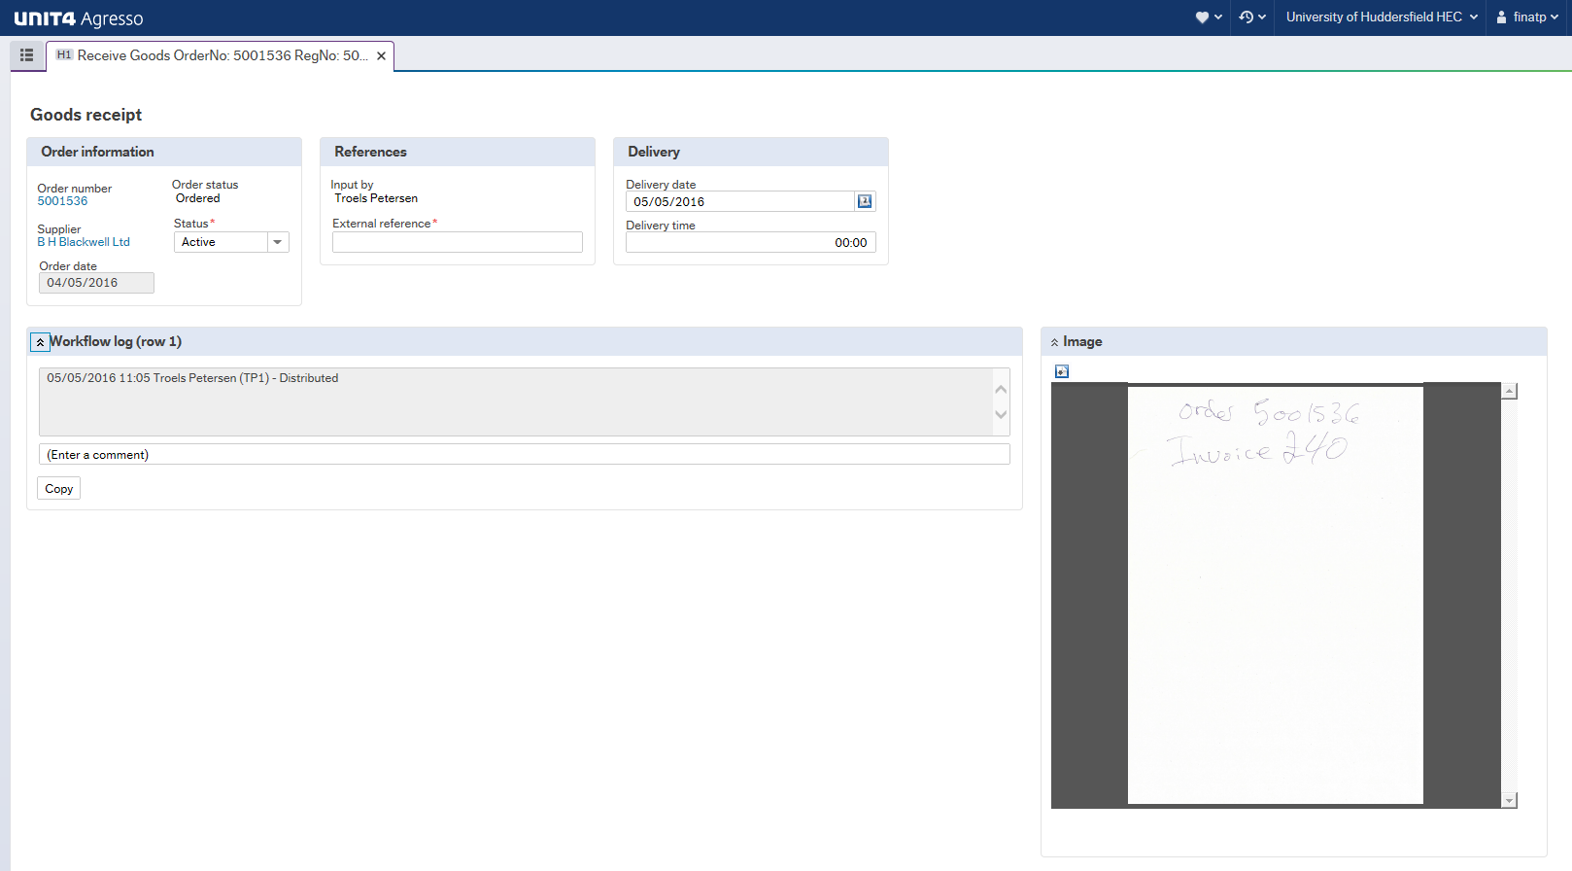
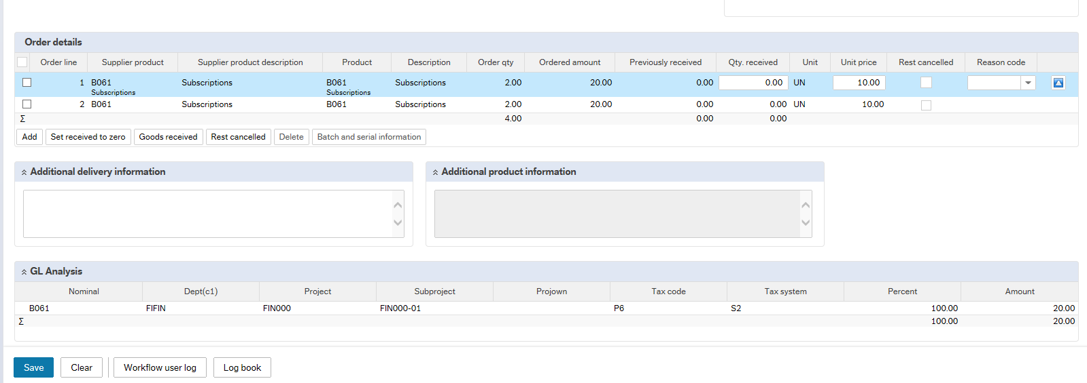
The invoice can be seen on the right hand side of the screen. You can enlarge this by clicking on the open/download icon.
Goods Received: if you are receiving the full amount of an order line(s), instead of typing in the amount in Qty Received, you can tick the check boxes at the beginning of each relevant line and then click This will put the total Ordered Qty into the Qty. Received column (useful if there are many lines to an order). You can then click on the Save icon to save the changes.

Rest Cancelled: If there are more items outstanding for that order line and you are not going to receive them, you can cancel the remainder by ticking the first column of the order line and selecting ‘Rest Cancelled’
This will close the outstanding quantity on that line. Once the invoice is posted, it should close the line and show as ‘Finished’.
If the amount that you deliver is the same amount on the invoice, the system will then post the invoice to the ledger ready for payment.
Making an enquiry on a requisition
If you would like to enquire on the progress of a requisition you can select
Procurement/ Requisitions/ Enquiries/ Workflow enquiry - Requisitions from the main menu and the following screen will appear.
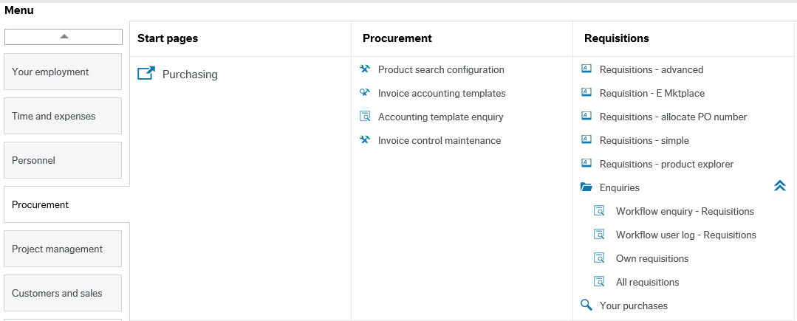

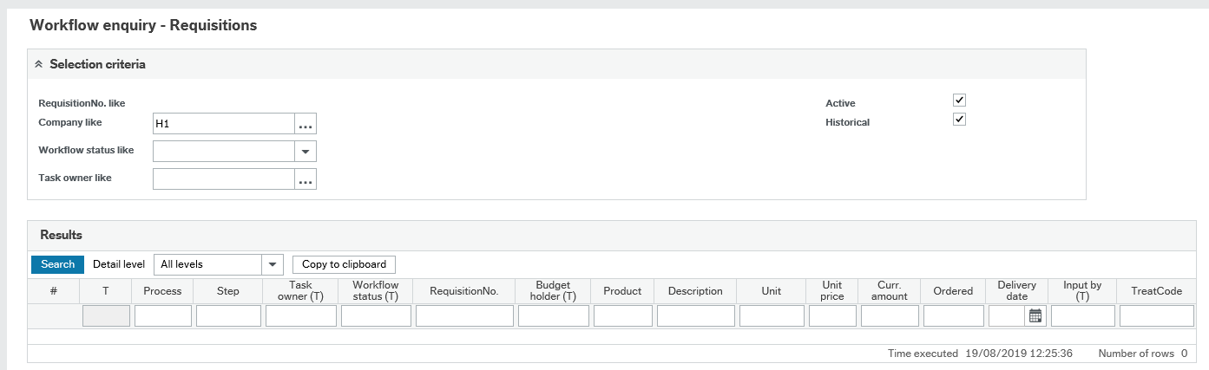

To filter down your search, you can type your requisition number in the RequisitionNo column.
Then click on Search
This brings all lines relating to the requisition number.
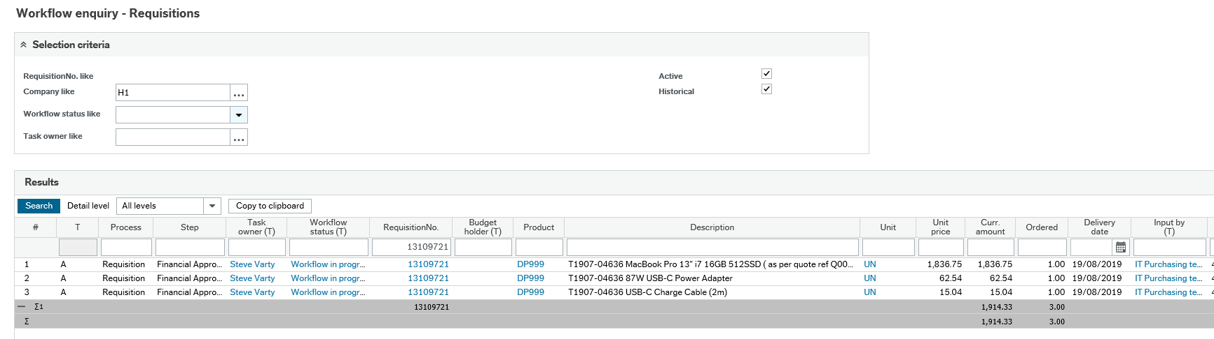
Using the example below, you can see this requisition is currently waiting for Financial Budget Holder Approval. You can identify the name of the approver under the Task Owner column.
You can also view the work flow map by clicking on the Workflow status hyperlink. This shows a pictorial view of the workflow and indicates to whom the requisition has been routed for approval.
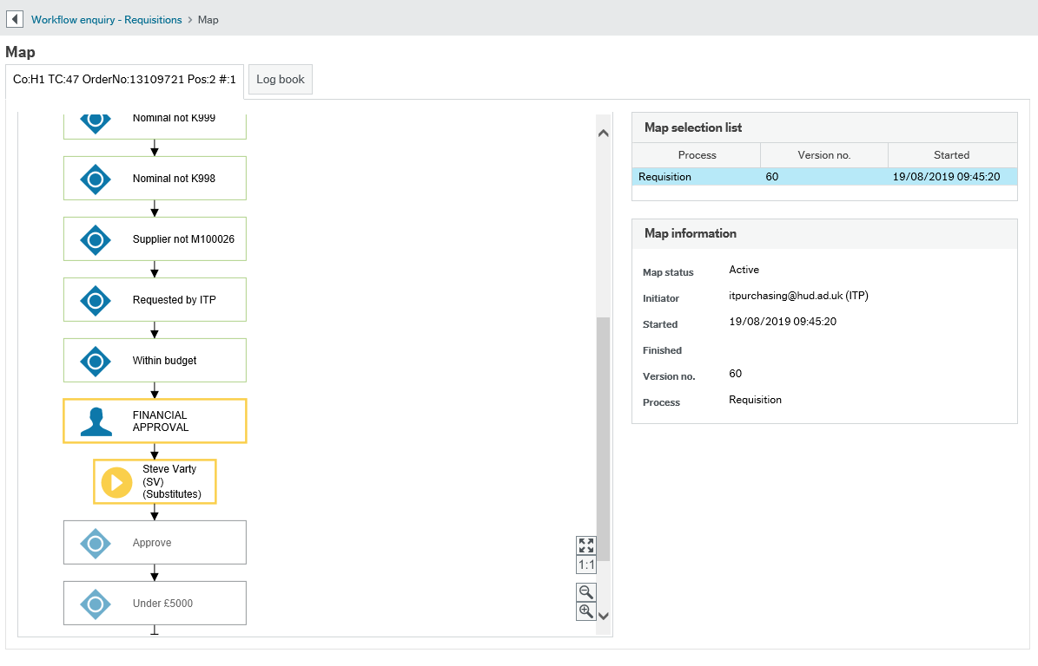
Green - these steps have been completed.
Yellow - this step is awaiting action and has not currently been completed.
Red - the steps highlighted in red indicate that the budget holder has rejected the requisition; therefore the requisition has been routed back to the inputter for amendments. For example, an incorrect Subproject could have been entered or there could be no value on the order.
If you move your mouse over a box it will provide information on when the step started and finished and the person who actioned that step.

