Peer Review Approval for Principal Investigator
When a project has been created and the project type is Research or Contract Research then the project will enter the peer review workflow. The Principal Investigator (PI) will receive an email alert asking him/her to log onto Agresso to action the task.
If you follow the link from the email this will open up the following log on screen for Agresso
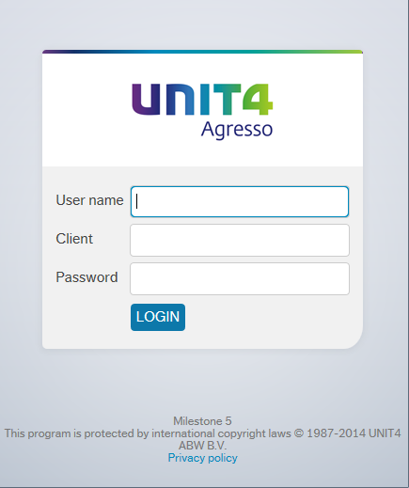

User name – your usual log on id
e.g. FINAMT
Client – H1
Password – this has to be alpha - numeric and minimum 7 digits
Note: if you do not know your log in details please contact the Agresso team (ext 3833 / 01484 473833, or email agressosup@hud.ac.uk) and they can let you know.
Once logged onto the system you can see your outstanding tasks by clicking the task icon in the right top corner. If you click on the task that relates to Peer Review this will open up the Approval on the right of the screen with the relevant detail in.
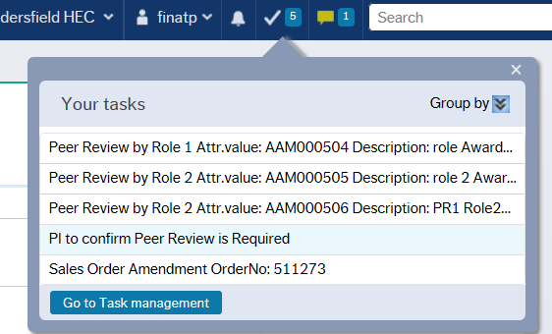

There is a yellow textbox which provides some basic information as to what is required for you to do.
As the PI you will need to confirm if peer review is required. You can select the following options at the top of the screen:
- No PR available
- Not Applicable
- Peer Review Required
- Too close to submission
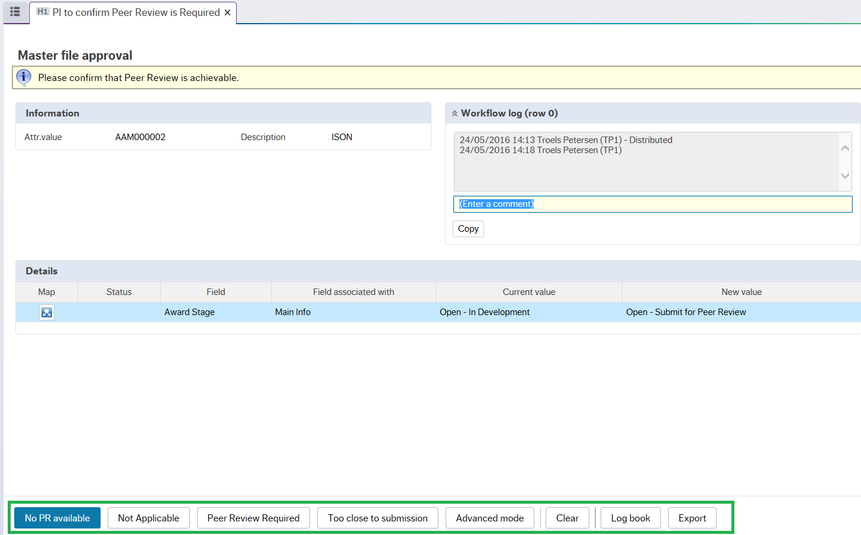
Once you have selected the relevant option the task will be processed and, if there are no more tasks to process you will see the following screen showing that the task has been completed successfully.
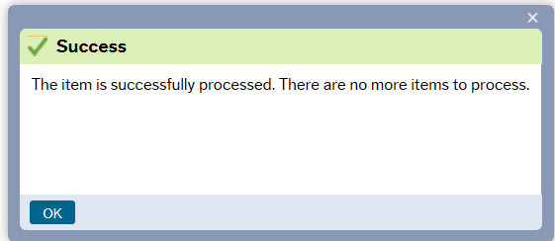

If no peer reviewers have been set up on the project then the PI will receive an email and a task similar to the one below to remind them that the relevant people need to be added onto the project as peer reviewers.
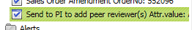
If you have created the project yourself you can log onto Agresso and set these up on the Peer Review tab within the project. If the project was created by another user then you will need to speak to them to enter the Peer Reviewer(s).
Once the Peer Reviewer(s) are set up return to this task and approve it to confirm that the peer reviewers have been added.
The system will then send alerts to the peer reviewers asking them to complete the peer review process. Once this has been completed they will enter a comment on the system to conclude the process.

