Peer and Ethics Review Approval
When a project has been submitted for review and it is a Research type project it will require some form of peer review to occur. The Principal Investigator will receive a task to confirm that peer review will take place. There will also always be an ethics review process. Once he/she has confirmed this, an email will be sent to yourself as the peer reviewer or person confirming that an ethics review has taken place, along with a task to be actioned on Agresso.
If you follow the link from the email you receive this will open up the following log on screen for Agresso.
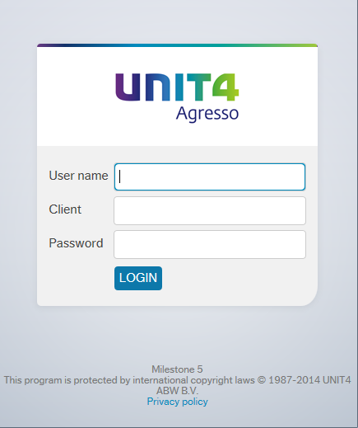

User name – your usual AD log on id
e.g. FINAMT
Client – H1
Password – this has to be alpha - numeric and minimum 7 digits
Note: if you do not know your log in details please contact the Agresso team (ext 3833 / 01484 473833, or email agressosup@hud.ac.uk) and they can let you know.
Once logged onto the system you can see your outstanding tasks by clicking the task icon in the top right corner of the page. This will open the following task list.
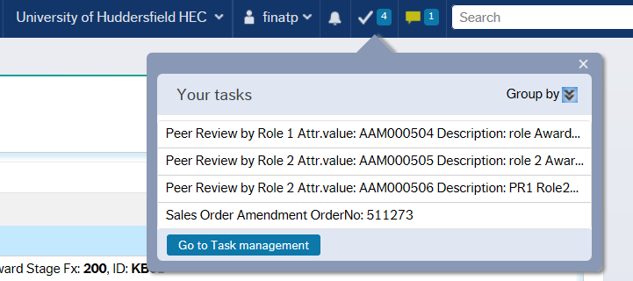
If you click on the task that relates to Peer Review this will open up the Approval on the right of the screen with the relevant detail in. It also shows a yellow box which provides some basic information as to what is required.
When you have completed the peer review along with all the necessary documentation, you can log on and go to the task to select the option to complete. A short comment must be added to summarise the findings of the review.

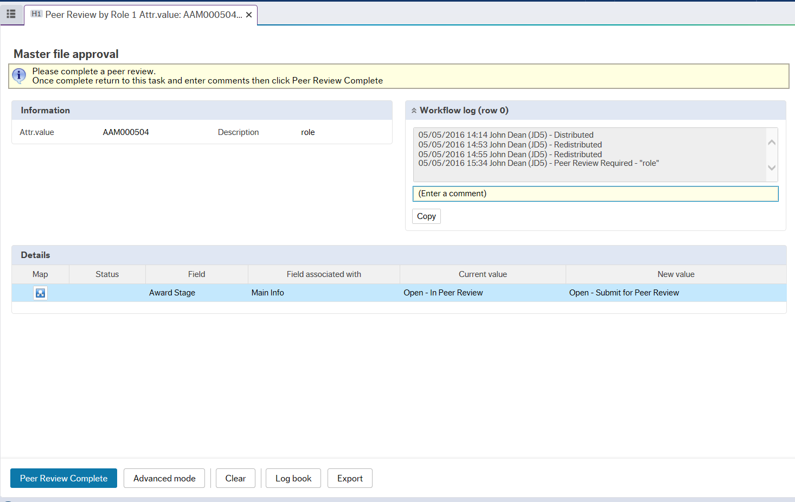
There will also be an Ethics Review task sent through to a specific person that has been selected when creating the project, similar to the screenshot below.
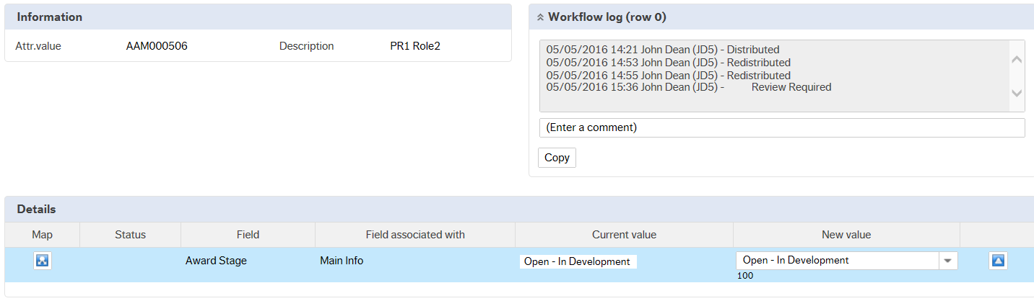
Perform ethics review in usual manner and once complete click "Ethics Review Complete" button at bottom left of window. Inform your school research admin where documents are so they can be attached.
This will finish the Peer review and Ethics workflow and enable the project to progress to the next stage. These reviews must be completed before the project costing can be sent to the Dean for final approval.

