Purchase Card Coding

Instruction Documentation

Finance System Support

Email - FinanceSystemsSupport@hud.ac.uk

URL - https://agressoweb.hud.ac.uk/MS7_Live_Web/Login/Login.aspx

Training - https://staff.hud.ac.uk/finance/financesystems/training/

Purchase Card Coding
Contents
Introduction 3
Log in to Unit4 4
Purchase Card Coding Task 5
Amending the default coding details 6
Attaching receipts to Purchase Card transactions 8
Purchase Card Coding – Splits 10
Trouble shooting 12

Introduction

Purpose
Purchase cards are one method of purchasing at the University, preferred time saving process of a purchasing payment. Quick payment to the supplier, most efficient way to purchase goods or services.

Fraud
Lost or stolen purchase cards, or if you suspect a fraudulent transaction has occurred, the card holder must immediately contact the bank, card provider. Details found on the reverse of the purchase card.
Alert the Treasury Accountant in central finance with anything to do with fraud, card limits, any relevant purchase card related details.
Contact your local Anti-Fraud Champion.

Keep cards and PINS safe and secure. The card holder should treat like their own card, safekeeping responsibility down to this individual. Details should never be written down for security reasons, the card should be present at point of sale.

The purchase card is for work purposes only, no personal spend should occur even in emergencies, this is not permissible. Individuals should not benefit from using purchase card e.g. cash back sites, points, etc.

Purchase cards may not be used to avoid preferred or contracted suppliers - ensure spend is line with University’s Procurement Policy.

Deadlines
Coder to code transactions as soon as possible. This is an audit requirement of the University to aid identifying fraudulent transactions. Unit4 will send regular timely reminders to the coder if coding task not actioned.

Delays in coding and authorising should not occur. If issues have arisen this should not stop coding the purchase card spend. If for example disputes occur and credits are required, this transaction will be coded to offset this spend.

If lateness of coding constantly occurs you may find the card balance is reduced to zero.
The University is the owner of the card and can halt spending if misused or not following procedures.

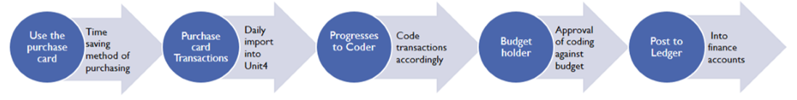
Workflow overview of process steps for purchase cards

NB: A coder can never code and approve spend, the approval will escalate to a supervisor if spending on own budget.

Log in to Unit4

Before logging into Unit4
Note: if you have not used Unit4 or require initial training contact support via email to obtain access FinanceSystemsSupport@hud.ac.uk

By following the URL you can log on to the Live Unit4 system:
https://agressoweb.hud.ac.uk/MS7_Live_Web/Login/Login.aspx

Alternatively, via the Staff Hub internet page login:
On the black navigation bar near the top of this page, locating the link Online Systems.
This opens a new page which you will need to scroll down to locate the link for
Unit4 (campus only).

To note: OFF campus you will need to login via Unidesktop to access.

The Login box should appear. Enter login details and then click the Login button:

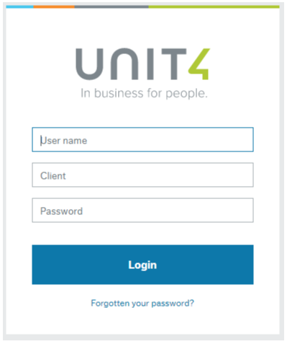
User name: the same as your computer login e.g. FINALS

Client: H1 is the University company to be used

H1 - (Main Company)
H3 - (UHEL Company)

Password: must be at least 6 digits and include a number
Forgotten your password? Reset by clicking the link

This will open a screen like the following fig 1.1
The ‘book ends’ menu available on the left of the screen will vary according to your role.
To access your outstanding tasks click the icon in the top left toolbar, circled is the location of the task list.

fig 1.1
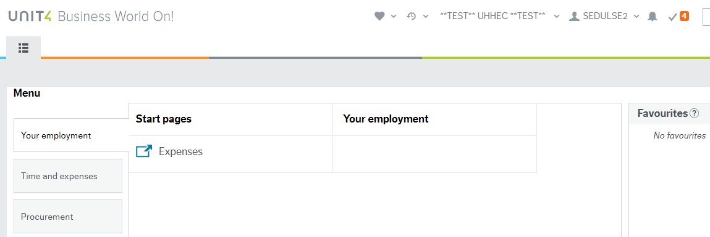

Purchase Card Coding Task

- Click on the task line rather than the ‘Task Manager’ option.
In the example fig 1.2 there are several Purchase Card coding tasks displayed on the left hand side of the screen.

The first task is the one which is highlighted in blue on the left and details displayed in the right hand window.

Fig 1.2
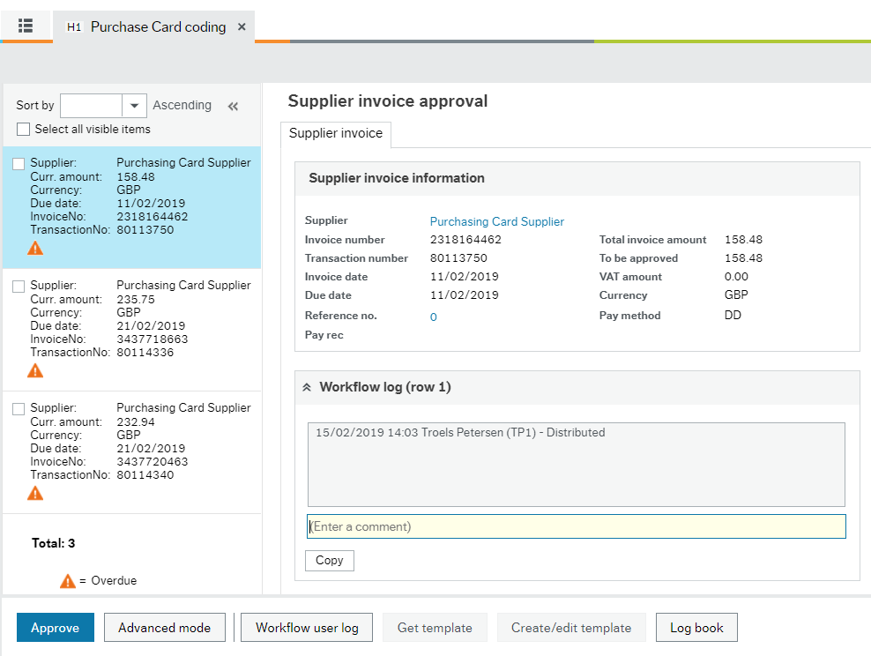

NOTICE default Supplier invoice information fig 1.3
Supplier – Purchase Card Supplier
Total invoice amount – GROSS purchase value
To be approved – NET amount to budget holder
VAT amount – will always show as zero 0.00 until updated

Fig 1.3

NOTICE default import transaction details
Nominal = P9999, Subproject = FIN999, VAT = P3, Description from statement
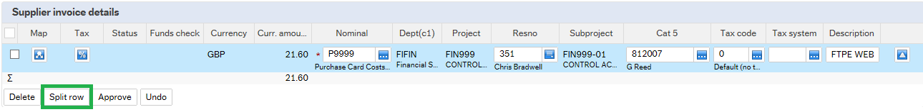

- The Nominal, Subproject and Description and VAT Tax code MUST all be amended from the default values.

Amending the default coding details

- Nominal - used to identify what financial transaction has happened e.g. books, stationery. This MUST be amended from the default P9999.
NB never use an 8 code as this is an income code.

As the Nominal is updated the Tax code will automatically change to P6, but this will incorrectly ADD VAT onto the statement figure so must be amended.
The Tax code on the line detail must be amended to P8 if VAT is shown on the receipt, purchase evidence or P3 if not, no VAT.

Tax code default example:
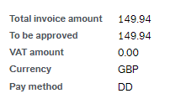
Statement ‘Total invoice amount’
This amount will stay the same

To be approved
This is the NET value which may change depending on VAT coding
P3 = NO VAT P8 = includes VAT

VAT amount
This value may change depending on VAT charged

P/card coding to P8 example:

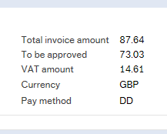
To be approved
Is the NET value approved by the budget holder
For the P/card we want the system to take VAT OFF the ‘Total invoice amount’

VAT amount
P8 coding - the transactions VAT amount has changed to include VAT

- VAT - if P8 is used, then in most cases the Tax System should be S2 fig1.4.
NB: the only case this doesn’t apply to would be if the Subproject CPK000-01 is used, in this case the Tax Code would be P8 and the Tax System would be S1.

Fig 1.4
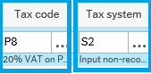

- VAT - if P3 is used, the VAT amount will be 0.00 and the ‘Total invoice amount’ and
‘To be approved figure’ will remain the same matching figure fig1.5

Fig 1.5

- Subproject - identifies which part of the University owns the transaction and is the responsibility of a budget holder. The budget holder will accept or reject this coding.

- Amend the default FIN999-01 to the relevant subproject.

NB if the subproject you require is not listed you will need permission from the budget holder or your school finance office to have access. This approval requires emailing to Finance Systems Support to update.

All purchase card transactions are coded in H1, even if it is a H3 subproject. The transactions are journaled from H1 to H3.

If it is a H3 subproject and the tax code is P8, make sure the Tax system is S2.
This is because when the transactions are moved from H1 to H3 the tax system will be changed to S1 and will recover the VAT.

- Description - ensure this is amended to clearly show what has been purchased.
Suggesting starting with the Supplier’s name and then continue with additional detail of transaction, the budget holder needs to recognise what has been purchased.

- Final check - before proceeding check that the
- Total invoice amount is the GROSS value and matches purchase card statement
- To be approved amount and VAT amount matches the details on the receipt and total the GROSS value
- Nominal, Subproject and the Description have all been amended accordingly
- If everything is correct click on the Approve icon in the bottom left corner which will then route the line to the relevant budget holder to approve.

Review the purchase card coding task list fig1.6 and if there are more tasks awaiting attention then click on each one and amend the default coding as described.

Fig 1.6

NOTE: The payment has already occurred, the task is to confirm the subproject commitment, delays in coding should NOT occur, refer to Introduction – Deadlines.

Attaching receipts to Purchase Card transactions

There is an option to attach receipts to each purchase card transaction. This allows the budget holder to be able to view the receipt before an accept or reject decision is made against the transaction.

Once the task is accessed and completed as the coding detail instructions prior you can attach receipts by clicking on the in the top right corner.

- The below screen fig1.7 will open, click on from the lower screen.

Fig 1.7
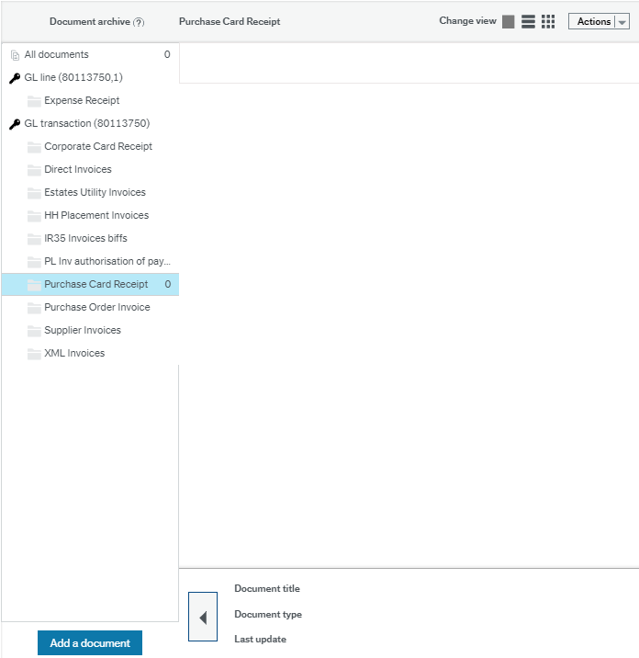

- An additional box will then appear fig1.8

Fig 1.8
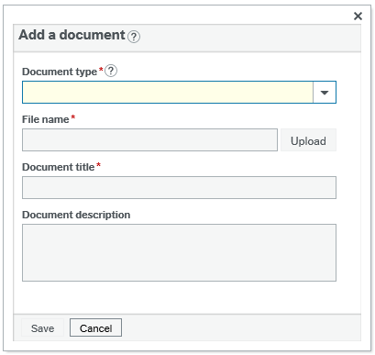

- Under the Document type fig1.9, click on the drop down arrow and select Purchase Card Receipt

Fig 1.9
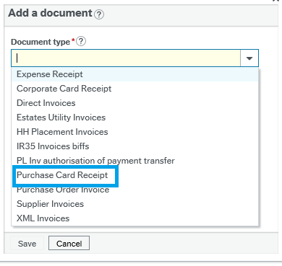

- Select Upload and find where you have saved the receipt fig2.0

Fig 2.0
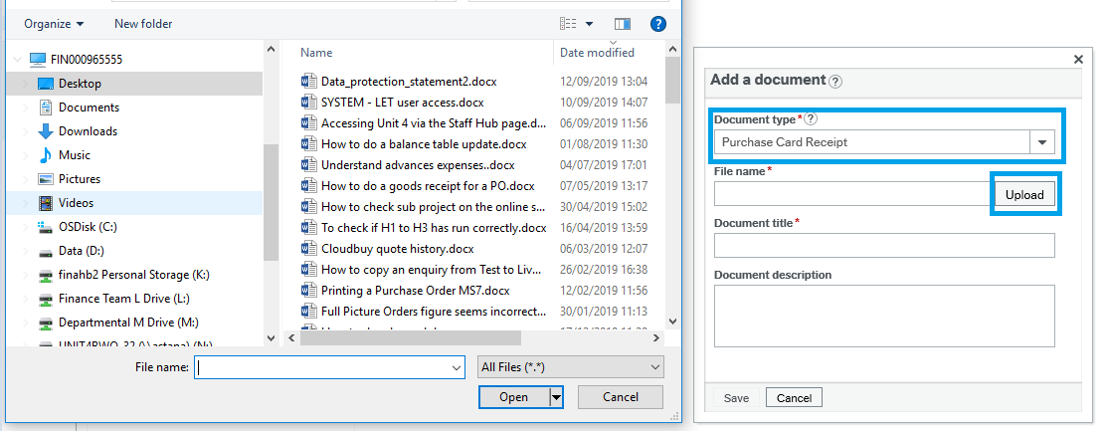

- Once you have selected the correct file and clicked Open, then click Save.

The image of the receipt will display fig2.1, you can close the pop up box by the small x.

Fig 2.1
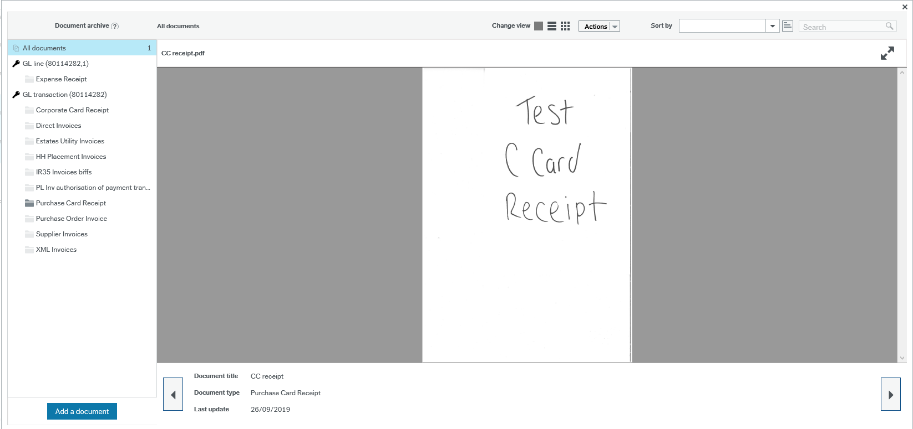
Once a receipt is attached, the paper clip will then shade blue

- Once all the details are updated and completed on the purchase card coding task you can click Approve.

This task will then enter workflow and the budget holder will be able to see the image of the receipt to aid understanding of the approval task.

Purchase Card Coding – Splits

- To process splitting Subproject, Nominals or VAT
- When the coding task is open click icon in the bottom left corner.

- The screen then opens and the Advanced mode will now say Simple mode.

- When the screen opens, code the first transaction line as usual and ensure that the Nominal, Subproject and Description are amended from the default values.
- Click near the bottom of the page.

The system will add another coding line beneath the first one.

- On the new row complete the Nominal, Subproject and Description.
- Next enter the GROSS amount to be coded to the new subproject.
The amount on the line above will change automatically.
- Enter the correct Tax code either P8 or P3.

Fig2.2 the Tax code and the Tax System from the original line will copy to the new line. Ensure the Tax Code and Tax System are correct.
If P8 is used, then in most cases the Tax System should be S2.
Split row can also be used to split the cost between different subprojects.

Fig 2.2
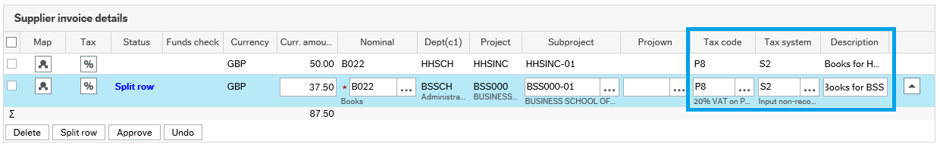

Split row can also be used if only part of the transaction is vatable and part of it isn’t fig2.3

Fig 2.3
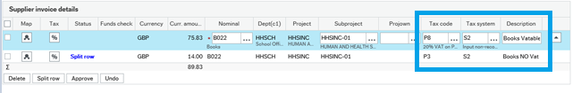

- Once breakdown completed, click on Simple Mode in the bottom left corner to return to normal view.
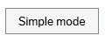

- Once all the details are updated and completed on the purchase card coding task you can click Approve.

- Success message to alert that this task will now escalate the budget holder. Click OK to close.

